Automotive cover goes here

AUTOMOTIVE SERVICE TECHNICIAN
Activity Plans

Automotive Service Technician

Table of Contents

Acknowledgements . . . . . . . . . . . . . . . . . . . . . . . . . . . . . . . . . . 3
Compressed Air . . . . . . . . . . . . . . . . . . . . . . . . . . . . . . . . . . . . 5
Tire Identification . . . . . . . . . . . . . . . . . . . . . . . . . . . . . . . . . . . 17
Vehicle Inspection . . . . . . . . . . . . . . . . . . . . . . . . . . . . . . . . . . . 27
Roadside Survival . . . . . . . . . . . . . . . . . . . . . . . . . . . . . . . . . . . 35
Nuts and Bolts . . . . . . . . . . . . . . . . . . . . . . . . . . . . . . . . . . . . 43
Hand Tools and Power Tools . . . . . . . . . . . . . . . . . . . . . . . . . . . . . 53
Fill in a Work Order . . . . . . . . . . . . . . . . . . . . . . . . . . . . . . . . . . 71
Oil Change . . . . . . . . . . . . . . . . . . . . . . . . . . . . . . . . . . . . . . 75
Welding . . . . . . . . . . . . . . . . . . . . . . . . . . . . . . . . . . . . . . . 85 The Basics of Four-Stroke Engines . . . . . . . . . . . . . . . . . . . . . . . . . . 93
Compression Testing . . . . . . . . . . . . . . . . . . . . . . . . . . . . . . . . . 107
Tire Change . . . . . . . . . . . . . . . . . . . . . . . . . . . . . . . . . . . . . . 117
Wheel Balance . . . . . . . . . . . . . . . . . . . . . . . . . . . . . . . . . . . . 123
Tire Repair . . . . . . . . . . . . . . . . . . . . . . . . . . . . . . . . . . . . . . 129
Lifting Vehicles . . . . . . . . . . . . . . . . . . . . . . . . . . . . . . . . . . . . 135
Solder Wire . . . . . . . . . . . . . . . . . . . . . . . . . . . . . . . . . . . . . . 143
Micrometers . . . . . . . . . . . . . . . . . . . . . . . . . . . . . . . . . . . . . . 153
Safety considerations . . . . . . . . . . . . . . . . . . . . . . . . . . . . . . . . . 167 Becoming an Automotive Service Technician . . . . . . . . . . . . . . . . . . . . . 179 Information Handouts
Overview for the Automotive Youth Explore Trades Skills . . . . . . . . . . . . 205 What's Included in a Complete Brake Job . . . . . . . . . . . . . . . . . . . . . . . 207
Hazard Assessment: Batteries and Boosting . . . . . . . . . . . . . . . . . . 209

Acknowledgments and Third Party Copyright

Youth Explore Trades Skills Learning Resources Development
Open School BC, the Custom Programs work unit of the BC Ministry of Education, and SkilledTradesBC are grateful to the following individuals and organizations for their contributions to the Youth Explore Trades Skills Learning Resources Development Project.

Resource Development Planning Session (Nov. 22, 2013)
Paul Elmont, SD 22 (Vernon)
Ken Jorgensen, SD 57 (Prince George) Dick Brouwer, SD 63 (Saanich)

Writing
Paul Elmont, SD 22 (Vernon)
Ken Jorgensen, SD 57 (Prince George)

Review
Dick Brouwer, SD 63 (Saanich)

2013 Curriculum Advisory Committee
Brian Campbell, District Principal, Careers and International Education, SD 60 (Peace River North)
Larry Espe, Superintendent of Trades and Student Transitions, BC Ministry of Education Colleen Hannah, Aboriginal Agreements Coordinator, BC Ministry of Education
Rodger Hargreaves, Career Programs, SD 62 (Sooke)
Mike Howard, President, BC Technology Education Association, SD 19 (Revelstoke) Erin Johnston, Manager, Labour Supply Initiatives, SkilledTradesBC Eleanor Liddy, Director, Open School BC
Eric MacNeil, President, BC Culinary Arts Specialist Association
Jim Pelton, former Director, Training Delivery, SkilledTradesBC
Glenn Rowan, Education Officer, Graduation, Dual Credit, Industry Training, BC Ministry of Education
Tim Winkelmans, Lead, Graduation Standards, Educational Technologies, Learning Alternatives, BC Ministry of Education

2013 Resource Development Planning Session (July 10, Victoria BC)
Dick Brouwer, SD 63 (Saanich) Jeff Dickson, SD 35 (Langley) Brad Edmondson, SD 36 (Surrey)
Adrian Hill, Project Manager, Open School BC
Mike Howard, President, BC Technology Education Association, SD 19 (Revelstoke) Tom Hoyme, SD 42 (Maple Ridge-Pitt Meadows)
Eleanor Liddy, Director, Open School BC
Erin Johnston, Manager, Labour Supply Initiatives, SkilledTradesBC Ken Jorgensen, SD 57 (Prince George)
Karen Larsen, Career Programs Coordinator, SD 39 (Vancouver)
Martin Lim, Vice-President, BC Technology Education Association, SD 36 (Surrey) David Olsen, SD 69 (Qualicum)
Stu Rhodes, SD 63 (Saanich)
Glenn Rowan, Education Officer, Graduation, Dual Credit, Industry Training, BC Ministry of Education
Rhonda Stangeland, SD 38 (Richmond)
Chris Teskey, Project Manager, Open School BC
Cory Williams, Manager, Program Standards, SkilledTradesBC

Open School BC Production Team
Copyright: Shannon Sangster Editing: Keith Learmonth
Graphics: Max Licht (http://www.maxlicht.com) Graphics Coordination: Christine Ramkeesoon Photography: Dennis Evans
Project Managers: Adrian Hill, Tracey Peever, Chris Teskey
Project Supervision: Monique Brewer (Director), Jennifer Riddel (Manager, Instructional Services)
Production Technicians: Beverly Hooks, Brian Glover Website Construction and Design: Christine Ramkeesoon

Third Party Copyright
Every effort has been made to contact copyright holders for third party works included in the Youth Explore Trades Skills learning resources. If you have any questions or concerns, please contact openschoolinfo@gov.bc.ca

Compressed Air

Description
Students will be introduced to the potential hazards of working with compressed air and how to appreciate the benefits of air-operated tools. Students will also be shown the safe and proper operation of air tools.

Lesson Outcomes
The student will be able to:
- Recognize and understand the dangers and the safe use of compressed air
- Recognize the benefits of using compressed air tools over electrical or hand tools
- Describe the operation and use of several commonly used air-operated hand tools
- Connect and disconnect a variety of air tools to an air supply
- Describe the correct procedure to maintain air tools connectors and the air supply

Assumptions
- Students have little or no previous knowledge or skill in the use of compressed air tools.
- The teacher has previously used air tools and has a good working knowledge of air- operated tools.

Estimated Time
Sixty minutes if the lesson is divided into three 20-minute sessions consisting of (1) explanation,
- demonstration and (3) student practice time

Recommended Number of Students
20, based on the BC Technology Educators’ Best Practice Guide, preferably working in pairs (will depend on the availability of equipment)

Facilities
Any shop facility with compressed available

Tools
  - Sufficient air hoses with connectors for each pair of students if possible. If not, then stations can be made with a short length of hose and a connector installed. This will allow students to practise connecting and disconnecting different air tools despite them not being connected to an air supply.
  - As many different types of air tools as can be located to demonstrate their use and purpose to the students.
  - An “air gun” (impact wrench), air drill, air/die grinder, air hammer/chisel and a “blow gun” should be the minimum set of tools available for demonstration. Additional tools would be an asset.
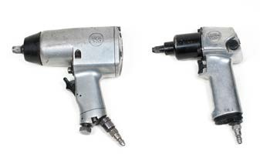
Figure 1—Impact wrench

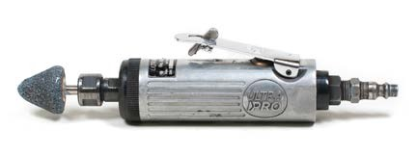

Figure 2—Die grinder

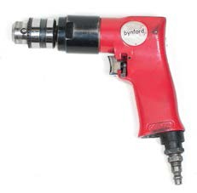

Figure 3—Air drill

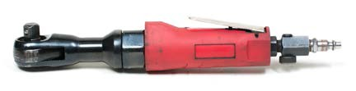

Figure 4—Air ratchet

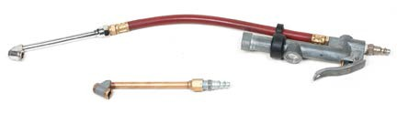

Figure 5—TIre inflator

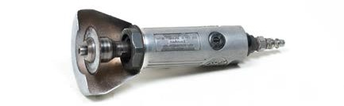

Figure 6—Air cutter

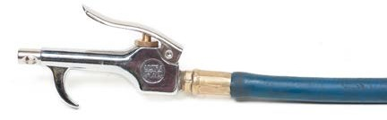

Figure 7—Air blow gun

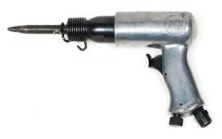

Figure 8—Air chisel

Materials
- “Cleaning with Compressed Air” handout for each student, listing the dangers of using high-pressure air (see “Resources” section).
- Safety glasses
- Sufficient air hoses with connectors for each pair of students if possible. If not, then stations can be made with a short length of hose with a “female” connector installed for students to practise connecting and disconnecting different air tools.
- A sufficient amount and variety of air tools (listed in the “Tools” section) and attachments for students to be able to learn all types of tools and how they connect and operate.

Resources
“Cleaning with Compressed Air.” Canadian Centre for Occupational Health and Safety www.ccohs.ca/oshanswers/safety _haz/compressed_air.html

Demonstration
- Begin with an explanation of how air is delivered to the shop. Show the students the location of the air supply (compressor).

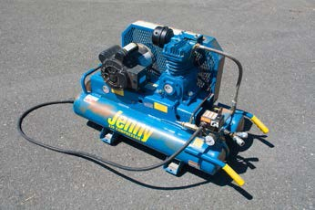

Figure 9—Air compressor

- Ensure access is possible for all students, or have a portable unit available for the demonstration. Show the start-up procedure as explained in the owner’s manual and follow up with the scheduled maintenance described in the same manual. This will include checking the air filter, crankcase and oil level and also draining the tank daily to ensure that no condensation has built up inside the air tank, which could otherwise lead to rusting.
- Describe and demonstrate the connection of air fittings. Describe the relationship and how to identify “male” and “female” connectors. Demonstrate how to recognize faulty air hoses and connectors by showing poorly installed connectors, and cut or leaking hoses and fittings.

Activity

- Start with an explanation of the types of air fittings attached to an air hose. Describe and explain the use of “male” and “female” terminology in relation to shop tools and equipment.

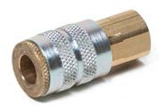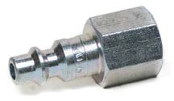
Figure 10—Female coupler Figure 11—Male coupler

- Have students obtain safety glasses and demonstrate the need for glasses when connecting and disconnecting an air line to its supply connector, especially at eye level.
- Hand out a copy of “Cleaning with Compressed Air” to each student and have them read along while explaining the dangers of high-pressure compressed air. An open discussion should be prompted to raise any additional questions that may promote safety awareness among all students. Lead a discussion on where air tools should be used (e.g., where there is no available electrical power or in an explosive environment).
- Have students work in pairs to connect and disconnect tools and fittings to an “uncharged” air line to learn the process.
- Demonstrate and then have students operate the forward and reverse function of tools such as air drills, impact wrenches and ratchets.
- Have students work in pairs to connect and disconnect several air tools to a “live” air supply line and become comfortable with the tools’ operation.
- Show the students how to coil the air hose in the correct manner by making as long a loop as is practical to hang on a hook on the wall. To help the hose coil properly, demonstrate how to “rotate” the hose away from you to form the coil, in much the same way as a rope is coiled. Have the students try doing the coil with the hose connected to the air supply and again when it’s not connected, to see how much easier it is when it’s disconnected.
- Explain the need for safety glasses or shields when using a blow gun and undamaged cutter wheels, and explain the need for guards on air/die grinders.

Cleaning with Compressed Air

Is it a good idea to use compressed air to blow dirt off clothing or work surfaces? Is cleaning with compressed air allowed by law?
What are the hazards of using compressed air?
What should I use instead of compressed air for cleaning purposes? Where compressed air is allowed for cleaning, how can I do it safely?

Is it a good idea to use compressed air to blow dirt off clothing or work surfaces? No. Although many people know using compressed air to clean debris or clothes can be hazardous, it is still used because of old habits and the easy availability of compressed air in
many workplaces. However, cleaning objects, machinery, bench tops, clothing and other things with compressed air is dangerous. Injuries can be caused by the air jet and by particles made airborne (re-enter the air).

Is cleaning with compressed air allowed by law?
In many Canadian jurisdictions, cleaning with compressed air is not allowed by law. Alberta, Newfoundland, Prince Edward Island, Quebec and Saskatchewan specifically mention that compressed air shall not be used to clean clothes, or in other situations cleaning a person, machinery, work benches, etc. Reference to cleaning may also be included with specific mention to it being prohibited when there is a risk to the worker being injured (federal regulations, Ontario, British Columbia, North West Territories, Nunavut and the Yukon).
In some cases, other legislation may apply. For example, cleaning with compressed air is prohibited in Manitoba and Ontario when working with asbestos.
Always check with your jurisdiction for more information.

What are the hazards of using compressed air?
First, compressed air is extremely forceful. Depending on its pressure, compressed air can dislodge particles. These particles are a danger since they can enter your eyes or abrade skin. The possible damage would depend on the size, weight, shape, composition and speed of the particles. There have also been reports of hearing damage caused by the pressure of compressed air and by its sound.
Second, compressed air itself is also a serious hazard. On rare occasions, some of the compressed air can enter the blood stream through a break in the skin or through a body opening. An air bubble in the blood stream is known medically as an embolism, a dangerous medical condition in which a blood vessel is blocked, in this case, by an air bubble. An embolism of an artery can cause coma, paralysis or death depending upon its size, duration and location.

While air embolisms are usually associated with incorrect diving procedures, they are possible with compressed air due to high pressures. While this seems improbable, the consequences of even a small quantity of air or other gas in the blood can quickly be fatal.
In addition, using air to clean forces the dirt and dust particles into the air, making these contaminants airborne and creating a respiratory hazard.
Unfortunately, horseplay has been a cause of some serious workplace accidents caused by individuals not aware of the hazards of compressed air, or proper work procedures.

What should I use instead of compressed air for cleaning purposes?
Use wet sweeping techniques, sweeping compounds, or vacuum cleaners equipped with special filters or other devices to prevent dust from being recirculated into the air.

Where compressed air is allowed for cleaning, how can I do it safely?
A “quiet” nozzle (i.e. one with low noise emission) should be selected.

The nozzle pressure must remain below 10 psi (69 or 70 kPa) and personal protection equipment (PPE) must be worn to protect the worker’s body, especially the eyes, against particles and dust under pressure.
Note: Air pressure is legislated by New Brunswick (69 kPa), Yukon (69 kPa/10 psi) and where permitted under federal (69 kPa/10 psi), British Columbia (70 kPa/10 psig), North West Territories and Nunavut (68.9 kPa/10 P.S.I.) legislation.
The Nova Scotia regulation states:

101. (2) Where compressed air is used to clean a surface or person, an employer shall ensure that the device that is used to deliver the air is
- commercially manufactured and approved in the manufacturer’s specifications for the purpose of cleaning a surface or person with compressed air; or
- certified by an engineer as adequate for the purpose of cleaning a surface or person with compressed air.
Occupational Safety General Regulations N.S. Reg. 44/99 Section 101 Ontario does not specify a pressure limit but does state:
66. A compressed air or other compressed gas blowing device shall not be used for blowing dust or other substances,
- from clothing worn by a worker except where the device limits increase in pressure when the nozzle is blocked; or
- in such a manner as to endanger the safety of any worker. Industrial Establishments R.R.O. 1990, Reg. 851

In addition, air guns should also be used with some local exhaust ventilation or facilities to control the generation of airborne particulates. When compressed air cleaning is unavoidable, hazards can be reduced by making adjustments to the air gun such as:
  - chip guards or curtains that can deflect flying dust or debris,
  - extension tubes that provide the worker a safer working distance, or
  - air guns equipped with injection exhausts and particle collection bags.

Document last updated on April 7, 2010
Copyright ©1997–2014 Canadian Centre for Occupational Health & Safety Date Modified: 2010–04–07

Cleaning with Compressed Air Quiz

Instructions: Read the “Cleaning with Compressed Air” handout and answer the following questions.
- Explain how compressed air is produced and delivered to shop outlets. Answer will vary depending on facility.
- List two important safety rules to remember when using compressed air tools. Always wear eye protection.
Never blow air at exposed skin.

- Give two examples of when air-operated tools are more suitable than electrical tools. A flammable environment
Main power is not yet installed to a new building.

- Why should an air compressor storage tank be drained daily? To stop the inside of the tank from rusting from condensation.

- If compressed air MUST be used to blow off machinery, what is the maximum pressure? 10 pounds per square inch (PSI).

Tire Identification

Description
Students will be introduced to the basics of tire identification and how to interpret the sidewall markings. Maintenance of a tire is as important as knowing its use and application. Students
will be instructed on how to recognize typical tire wear patterns and know when a tire should be replaced.

Lesson Outcomes
The student will be able to:
- Read, understand, explain and record identification markings on the tire sidewall
- Identify and explain the legal tread depth requirement for a highway tire
- Identify and describe the difference between a conventional and a directional tire
- Identify and describe several wear patterns of a tire and the probable causes

Assumptions
- The students will have little or no prior knowledge of tires or their use.
- The teacher is familiar with the information being taught.

Terminology
Aspect ratio: the relationship between the height of the tire’s sidewall and the tire’s width. If the height of the sidewall is 45% of the width, the aspect ratio is 45. In the tire size 225/45R17, the aspect ratio is 45.
Camber: the inward or outward tilt of the top of the tire. Positive camber is when the top of the tire is angled away from the centre of the vehicle (or car). Negative camber is when the top of the tire is angled towards the centre of the vehicle.
Directional tires: any tire that has an arrow on the sidewall indicating the direction of rotation. The tread is designed for the tire to work in one direction only. Mainly designed for wet road conditions. If the tire is put on the wrong side of the vehicle, then water between the tire and the road will build up and loss of traction will occur.
Sipes: the small slits included on the edge of a tire tread pattern, designed to increase traction.

Toe-in and toe-out: These two terms describe when the front of the tire points inward or outward. When the tires point inward the car is said to have toe-in. When the tires are pointing outward the car is said to have toe-out.

This work is licensed under a Creative Commons Attribution-NonCommercial-ShareAlike 4.0 International License unless otherwise indicated. 17

Tread depth: the distance from the base of the tread groove to the top of the tread.

Tread depth gauge: a measurement device used to measure wear and the remaining amount of tread on vehicle tires. In the U.S., the unit of measurement used in tread depth gauges is 32nds of an inch. In other countries, it is millimetres.
Wear bar: a band found between the tread blocks of a tire, designed to indicate when a tire is within 3⁄32" (1.6 mm) of its tread depth and should be replaced.
Winter snowflake designation: the mountain/snowflake symbol found only on the sidewall of winter tires. Winter tires have a different tread pattern and tread compound that maximize traction during winter driving conditions.

Estimated Time
60 minutes (including a question and answer session)

Recommended Number of Students
20, based on the BC Technology Educators’ Best Practice Guide, working in pairs

Facilities
  - Sufficient open space for each pair of students to move freely from station to station.
  - Workbenches would be an asset, in order to have tires off the floor for ease of inspection.
  - Shop facilities with access to compressed air would be an advantage but are not necessary.

Resources
  - Handout of tire identification for each student to fill out for marking
  - Used tires from a tire shop for students to diagnose—at least six different tires with a variety of types and sizes. The teacher will need to generate a record of all tire defects and their causes.

What Is The Winter Tire Symbol?
https://info.kaltire.com/what-is-the-winter-tire-symbol/

Winter Tire Safety Tips—Transport Canada
www.tc.gc.ca/eng/motorvehiclesafety/safevehicles-safetyfeatures-wintertires-index-468.htm

Proper Tire Inflation—Cooper Tire Canada
http://ca.coopertire.com/Tire-Safety/Tire-Safety-TIps/Proper-Tire-Inflation.aspx

Activity

- Group the students into pairs and have them document their names on their handout sheets.
- Have students locate and write down the information required as per the handout.
- Randomly pick students to explain to the class the sidewall information of the particular tire they are working on.
- Explain the “snowflake” on a tire and why it is a winter standard below a specific temperature of 7°Celsius (because the rubber compound in summer tires gets too hard to get traction).
- Explain how sipes help grip an icy surface.
- Demonstrate the use of a tread depth gauge, and explain the legal limit of 3 mm of tread depth for a highway tire across 75% of the tread width. Show the “wear bar” indicator between the treads.
- Have students individually measure a tire tread depth and record their findings on their own sheets for marking.
- Have students inflate a tire to the correct cold pressure according to the owner’s manual.
If the driver’s manual is not available or the door notice does not match the type or size of tire installed, the recommended inflation pressure to fill a tire should be about 3–5 psi less than maximum pressure listed on the tire sidewall. Maximum pressure is designed for use with maximum load—usually, a car is not fully loaded. Also, as tires warm up, the air inside them also warms, increasing the pressure. The link to a “Proper Tire Inflation” web page is included in the “Resources” section.
- Students should be given a randomly selected used tire and be asked to describe the sidewall markings and determine any tread defects and possible causes.

Tire Identification and Markings

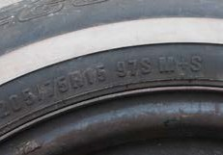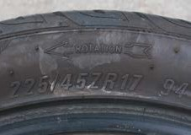

Figure 1—Mud and snow (P) passenger tire Figure 2—Directional tire

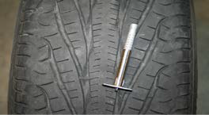

Figure 3—Directional tire with wear bar indicated; depth gauge indicates 5 mm depth reading.

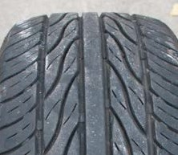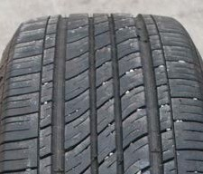
Figure 4—Siped directional tire Figure 5—Conventional tire

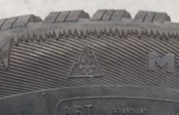

Figure 6—The winter snowflake designation for winter-use tires
Figure 7—Winter snowflake designation on tire

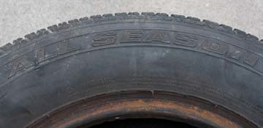

Figure 8—All-season tire

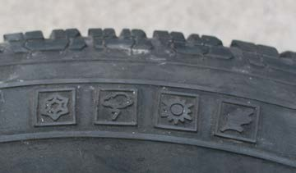

Figure 9—All-season symbols

Some Common Tire Wear Patterns and Issues

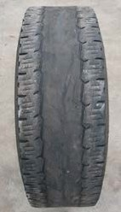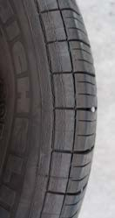

Figure 10—Centre wear
The tire in Figure 8 was overinflated, causing the centre ring only to contact the road.
Figure 11—Cracking and bulging Cracking and bulging usually comes from hitting a pothole, curb or from an older tire.

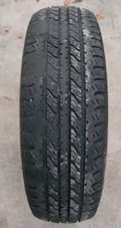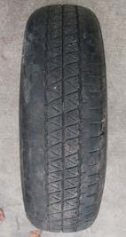

Figure 12—Cupping
Cupping happens when worn or damaged suspension components cause the tire to bounce as it travels. Bad shock absorbers are the usual cause.
Figure 13—Underinflated tire
The inside and outside edges are worn down; the middle is not. This is a telltale sign of underinflation.

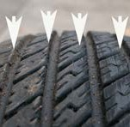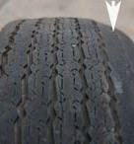

Figure 14—Feathering
Feathering happens when a vehicle has a Toe In or Toe Out alignment issue. Note the slanted wear and high points on the edge of each row of tread
Figure 15—Camber wear
With camber wear, the tire wears on one side only. This is usually a sign of the camber being out of adjustment.

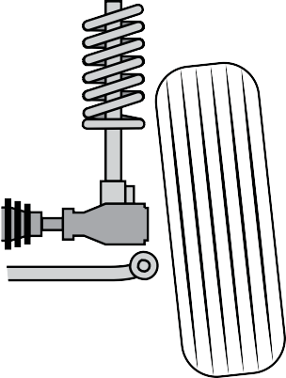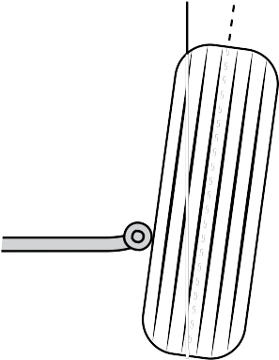
0 +
0
Road surface
Positive camber
Negative camber

Figure 16—Positive and negative camber

Figure 17—Negative camber car

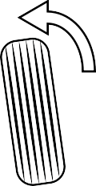
Toe in
Toe out
Front
Front

Figure 18—Toe in and toe out

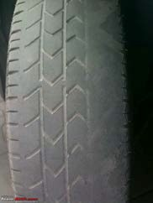
Figure 19—Tire wear from toe-in or toe-out

Tire Identification
25
Youth Explore Trades Skills

Tire Identification Worksheet
Automotive Service Technician
Example below is for a Goodyear M&S (mud and snow) 235/60R15 radial tire with 8 mm tread wear remaining.

Tire # | Tire Manufacturer | Type | Width | Aspect ratio | Diameter | Maximum pressure | Tread depth
1. | Goodyear | M&S | 235 mm | 60 (%) | 15 inches | 35 psi | 8 mm (5⁄16")
2.
3.
4.
5.

This space is to document any observations made of each tire.

Vehicle Inspection

Description
This activity plan will enable students to understand the importance of customer service in the automotive industry. Customers are not normally charged for courtesy checks, but these
inspections may often reveal problems that need to be repaired. Most of these checks are done routinely during an oil and filter service.
The vehicle inspection checklists found at the end of this activity plan may be used for maintenance checks. Inspection checklists are normally based on a vehicle’s service requirements and its mileage. These inspection checklists correspond to the service checklists found in any vehicle owner’s manual.

Lesson Outcomes
The student will be able to:
- Assess a vehicle’s needs and possible service requirements
- Keep regular maintenance records of work done and possible work needed
- Perform regularly scheduled maintenance work

Assumptions
- Students will have little or no prior knowledge of maintenance or repairs of a motor vehicle.
- The teacher must have a good working knowledge to demonstrate to students maintenance procedures and how they are to be performed on a vehicle.
- Students will have been taught how to safely lift a vehicle.

Terminology
Terminology will be taught and explained by the teacher as it is required during the lesson.

Estimated Time
90 minutes

Recommended Number of Students
20, based on the BC Technology Educators’ Best Practice Guide

This work is licensed under a Creative Commons Attribution-NonCommercial-ShareAlike 4.0 International License unless otherwise indicated. 27

Facilities
- A fully equipped automotive facility with hoists and/or floor jacks and stands. In order to do a thorough and proper inspection, a vehicle must be raised on a hoist for an under-vehicle inspection.
- More than one vehicle would be beneficial, depending on the class size.

Tools
- Several rolls of paper towel or wipes for checking oil levels, cleaning windows, etc.
- Window cleaner is recommended as a customer service to clean the windows when finished
- Tire pressure gauges
- Tire inflation tool
- Hoist or jack and stands
- Vacuum cleaner
- A typical tool box assortment of mechanics’ hand tools found in any good repair shop
- Antifreeze tester
- Tools and chemicals to service the battery
- Tire machine to change over from winter to summer tires (see Tire Change)

Materials
- Radiator antifreeze/coolant
- Windshield washer liquid
- A selection of various oils and lubricants needed for changes or top-up of fluid levels
- Inspection sheets
- Clipboards
- Pencils

Resources
- Work orders
- Vehicle service specifications that can be found online, in shop manuals, owner’s manuals, etc.
- Vehicle inspection checklists

“Cleaning with Compressed Air.”
Canadian Centre for Occupational Health and Safety
www.ccohs.ca/oshanswers/safety_haz/compressed_air.html

Discussion of Activities
- Courtesy Check—A visual or “hands off” inspection is done quickly with little or nothing being touched. Safety items like lights and wipers are checked, along with some courtesy cleaning.
- Under the Hood Inspection—This is a quick visual of items that can be checked under the hood, for example fluid levels. This general inspection is more in-depth than the visual inspection and can include some minor work.
- Under Car Inspection—A quick visual of items that can be checked under the car, like exhaust and tires. This inspection can involve more detailed adjustments and repairs than the visual inspection and the under the hood inspection.
At the end of this activity plan, checklists are included for each of these services. The checklists can be introduced progressively, but could also be used in conjunction with other lessons (e.g., Lifting Vehicles).

Youth Explore Trades Skills 29

Activity

The teacher should first demonstrate or describe the skills as the students observe. Then have students work in pairs to display the skills learned on the same or a different vehicle. Students should alternate when doing the skills, so the same students are not doing all the work.
  - Vehicle should be washed and cleaned out to allow for a good inspection of both the inside and outside of the vehicle. This is a valuable customer service that students should learn.
  - A work order needs to be filled out with all the relevant vehicle and customer information. This information is necessary for step #4.
  - Service inspection sheets should be completed as required.
  - Wheels should be removed so that brakes and related components can also be inspected.
  - Any items that need attention arising from the inspection such as belts, hoses, lights, brakes or oil change should be listed on the work order along with a repair estimate.

Evaluation Guidelines
The following components of the activity can be assessed:
- Completion, legibility and accuracy of each work order and service inspection sheet
- Estimates can be evaluated for accuracy, based on the detailed list of repairs to be done.
- Quality of work done to complete the service or repair
- Quality of washing and detailing of the vehicle (inside and out)
- If students are working in groups, one student can be designated as a group leader and can be evaluated on leadership and organizational skills.

Courtesy Check

Date: | Customer name: |  | W/O #
Year: | Make: | Model: |  | Licence:
Mileage: |  | VIN:

Place a check mark if an item passes inspection or an X if it fails.

Item to be Checked Pass Fail Comments
Glass
Front windshield—cracked, chipped, broken
Rear window—cracked, chipped, broken
Side windows—cracked, chipped, broken
Driver’s window—operates up and down
Mirrors—interior and exterior
Lights
Headlights—low beam
Headlights—high beam
Tail lights
Licence plate light
Brake lights
Back-up lights
Rear turn signals
Front turn signals
Front running lights
Hazard lights
Side/clearance lights
Interior light
Fog lights
Other
Windshield wipers—cracked, broken, hard
Horn
Tire pressure check (x4)
Spare tire pressure check
Body damage
Shock bounce test (x4)
Clean windows inside
Clean windows outside
Vacuum inside

Technician’s signature:

Under Hood Inspection Checklist

Date: | Customer name: |  | W/O #
Year: | Make: | Model: |  | Licence:
Mileage: |  | VIN:

Place a check mark if an item passes inspection or an X if it fails.

Item to be Checked Pass Fail Comments
Battery
Clamps tight
Clamps clean
Battery fluid level (where applicable)
Fluid Levels
Oil level and condition
Brake fluid level and condition
Power steering level and condition
Windshield washer fluid
Clutch fluid level and condition (manual transmission only)
Coolant Hoses (squeeze and visually check connections for leaks)
Radiator top hose
Radiator bottom hose
Heater hoses (2)
Heater bypass hose
Fluid leaks
Fan belt(s)
Cracks
Tension – 1/4 – ½” deflection (6-12 mm)
Coolant
Radiator coolant fluid level (expansion tank and/or radiator cap removal)
Note: do not remove radiator cap while engine is hot!
Antifreeze protection strength
Radiator cap test
Radiator pressure test (to cap pressure only)
Automatic transmission level (engine on and in park)

Technician’s signature:

Under Car Inspection Checklist

Date: | Customer name: |  | W/O #
Year: | Make: | Model: |  | Licence:
Mileage: |  | VIN:

Place a check mark if an item passes inspection or an X if it fails.

Item to be Checked | Pass | Fail | Comments
Fluid levels
Differential fluid level
Transmission fluid level (manual only)
Suspension
Shocks—loose, broken, leaking
Spring—loose, broken
Exhaust system
Loose, broken, leaking, rusted
Front brakes
Brake pads and rotors
Brake hoses—cracked
Fluid leaks
Rear brakes
Shoes or pads and rotors or drums
Brake hoses—cracked
Fluid leaks
Drive line
U joints on driveshaft (if equipped)
Rubber boots on CV shafts (if equipped)
Front Tires
Rotation
Wear patterns
Tread life
Physical damage
Rear tires
Rotation
Wear patterns
Tread life
Physical damage

Steering
Ball joints—movement or play
Tie rod—movement or play
Wheel bearings—movement or play
Chassis lubrication (if equipped)
Leaks
Engine oil leaks
Transmission oil leaks
Engine coolant leaks

Technician’s signature:

Roadside Survival

Description
For most people a roadside breakdown can be very frustrating and sometimes even scary to the point of feeling totally helpless. This Activity Plan will describe what to do in the three most frequent situations that cause a roadside breakdown and will help students learn a few basic skills to “get you home.”

Additional
Tasks that are shown to the students must be pre-tried by the teacher to ensure successful delivery.

Lesson Outcomes
The student will be able to:
- Establish a roadside safety perimeter
- Safely change a flat tire on the roadside
- Boost a car with a dead battery
- Perform a temporary repair of a burst radiator hose

Assumptions
- Students will have little or no prior experience of vehicle care or maintenance.
- The teacher will have a good working mechanical knowledge and skills appropriate to teaching the necessary lessons.

Terminology
Terminology used will be taught to students as required by the teacher.

Estimated Time
Each session 30 minutes (3 × 30 minutes)

Recommended Number of Students
20, based on the BC Technology Educators’ Best Practice Guide

Facilities
- Lessons may be taught indoors or outdoors, as preferred.
- To realistically demonstrate most of these skills it is recommended they be done outdoors.
- More than one vehicle would be an asset, depending on the class size.

This work is licensed under a Creative Commons Attribution-NonCommercial-ShareAlike 4.0 International License unless otherwise indicated. 35

Activity 1: Change a Flat Tire

Tools
  - Lug nut wrench
  - Vehicle jack and any attachments
  - Wheel chocks

Materials
  - 12" length of pipe to extend the vehicle’s own lug nut wrench
  - Flares and/or warning triangles
  - The spare wheel for the vehicle being used for the demonstration

Activity
- Position the vehicle in a way to simulate traffic passing as if on a highway or road. Place the vehicle in park (if automatic) or 1st gear (standard) and apply the emergency parking brake.

Remember, it is YOUR responsibility to protect yourself from passing cars.
Many drivers have been killed while changing a flat tire because they didn’t protect themselves from traffic.

- Ensure the vehicle is positioned in such a way as to block any traffic from hitting the person changing the tire. For example, park the car on an angle to keep the person changing the tire protected from passing vehicles.

Road | Front | = Flat tire |  | Road | Front | = Flat tire

= Flat tire
= Flat tire
Front
Front
Road
Road

Figure 1—Positioning a vehicle with a flat tire to block any traffic from hitting the person changing the tire while changing it

- Place the warning devices to give traffic sufficient warning of a traffic hazard (Figure 2). Discuss options of emergency flashers, etc., for nighttime safety concerns.

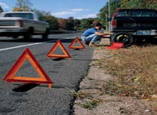

Figure 2—Emergency warning triangles

- Demonstrate the use of the vehicle factory jack before installing it under the vehicle, and how to select the proper position to place the jack (usually a few inches inboard of the wheels). All vehicle owner’s manuals contain instructions on how to operate the vehicle jack.
- Install wheel chocks (Figure 2) before removing lug nuts on a wheel, so as to stop the wheel from rocking while nuts are being removed.
- Install the vehicle lug nut wrench as needed to begin the process of removing the lug nuts.

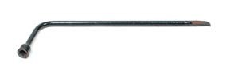
Figure 3—Lugnut wrench

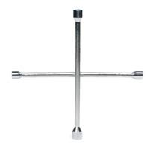
Figure 4—Cross lugnut wrench

- Set up the car jack as a fulcrum under the lug nut wrench, and add the pipe for additional leverage (Figure 5).

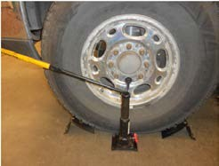

Figure 5—Using a pipe for additional leverage and the car jack as a fulcrum under the lug nut wrench

- Install wheel chocks on any wheel not being raised.
- Loosen the lug nuts.
- Use the spare wheel as a safety device under the car should the jack fail.
- Move the vehicle jack to the lifting position and raise the vehicle.
- Change the flat tire, replace the lug nuts and tighten as required. Note: Students may benefit from a safety discussion pertaining to the use of tapered lug nuts and torque patterns. See Activity Plan 5: Nuts and Bolts for more detailed information.

Information on Wheel Lug Nuts and Torque
Wheel lug nuts need special consideration, as pulling wheels on and off is an everyday occurrence in an automotive shop. In order to avoid damage to the wheel or vehicle when replacing wheels, there are two things to be concerned about. Failure to follow the steps below could result in expensive replacement of wheels, repairs to the vehicle or injuries due to the wheel falling off while driving.
- Most wheels are held on by tapered lug nuts. Ensure that the tapered side contacts the wheel first. If you look at the wheel you will see a corresponding taper to accept the tapered nut. The tapered side must point in toward the middle of the vehicle. This will ensure the wheel will be centred and the lug nuts stay tight.

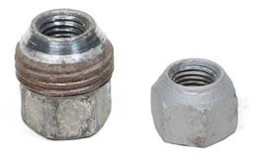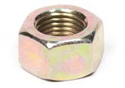

Figure 6—Tapered lug nut Figure 7—Regular flat nuts

- Lug nuts must be torqued in sequence with a torque wrench or a torque stick, to the manufacturer’s specifications. This will ensure that the wheel or rim will not be damaged or warped due to incorrect tightening or overtightening. Figure 7 indicates the torque sequence, depending on the number of lug nuts. Simply tighten the lug nuts in the order indicated. A good practice for torquing is to snug all the nuts up first, then do the final tightening to the proper torque using the proper sequence.

4-Lug nut wheel
5-Lug nut wheel

1
1
3
4
3
4
6-lug nut wheel
2
5
2
3
1
5
8-Lug nut wheel
6
2
10-Lug nut wheel
4
8
1
10
6
3
1
3
4
5
7
8
6
5 7
2
2
9
4

Figure 8—Wheel nut lug torque sequence

Activity 2: Boost a Dead Battery

Tools
  - Booster cables
  - Safety goggles

Resources

What You Need to Know About Boosting a Car (Canadian Tire)
www.youtube.com/watch?v=7cMS9thXVNE

Activity
Open the vehicle hood. Using a discharged battery enhances the demonstration by adding realism. Safety protocols dictate that all students should be wearing safety glasses from this point forward.
If a second vehicle is used to boost the “dead” vehicle, it is wise to disconnect the negative cable of the boosting vehicle to avoid damage to its computer systems.
Make sure both vehicles have everything electrical turned off and the ignition keys are removed, driver’s window is open and doors are all closed (to put vehicle systems in sleep mode).
Install the booster cables in the following order:

  - First, the positive cable (red +) is connected to the dead vehicle battery positive post (red +).
  - The other end of the positive booster cable (red +) is connected to the good vehicle battery positive post.
  - The negative (black –) booster cable is connected to the good battery negative terminal.
  - The other end of the negative (black –) cable is connected to any clean solid metal (steel) component on the dead vehicle engine or engine mounts.

Never connect a booster cable to a dead vehicle battery negative terminal (hydrogen gas fumes are explosive and may be present around a recently discharged/charged battery). If a spark is initiated near a battery, a serious explosion could occur.

Remove the cables in the reverse order, taking care not to make contact when doing so.

Activity 3: Temporary Repair of a Burst Radiator Hose

Tools
- Several rolls of electrical tape (black tape)
- Scissors or a sharp knife
- Cleaning cloth and water to wash and dry the radiator hoses
- Heavy duty garbage bag (to demonstrate carrying water for radiator)

Activity

Always check first to see whether the cooling system is hot. If there is any heat coming from the radiator or the radiator hose, wait until the cooling system has cooled completely before making any repairs.
Never remove the cap if the system still has pressure.

- Find a cloth or glove and slowly remove the radiator cap. Be careful of any hot water or steam that might be present. Allow the cooling system to cool slowly and vent any steam. DO NOT add water at this point.
- Clean and dry the hose about 2" on either side of the burst section all around the hose. It’s important for it to be clean and dry or the tape will not stick (Figure 8).

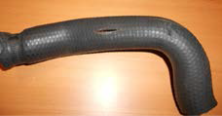
Figure 9—Clean and dry the hose about 2" on either side of the burst section

- Start a wrap of black electrical tape about 1–2" before the split section of the hose. Continue to wrap the tape around the hose, being sure to overlap each wrap about a half width over the last wrap (Figure 9). Do not stretch the tape when wrapping; just use the resistance of the roll of tape as it unwraps.

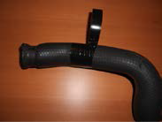

Figure 10—Wrapping electrical tape

- Continue about 1–2" past the opposite end of the split. Now return the same way back to the start of the split. Additional wraps can be done if extra strength is required. Use a sharp knife or scissors to cut the tape or the end will not stick and it will unravel (Figures 10 and 11). DO NOT pull the tape apart when finished.

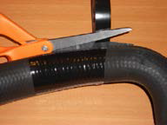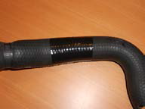
Figure 11—Cutting the electrical tape Figure 12—Completed repair

- Reinstall the hose if it was removed.
- Fill the cooling system with water. If a jug is not available to carry water to refill the radiator, a small, strong garbage bag works well. A wheel hubcap, a baseball cap and many other things may also work.
- Leave the radiator cap loose—turn the cap until it latches on the first click but is still not tight. This will prevent the cooling system from building up pressure. Excessive pressure is undesirable, as it will push the tape off the split section.

Nuts and Bolts

Description
This Activity Plan will enable students to identify the differences between metric and imperial bolts (cap screws). They will learn how to measure a bolt and determine the thread type by using a thread gauge. Students will also be taught how to drill a hole and tap a thread into a piece of soft metal. After making the threads, they will be shown the causes of stripped threads and how to strip those threads. After the destruction of the threads the students will be shown a thread repair method by installing a product called a HeliCoil insert.

Lesson Outcomes
The student will be able to:
- Make threads in a piece of aluminum and then strip the threads to allow for a new thread insert to be installed.
- Identify metric and imperial bolts by their designation marks
- Use a thread gauge to identify the different types of thread pitches

Assumptions
Students have little or no previous knowledge or skill in the material being covered.

Terminology
Any terminology used will be explained as required during the activity.

Estimated Time
2 hours

Recommended Number of Students
20, based on the BC Technology Educators’ Best Practice Guide

Facilities
Shop space with bench space and a metal work vise for each group pair (12 stations)

This work is licensed under a Creative Commons Attribution-NonCommercial-ShareAlike 4.0 International License unless otherwise indicated. 43

Tools
- Metalwork vises
- Sufficient hammers and centre punches
- A drill press, if students have previously been taught how to safely operate it
- Hand drills to drill aluminum strips, with drill bits sized to match the threads being tapped
- Threading oil or lubricant
- Tap and die sets sufficient for the class size being taught
- Torque wrench
- Thread gauge

Materials
- A 1" x 1" x ¼" piece of aluminum flat bar for each student
- Selection of bolts of various types, threads and sizes for demonstration examples
- Sufficient bolts for students to match to the threads being tapped in the aluminum strip

Introduction: Common Types of Nuts and Bolts
Vehicles contain many different styles and types of nuts and bolts. Below is a list of common types of nuts and bolts that students should become familiar with.
Hex or flat nut: general usage
Lock nut (Nylock nut): used for safety reasons when a nut should not come loose due to vibrations. Lock nuts are often found on front wheel drive axles or exercise equipment.
Taper nut: used to help centre objects, for example on the wheel of a car
Slotted or castle nut: used in conjunction with a cotter pin on objects that turn or twist, for example on a tie rod or ball joint
Cap or acorn nut: used to give a finished appearance by covering the end of the thread
Wing nut: used when only hand tightening is needed
Cap screw: often referred to as a bolt
Thumb screw: used when only hand tightening is needed
Set screw: used to secure objects without the head protruding, for example on a pulley so the belt does not rip
U bolt: used to secure objects to a shaft, for example springs to the differential
Note: Students may benefit from a safety discussion pertaining to the use of tapered lug nuts and torque patterns. See Activity Plan 4: Roadside Survival for more detailed information.

Activity 1: Identifying Bolts

- Lay out a selection of bolts on the workbench in random order. Have each student select a bolt and describe what markings they see.
- Have students work together in pairs using a steel rule (not “ruler”—that’s a king) to measure the length and diameter of the bolt they have selected. Each steel rule should be graduated in both scales, as both imperial and metric can be found in Canada.
- Working from their handout, students should be able to document each bolt they identify for type, length, thread pitch and strength classification.
- Additional handouts can then be modified and handed out to students as a test page at a later date.

Metric and Standard Sizing
All import vehicles—including both European and Asian models—have metric nuts and bolts. The only exception is older British vehicles (pre-1985), which could have Whitworth, standard or metric sizes.
All domestic vehicles fabricated before 1975—including Canadian and American models—have standard nuts and bolts. In 1975, Canada adopted the metric system. During the transition period between 1975 and 1985, Canadian-made vehicles had a mixture of metric and standard nuts and bolts. Chassis parts and heavy-duty trucks were the last items to completely change. Virtually all new Canadian-made vehicles are now made with metric nuts and bolts. Exceptions include some parts such as transmissions, which may be made in the USA and shipped to Canada to be installed in Canadian vehicles. These may have standard or metric nuts and bolts, as the USA is slowly switching to metric. Make sure you are aware of what type of nut or bolt you are working on. Check the fit of the socket or wrench to make sure it is tight (no wiggle) before attempting to tighten or loosen it.

An easy way to determine if a cap screw (bolt) is standard or metric is to look at the markings on the head. A standard cap screw will have radial line markings on the head. The more lines, the higher the quality and strength of the cap screw. A minimum grade 5 bolt (standard) or
8.8 (metric) is required for all automotive applications.

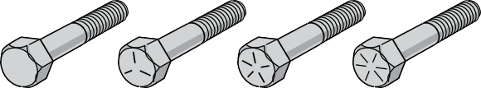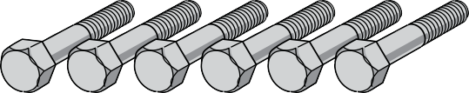Figure 1—Standard cap screw markings Figure 2—Metric cap screw markings

Grade 2 Grade 5 Grade 7 Grade 8

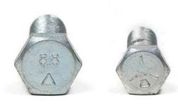

Figure 3—Metric and standard cap screws

Activity 2: Tap a Hole

- Cut a 1" piece of aluminum and file the ends smooth to remove any sharp edges.
- Mark out the centre of the piece of metal and centre punch a mark for the drill bit to locate.
- Drill the appropriate size hole for the size of tap being used to tap the threads. Refer to a Tap and Drill Chart.
Note: The appropriate hole size to be drilled must be smaller than the intended finished size. This is because the tap must have something to cut threads into. Remember: the outside diameter of a bolt includes the crest of the threads. For example, a ¼" bolt has an outside diameter of ¼". If you were to drill the hole ¼", the threads of the bolt (and the tap) would have nothing to grab onto. You must drill the hole slightly smaller so the tap can make threads to the correct ¼" size.
- Install the appropriate tap into a tap handle.
- Make sure the tap is straight and perpendicular to the metal.
- Turn the tap handle one turn clockwise to begin threading the hole.
- Rotate the tap handle ½ turn counter-clockwise to break the chip being created.
- Repeat steps 6 and 7 until the hole is completely tapped (or threaded).

Activity 3: Test Threads

- Find a bolt that will fit your newly formed hole.
- In small increments, use a torque wrench to tighten the bolt into the newly formed hole.
- Continue to tighten the bolt until the threads strip. This is where the threads fail and the bolt will continue to move but will never tighten. Record the torque reading.
- A regular nut and bolt of the same size can now be demonstrated using the same process, to show how much more strain can be applied to steel compared with aluminum threads.

Activity 4: Teacher Demonstration— Install a HeliCoil Insert

Now demonstrate drilling out the damaged threads and installing a HeliCoil insert. It may be cost-prohibitive for all students to install a thread insert, but it would be best if they were able to do so.

General Instructions for Installing a HeliCoil Insert
HeliCoils are precision-formed screw thread coils of 18–8 stainless steel wire. They are designed to replace damaged threads and to reinforce tapped threads in light materials, metals and plastics. Each coil possesses a tang that is used to drive the insert into a tapped hole. After insertion, the tang is snapped off.

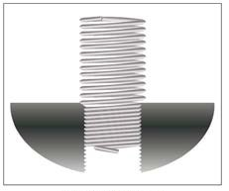
Figure 4

These instructions should be considered guidelines only. Always follow manufacturer’s instructions when installing a HeliCoil insert.

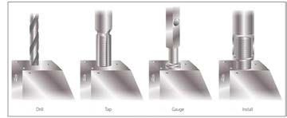
Figure 5

Drill
Identify the damaged threads by pitch and size. Drill them out using the specified drill size.

Tap
Using the screw thread insert tap, tap the hole to the minimum depth specified to fully install the HeliCoil insert—and the bolt or screw that will be screwed in afterwards.

Install
Install the HeliCoil assembly using the appropriate installation tool. The coil should be installed to between one-quarter and half a turn below the top surface of the tapped hole.

Remove Tang
Remove the tang to allow the bolt or screw to pass all the way through the insert. Break off the tang with a flat-bottomed punch or the tang breakoff tool provided. Place the tool squarely over the tang and then strike it sharply with a hammer. Tangs on spark plug
inserts and HeliCoil inserts with a diameter greater than ½" (12 mm), can be removed using needle-nose pliers.

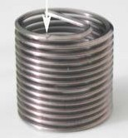
Figure 6—Inverted HeliCoil insert
Note the notch at the tang’s base, designed so the tang will break off more easily upon impact when struck with the tang breakoff tool

Resources

Thread Repair Using a HeliCoil Insert—RepairEngineering.com
www.youtube.com/watch?v=Z-uxtuE1xKM

Evaluation Guidelines
- Each student will be graded on the quality of the thread made in the supplied aluminum bar. (Note: This should be marked before the thread is stripped.)

Handouts
The handouts can be reused as a test at a later date by deleting relevant information of the thread type and size identification.

Measurement Test
Individual skill tests can be arranged by having students physically measure a collection of different bolts, and then sort them by type and size.

Comprehension Test
Have each student explain in writing, in his or her own words:
    - The process and procedure of how to tap a thread
    - The primary reasons how and why a thread is stripped
    - How a thread insert can be used to replace the damaged threads
    - When a thread insert would be used in place of undamaged threads (state several examples)
    - How a torque wrench is used and why it is necessary

How to Use a Tap and Drill Chart
- Determine the size (diameter) and pitch of thread to be used. This is called the tap size.
- Find the horizontal row on the chart that has the determined tap size.
- Find the appropriate drill size on the same row. Note: An alternate drill size is often given, due to the fact that drill sizing can be denoted in a number of different ways—mm, fractions (inches), letters and numbers.

Example 1—Metric (Figure 6)
M3.5 × 0.6 requires a 2.9 mm or #32 drill bit.
If a chart is not available, the usual rule of thumb is to use the next size smaller drill bit.

Tap and Drill—Metric Chart
Tap Size Drill Size (mm) |  | Drill Size (inch)
M1.6 x 0.35 | 1.25 | #55
M2 x 0.4 | 1.60 | #52
M2.5 x 0.45 | 2.05 | #46
M3 x.05 | 2.50 | #39
M3.5 x 0.6 | 2.90 | #32
M4 x 0.7 | 3.30 | #30
M5 x 0.8 | 4.20 | #19
M6 x 1 | 5.0 | #8
M8 x 1.25 | 6.8 | H
M8 x 1 | 7.0 | J
M10 x 1.5 | 8.5 | R
M10 x 1.25 | 8.8 | 11/32
M12 x 1.75 | 10.2 | 13/32
M12 x 1.25 | 10.8 | 27/64
M14 x 2 | 12.0 | 15/32

Figure 7—Example of drill bit size chart for metric taps

Example 2—Imperial; also known as “standard,” or inches (Figure 7)
A 5⁄16 – 18 tap size requires a .2570" or “F“ drill bit (in this case, a .2500" or ¼" would suffice).

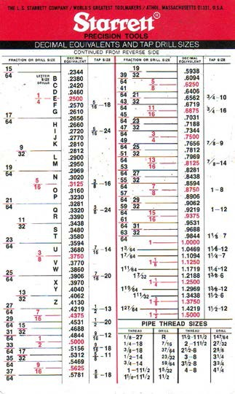

Figure 8—Example of drill bit size chart for imperial taps

Hand Tools and Power Tools

Lesson Outcomes
The student will be able to:
- Identify a variety of hand tools and power tools and describe their purpose, application and how they are operated in a safe and proper manner.
- A wide variety of tools should be introduced at this time. The more exposure and the sooner students get to experience new tools, the more interest students will develop.
- Most tools taught in this Activity Plan will be determined by the teacher, based on previous teacher experience and relevant courses taken by the students.

Assumptions
- Students will have little or no previous knowledge or experience with any of the tools being introduced to them.
- The teacher is proficient in the safe and proper operation of all of the tools being taught.

Terminology
Any terminology related to the tools being introduced will be taught to the students as it is required during the lesson.

Estimated Time
30–60 minutes

Recommended Number of Students
20, based on the BC Technology Educators’ Best Practice Guide

Facilities
It is recommended that this activity be taught in a facility where there is sufficient room for all the tools and for the students to move around freely.
Students are generally unaware of the dangers in handling some tools for the first time, especially air- or electrically-operated tools. Therefore adequate space is a primary concern for safety.

This work is licensed under a Creative Commons Attribution-NonCommercial-ShareAlike 4.0 International License unless otherwise indicated. 53

Tools
This may be a review lesson for some students, and may include new information for others. A wide variety of tools should be introduced at this time:
  - Hammers of different types and styles: ball peen, brass, rubber and plastic
  - Screwdrivers, punches, files, chisels, wrenches (including adjustable and pipe wrenches)
  - Electric drills, angle grinders, rotary drills (Dremel), metal shears
  - Air tools including impact wrenches, air drills, air hammers
  - Sockets: deep, standard and impact
  - Ratchets with different-sized drives: ¼”, ⅜", ½", ¾"
  - Hacksaw
  - Safety glasses

Materials
Handouts of tool descriptions and images with most common names are attached.

Resources
Most manuals and shop textbooks have sections on tools with images and explanations of use.

Adjustable Wrenches

Information on adjustable wrenches
http://navyaviation.tpub.com/14310/css/14310_35.htm

Toolmanship: Your Complete Guide to Wrenches (The Art of Manliness)
www.artofmanliness.com/2013/03/05/toolmanship-your-complete-guide-to-wrenches/

Activity

- Workstations should be set up with a variety of similar tools grouped together. Have students identify them by name and then explain how they are used.
- Handouts should be given for students to make notes and connect the names as they see the tools.
- Power tools can also be identified the same way if specific stations are set up for power tools.
- During this activity, additional reinforcement should be given on the use of safety glasses when operating power tools or when striking two metal objects together—such as hammer and a punch.
- Specific tasks can be given at a station that is related to a tool. [Marking out a scribe line when introducing a scribe, for making a centre punch mark at an intersection of a piece of metal.]
- Cutting a small piece of metal with a hacksaw, and then filing the edges smooth would add a practical component to a hacksaw lesson and introducing a file.

Evaluation Guidelines
- Evaluation of a skill can be connected to marking a handout filled out by a student.
- Handout sheets with tool names deleted can be reworked into tests.
- Cards with tool names written on them can be used for students to select the tools and describe or demonstrate how to use them.
- Accuracy of layout marks with a scribe and centre punch mark.

Notes on Tools
Torx screwdriver: found on newer cars (1990 and above). Do not confuse a torx screw with the Phillips screw, as you will strip the screw head.
Brass, rubber and plastic hammers: often called soft face hammers. Use only when you don’t want to damage the surface of something. A steel ball-peen hammer will damage, dent or chip soft metals like aluminum, tin and sheet metal.
- A brass hammer is often used when removing an aluminum cylinder head.
- A rubber or plastic hammer is used when installing a hubcap.

Wrenches (all types): whenever possible, pull on a wrench—rather than push—for more control in case the wrench slips or the bolt breaks. It’s easier to recover body position in a pull situation.
Crescent (adjustable) wrenches: the solid jaw should be on the pull side of the nut rather than the loose adjustable jaw, to prevent slippage.

Oil filter wrenches: there is a large variety of oil filter wrenches because oil filters come in three basic diameters but can be awkwardly placed.
Files: do not tap files together or against other hard objects as they are brittle and will break.

Sockets: only use impact sockets when using an impact gun. They are stronger than regular sockets and will not crack.
Electric tools and extension cords: always think about where these are placed. Water dripping from cars can create pools, leading to electrical shock.

Photos of Hand Tools and Power Tools

Tools
This may be a review lesson for some students and may include new information for others. A wide variety of tools should be introduced at this time.

Hammers

Figure 1—Ball-peen hammer

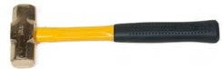
Figure 2—Brass hammer

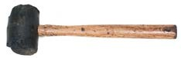
Figure 3—Rubber hammer

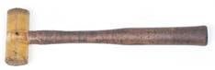
Figure 4—Plastic hammer

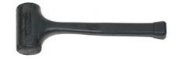
Figure 5—Dead blow hammer

Screwdrivers

Slotted Phillips® Robertson® Torx®

Figure 6—Types of screwdrivers

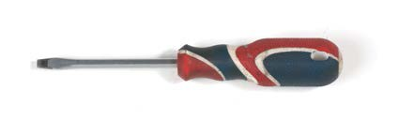
Handle
Shank
Ferrule
Blade
Head
Tip

Figure 7—Parts of a screwdriver

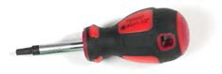

Figure 8—Stubby screwdriver

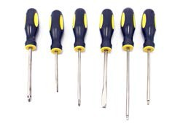

Figure 9—Assorted screwdrivers

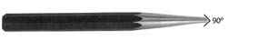

Figure 10—Centre punch

Figure 11—Brass punch

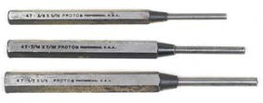

Figure 12—Drift punches

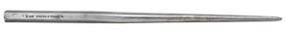

Figure 13—Taper alignment punch

Files

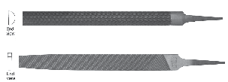
End view
Half-round file
End view
Flat file
Figure 14—File types

Point
Edge
Face
Heel
Tang
Length

Figure 15—Parts of a file

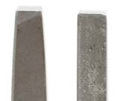
Figure 16—Files with tapered and blunt end

Teeth of a File
The teeth of a file are cut before the file has been tempered and hardened. There are three types of cuts: single, double and curved. As well, there are various grades of coarseness including rough, bastard and smooth. Figure 13 shows the cuts and file grades.

Single-cut Double-cut Curved tooth

Rough cut Bastard cut Smooth cut

Figure 17—Types of file teeth and degrees of coarseness

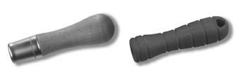
Metal ferrule
Wooden handle
Plastic handle

Figure 18—File handles

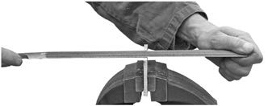
Figure 19—Proper filing technique

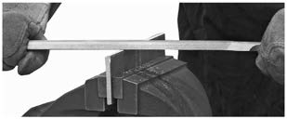
Figure 20—Draw filing

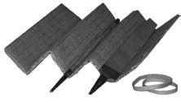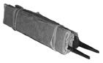

Figure 21—Storing files

Chisels

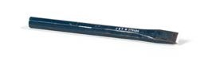
Figure 22—Cold chisel

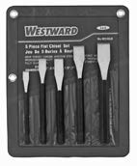
Flat chisels

Diamond-point chisel

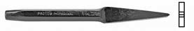
Cape chisel

Figure 23—Types of chisels

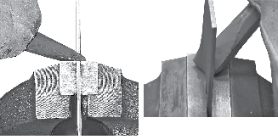
Chisel
Workpiece Stationary jaw

Level
Chisel
Figure 24—Correct use of chisel

Wrenches

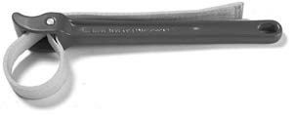

Figure 25—Strap wrench

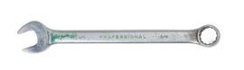

Figure 26—Combination wrench

Figure 27—Adjustable wrench

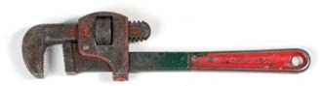

Figure 28—Stillson pattern pipe wrench

Figure 29—Flare nut wrench

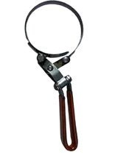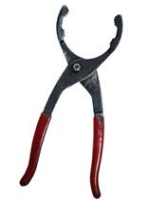
Figure 30—Oil filter wrenches

Electric Drills

Figure 31—Cordless drill with rechargeable battery

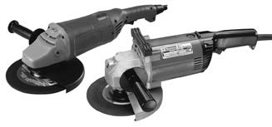Angle Grinders

Figure 32—Electric angle grinders with grinding disks

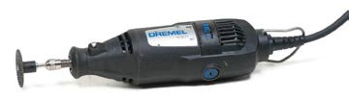

Figure 33—Rotary drills (Dremel)

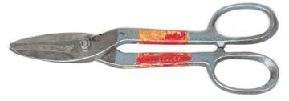
Figure 34—Metal shears

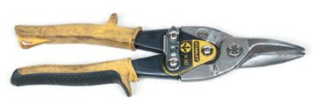

Figure 35—Aviation snips

Air Tools

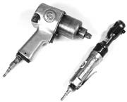
Figure 36—Pneumatic impact wrenches

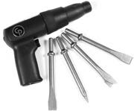

Figure 37—Air-operated hammer/chisel

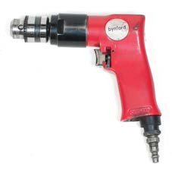
Figure 38—Air drill

Sockets: Deep, Standard and Impact

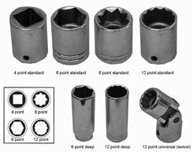
Figure 39—Various socket wrenches

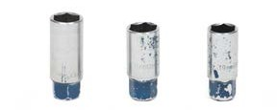

Figure 40—Spark plug socket wrench

Figure 41—Spark plug socket with rubber insert

Figure 42—Socket driver set

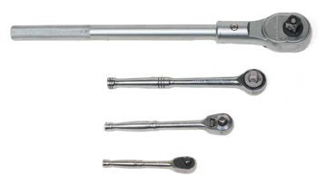
Figure 43—Ratchets with different-sized drives: ¼”, ⅜”, ½”, ¾”

Hacksaw

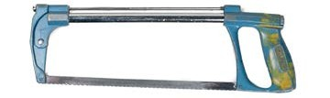Figure 44—Hacksaw

Safety Goggles

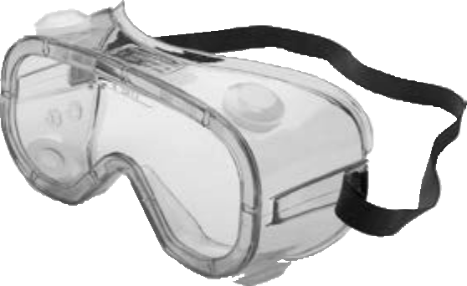Figure 45—Safety goggles

Fill in a Work Order

Description
All vehicle maintenance and repairs require a “paper trail.” A work order is used to ensure all required work is done accurately and as requested. There are as many different work orders in use as there are businesses that use them. The primary objective of this Activity Plan is to
have students understand the importance of work orders and how to fill them out accurately and completely.

Lesson Outcomes
The student will be able to:
- Successfully, completely and accurately fill in all the required information on a shop work order
- Locate primary and important required information on most vehicles
- Locate information online that might be needed to complete a work order
- Appreciate why accuracy and legibility are considerable importance on a work order
- Possibly extend this Activity Plan to vehicle repair estimates after the work order is completed

Assumptions
Students have little or no prior knowledge of work orders or “paper trails” that are required to be completed in most businesses.

Estimated Time
30 minutes per lesson depending on how in depth the teacher chooses to proceed

Recommended Number of Students
20, based on the BC Technology Educators’ Best Practice Guide

Facilities
This Activity Plan may be completed in any regular classroom, with access to vehicles at some point during the class if the teacher decides to have students gather real-life information.

This work is licensed under a Creative Commons Attribution-NonCommercial-ShareAlike 4.0 International License unless otherwise indicated. 71

Materials
- Writing instrument
- Blank work orders
- Clipboards
- Texts (shop manuals, if required)
- Owner’s manuals from vehicles

Resources
- Several computer stations with Internet access—vehicle data should be available to enable students to cross-reference vehicle information.
- If possible, photocopies of vehicle registrations to obtain vehicle details
- Several vehicles should be made available to copy actual VIN numbers for realism.
- Access to vehicle information resources such as All-data, Mitchell on Demand, Chilton, vehicle owner’s paper

Activity

Have students work in pairs or individually to fill out a work order using the information from a specific vehicle.
Vehicle information can be given ahead of time or left for students to locate as a search.

Work order information can be transferred from the student’s “shop copy” to an electronic version to provide a printed customer copy.
The reverse side of the work order can be used to list and record parts. Any supplies used and the cost of those items used should be listed.
Fictitious repairs could be requested and a work order filled out. An estimate can then be produced indicating repair times and costs.
Students can also be given a blank ICBC vehicle purchase form (vehicle ownership transfer form) or a photocopy of the front page and learn how it is filled out properly as another exercise.

Evaluation Guidelines
Work orders can be handed in and marked for legibility and accuracy.

Research assignments based on needed repairs can also be used to grade ability and accuracy of a search and estimate cost. This assignment can also be used to determine a student’s knowledge of what is involved in the actual repairs that are required.

Youth Explore Trades Skills 73

Oil Change

Description
This Activity Plan will demonstrate to students how to successfully perform an engine oil and filter change on a vehicle. Students will be given the opportunity to perform this activity on a vehicle of their own choosing to demonstrate the learned skills.

Lesson Outcomes
The student will be able to:
- Understand the process and protocols required to change the engine oil and filter on a vehicle
- Explain the reasons why regular oil changes are important and how they relate to the expression “pay now or pay later”
- Follow industry guidelines on recycling and disposal of plastic oil containers, used oil and filters
- Understand the reasons and benefits of the use of a torque wrench to tighten the drain plug
- Identify and competently use an oil filter wrench when required
- Research the information required to order the correct parts and supplies

Assumptions
- The student has no previous knowledge or experience in performing an oil and filter change.
- The teacher has a good understanding of this procedure and has previously performed this operation.
- Activity Plan 15: Lifting Vehicles will have been completed previous to this Activity Plan.

Terminology
All terminology required will be taught if required when it used in this task.

Estimated Time
30–60 minutes (Some students may take longer than 30 minutes the first time they conduct an oil change.)

Recommended Number of Students
20, based on the BC Technology Educators’ Best Practice Guide

This work is licensed under a Creative Commons Attribution-NonCommercial-ShareAlike 4.0 International License unless otherwise indicated. 75

Facilities
Ideally an indoor vehicle hoist with adequate lighting and a comfortable environment.

This activity could be performed on the ground on axle stands, but this is not an advisable situation for students to see all aspects of the details being taught.

Tools
  - Oil drain pan
  - Oil filter wrench
  - Wrenches to remove the oil pan drain plug
  - A socket set with a selection of sockets (most vehicles manufactured in the past 20 years use metric drain plugs)
  - Torque wrench
  - Recycling containers for used oil and filter

Materials
  - Work order
  - Oil change checklist
  - Access to vehicle information for torque values
  - Engine oil
  - Oil filter
  - Paper towel or wipes

Resources
  - Vehicle information system (All Data or Mitchell, vehicle service manual or Internet access)
  - Work order
  - Oil change checklist
  - Clipboards and pencils

Activity

Oil has been described as the lifeblood of the engine and as such should be changed often. Oil—along with the additives placed in it—performs five basic functions:
- Lubricates
- Cleans
- Cools
- Seals
- Cushions
Eventually the additives break down and wear out. Each vehicle manufacturer has its own recommendations on when to change the oil, but a general guideline is every 5000 km or 3 times per year.
Activity Plan 15: Lifting Vehicles will have been completed previous to this Activity Plan.
- If the vehicle is raised on a hoist for work, students should have knowledge and experience related to the safe operation of a hoist.
- If this activity is being performed at ground level, prior to its being completed students should have knowledge and experience of raising a vehicle and safely putting it on axle stands.

Prior to any work being done, Activity Plan 7: Fill In a Work Order will have been completed and the oil change checklist provided will have been filled out completely. This will ensure the proper oil and filter are available before any work begins.

- Have students find specifications for the torque value of the engine drain plug and complete the checklist information. If any additional oils or materials are required, they must be identified and available before the service is started.
- Ensure the oil temperature is at a safe level to be drained without risk of injury. Hot oil can cause serious burns if it comes into contact with bare skin. Proper protective clothing and safety glasses should be worn from this point forward.
- Provide a drain pan large enough to accept more oil than the vehicle engine holds.
- Demonstrate the proper body position for removing the engine oil drain plug to avoid getting splashed with used oil.

Figure 1—Draining oil

Due to the possible skin reaction to chemicals and pollutants in used oil, it is considered good practice (but is not mandatory) to wear latex gloves while draining engine oil.

- If the drain pan is being supported on a stand, ensure it is never left unattended. Also, ensure it never falls over or overflows. The risk of an environmental hazard is possible and the cleanup effort is not worth the risk of leaving it unattended.
- The drain plug should be cleaned off to remove any residual dirt and a new seal/gasket should be installed.

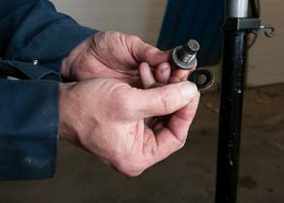

Figure 2—Drain plug seal

- When the drain plug is installed, it should be tightened to the correct torque value according to the vehicle manufacturer’s specification—no exceptions!

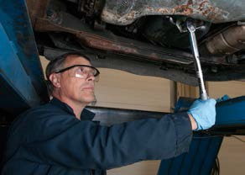
Figure 3—Use a torque wrench to tighten the oil drain plug.

The cost of replacing an oil pan that has been damaged beyond repair can be in excess of a thousand dollars if the oil pan happens to contain the transmission assembly, or the customer loses all their oil at highway speeds because the drain plug was either stripped or left loose.

- The engine oil filter should now be removed either by hand. If it is too tight, the use of the filter wrench can now be demonstrated.

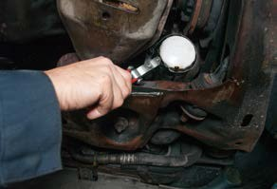

Figure 4—Remove oil filter

- The bottom of the filter base should be cleaned with a cloth and a visual inspection should be done to ensure the old oil filter seal has been removed with the old filter. If not, look for the seal being stuck on the engine where the filter goes. The old seal must be removed. A new oil filter always comes with a new seal. If the old seal has not been removed, and the new oil filter and seal are installed, the two seals will contact each other, large amounts of oil will leak out between them under high pressure and the engine will be damaged within minutes.

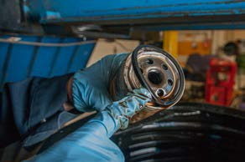

Figure 5—Make sure the old oil filter seal is removed with the filter.

- Lightly lubricate the new seal on the new oil filter base with engine oil and install it to the engine.

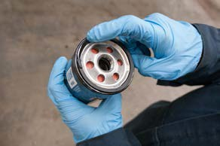

Figure 6—Lubricate the new oil filter seal

- Explain to the students that an empty oil filter takes time to refill. During this refill period the engine is running without oil pressure. You will notice this when you first start the engine. The engine oil light or oil pressure gauge takes about 10 seconds before it turns off or registers pressure. This light or gauge will need to be checked when starting the engine.
- The filter must not be over-tightened—do not turn more than ¾ to 1 turn after the seal contacts the oil filter base. Normally, the filter should be as tight as can be turned with one hand by an adult.
- At this point the teacher may choose to discuss where and how to properly dispose of oil and oil filters.

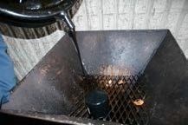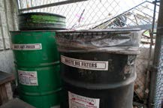
Figure 7—Oil disposal

- Fill the engine to the correct level with oil according to the engine specifications.

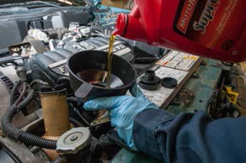

Figure 8—Fill engine oil

- Start the engine and count to 10 while watching the engine oil light or oil pressure gauge. The light should turn off or the gauge should register pressure by the time the 10 count is done.

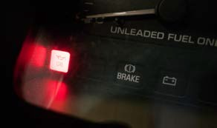

Figure 9—Oil light indicator

- If the engine oil light does not go out after 10 seconds, turn off the engine immediately and determine the problem:
  - Was oil installed?
  - Was the drain plug replaced?
  - Was the oil filter installed correctly?
  - Was the oil filter seal removed?

- Run the engine for about 5 minutes. If the vehicle is run in an enclosed space without good ventilation, it should preferably be connected to a proper exhaust extraction system.
- Wait approximately 5 minutes after the engine has been turned off for all the oil to return to the oil pan. Re-check the oil level and add more if required. Do not overfill past the full mark on the dipstick—if this occurs, some oil must be drained to avoid oil being forced out of the seals in the engine. The space between the “add” and “full” marks on a dipstick usually represents about 1 litre of oil.

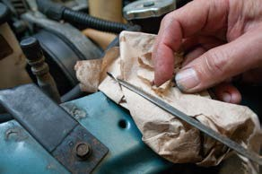

Figure 10—Check oil level using the oil dipstick

Evaluation Guidelines
The following components of the activity can be assessed:
- Completion, legibility and accuracy of work order and oil change checklist
- Practical evaluation of the oil change procedure
- Shop condition when finished (tools put away, oil wiped up, etc.)
- Vehicle condition (fingerprint marks, oil stains on the body work, etc.)
- Question/answer session on oil recycling and filter disposal

Oil Change Checklist

(This sheet must be completed before starting service work)

Customer Name Date

Vehicle: Year Make Model

Odometer Reading Licence Number

Engine Size Fuel Type Transmission Type

VIN

Initial as done

- Oil filter number and manufacturer

- Oil capacity including filter

- Recommended type and viscosity

- Drain plug torque

- Transmission fluid type

- Rear axle/diff oil type

- Transfer case oil type

- Lug nut torque specifications Ft/lbs Nm

- Tire pressures

Front

Rear

Spare

Service Technician’s Name(s) Work order #

Welding

Description
Oxyacetylene or fusion welding is one of the oldest methods of joining metal. Oxyacetylene welding equipment is very common in an automotive shop and has many uses. It is most often used to heat or cut seized or rusted parts that cannot be removed in other ways, or to weld small, thin metal pieces such as exhaust tubing and brackets.

Lesson Outcomes
The student will be able to:
  - Safely inspect and light, operate and shut down an oxyacetylene welding torch.
  - Weld a simple joint and demonstrate heating skills using the equipment in the automotive shop.

Assumptions
It is expected that the students will not have previously used oxyacetylene welding equipment and will not have previously learned skills specific to its use.

Terminology
Acetylene cylinder: a strong, welded steel container that is specially designed to store acetylene, a highly unstable and explosive gas. Acetylene cylinders must be kept upright when in use.
Acetylene regulator: used to regulate acetylene pressure from the cylinder to the mixer handle. The acetylene gas regulator is usually coloured red.

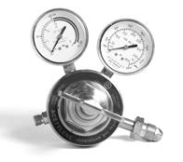
Figure 1—Typical acetylene regulator

This work is licensed under a Creative Commons Attribution-NonCommercial-ShareAlike 4.0 International License unless otherwise indicated. 85

“Beanie”: small skullcap hat used to protect the scalp from sparks

Coupon: typically small, pre-cut pieces of metal (roughly the size and shape of a “coupon”) used for practice welds
Gas hoses: connect the regulator to the mixer handle

Goggles: specially darkened glasses used to protect a welder’s eyes from the welding flame

Oxygen cylinder: cylinder forged from a single piece of strong, high-carbon steel with walls at least 6 mm (¼") thick. Oxygen is stored in these cylinders under enormous pressure.
Oxygen gas regulator: used to regulate oxygen pressure from the cylinder to the mixer handle. The oxygen gas regulator is usually coloured green.

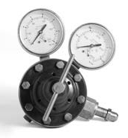
Figure 2—Typical oxygen regulator

Striker: the only approved means of lighting an oxy-fuel torch. Also known as a flint lighter or spark lighter, the steel cup traps the gas, and when the flint contacts the file segment it produces a spark that ignites the fuel gas. The model shown in Figure 3 is the most common type, though pistol grip strikers are also available.

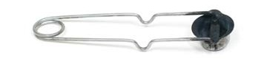
Figure 3—Striker

Tip cleaner: steel tip-cleaning needles with tiny file-like teeth, designed to loosen oxides and slag from the welding tip orifice
Torch handle: mixes and regulates the acetylene and oxygen gas flow to the welding tip. It also has a threaded end for changing to different tips. Sometimes called the mixer handle.

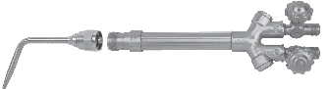
Welding tip
Torch handle oxygen valve
Torch handle
Torch handle fuel gas valve

Figure 4—Combination torch handle

Welding apron or jacket: protective gear worn over work clothes to prevent burns

Welder’s gloves: gloves designed to protect the welder’s hands from burns, usually made from soft cowhide leather
Welding cart: portable cart used to store and transport welding cylinders. The cart is designed to store the cylinders upright in a stable and secure position when stationary, and to roll easily when tilted back on its wheels.
Welding filler rod: a steel rod that comes in different thicknesses to help weld the pieces together.
Welding tip: screws onto the torch handle. It comes in different sizes and is changed depending upon the thickness of the metal to be welded or the area to be heated.

Estimated Time
60–120 minutes

Recommended Number of Students
20, based on the BC Technology Educators’ Best Practice Guide

Facilities
A regular automotive or welding shop with vises and metal-top benches

Tools
An operational oxyacetylene welding unit (preferably more than one unit), with attachments enabling use of more than one torch per unit. Installing equipment to accommodate a “Y” formation allows for the use of two stations per bottle.

Materials
    - Sufficient lengths of metal plates (coupons) for each student to practice (⅛" × 2" × 4"). Mild steel flat bar works well.
    - Two pieces of exhaust tubing cut into 1" slices for each student is sufficient for first-time practice.
    - Sufficient ⅛" oxyacetylene welding rods for each student
    - Oxyacetylene welding gloves and glasses or shaded face shields for each student

Resources

Oxyacetylene Welding (OAW)
PowerPoint presentation created by the York County School of Technology. Once you click on the link below, this resource should appear in your downloads folder.
http://tinyurl.com/qfdl4fs

Oxy-Acetylene Welding and Cutting
Good technical information. Geared more toward instructors than students. www.esabna.com/euweb/oxy _handbook/589oxy2_1.htm

Oxy-Acetylene Welding
Steve Biele’s instructional video, available at low cost www.weldingvideos.com/oawelding.html

ESAB Training Victor Videos
https://vimeo.com/esabtraining

Lighting Procedures Handout
See the handout at the end of this Activity Plan.

Safety Tests
Generic safety tests are available in the Heads-Up for Safety! resource that can be found at: www.bced.gov.bc.ca/irp/resdocs/headsup.pdf
An oxyacetylene safety information sheet can be found on page 85 of the document; a quiz is included on page 86.

Activity

- Have the students work in pairs to assist each other. Demonstrate the process of setting up and lighting the torch and then have each student display their ability to do the same.
- When each pair has shown mastery of lighting and shutting the torch down, the students can assist each other or practise welding their pieces of pipe together.
- When students are comfortable with lighting and shutting down the system and the pipe welding component, they can move on to the next stage. The teacher should demonstrate changing to the larger heating tip and should show how it operates. Then have students demonstrate.
- Students can then practise heating the samples of metal (coupon) while the teacher supervises. The students should be shown how to bend the metal into proper 90° angles.
- When both coupons are bent to form right angles, they can then be welded together to form a box with both ends open. This exercise will allow students to practise accurately attaching the pieces.
- If any very rusty pieces of metal bolted together are available, they make excellent demonstration pieces for heating nuts and bolts to remove seized parts.

Evaluation Guidelines
  - Proficiency and safe operation of the oxyacetylene equipment is a priority.
  - Accuracy is also an essential consideration when heating and bending metal to specified angles.
The information below explains how visual appearance can help determine the quality of penetration in a weld.

Speed of Travel and Movement
Speed of travel (rate of travel) is a very important factor in producing good fusion welds. The speed of travel depends on the base metal thickness, the welding joint design and the volume of heat produced by the welding torch.
If your speed of travel is too fast, the weld bead becomes too narrow and the bead ripples become pointed. The heat has not penetrated and the result is lack of fusion (Figure 5).

Figure 5—Weld bead formed when speed of travel was too fast

If your speed of travel is too slow, it will result in too much penetration and a scaly appearance on the weld bead (Figure 6).

Figure 6—Weld bead formed when speed of travel was too slow

If you allow too much heat to build up, the molten weld pool will collapse through to the bottom of the plate and leave holes (Figure 7). The underside of the weld might have molten metal that has solidified, forming icicle-like structures.

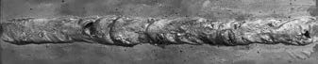
Figure 7—Weld bead formed with too much heat

If you complete your weld properly, it will have uniform bead ripples, even bead width and a shiny surface appearance (Figure 8).

Figure 8—Weld bead formed correctly

The movement of the torch is also extremely important. As soon as there is a small weld pool (pool of molten weld metal), start to move the torch forward with a side-to-side or circular motion. At the same time, insert the end of the filler rod into the weld pool, dipping the rod into and out of the weld pool. The filler rod should be withdrawn just enough to remove it from the weld pool, but not entirely from the flame, since it should not be allowed to oxidize or cool.
Coordinating the motion of the filler rod and the motion of the welding torch is an important factor in producing a quality weld. You will become better at this with continued practice.

Oxyacetylene Lighting Procedures for Welding Mild Steel

Lighting Up the Torch
- Ensure the tanks are upright and secure.
- Check the welding area for any flammables that should be removed (paper towel, spray cans, etc.).
- Unravel the welding hoses.
- Make sure the regulator T-handles are turned out loose.
- Open the acetylene tank ½–¾ turn.
- Open the acetylene torch valve ½ turn.
- Screw in the acetylene regulator T-handle adjusting valve to working pressure. (For welding, always use tip size for pressure.) NEVER go beyond 15 psi. This makes the acetylene very unstable and potentially explosive.
- Turn off the acetylene torch valve.
- Open the oxygen tank valve all the way.
- Open the oxygen torch valve ½ turn.
- Screw in the oxygen T-handle adjusting valve to working pressure. (For welding, always use tip size for pressure.)
- Turn off the oxygen torch valve.
- Ensure you are wearing all necessary safety equipment (goggles, gloves, apron, etc.).
- Open the acetylene torch valve ¼ turn, then light the acetylene using a striker.
- Open up the acetylene torch valve until most of the smoke/soot disappears.
- Slowly open the oxygen torch valve until a neutral flame is achieved.

Figure 9—Correct striker position

Shutting Down the Torch
  - Close the acetylene torch valve.
  - Close the oxygen torch valve.
  - Close the acetylene tank valve.
  - Close the oxygen tank valve.
  - Back out the acetylene regulator T-handle until loose.
  - Open the acetylene torch valve to drain the pressure. Both the tank pressure and line pressure regulator gauges should read 0.
  - Close the acetylene torch valve.
  - Back out the oxygen regulator T-handle until loose.
  - Open the oxygen torch valve to drain the pressure. Both the tank pressure and line pressure regulator gauges should read 0.
  - Close the oxygen torch valve.
  - Wrap up the welding hoses.
  - Clean the welding area.

Remember!
Acetylene on first, acetylene off first.

The Basics of Four-Stroke Engines

Description
Students will be introduced to basic engine parts, theory and terminology. Understanding how an engine works and knowing some key related parts and terminology is important for working on any vehicle. The information is broken down into three major sections: “Basic Engine Parts,” “Basic Engine Terminology” and “Basic Four-Stroke Cycle Engine Theory.“

Lesson Outcomes
The student will be able to:
  - Identify and explain the function of basic engine parts
  - Identify and explain basic engine terminology
  - Identify the four piston strokes of a four-stroke cycle engine
  - Describe the action and function of each piston stroke

Assumptions
  - The students will have little or no prior knowledge of how engines work, terminology or parts.
  - The teacher is familiar with the information being taught.

Note: This information is given as a guide to the minimum amount of material to be covered for a basic understanding of the engine and how it works. Much more can be added as the instructor sees fit.

Terminology
Valve train: all the parts that are used to open and close valves. This may include parts such as valve springs, keepers, lifters, cam followers, shims, rockers and push rods.
Any other terminology used will be explained as required during the activities.

Estimated time
90–120 minutes (including a question and answer session)

Recommended number of students
20, based on the BC Technology Educators’ Best Practice Guide

Facilities
A classroom, computer lab or workshop with tables and chairs sufficient for 20 students.

This work is licensed under a Creative Commons Attribution-NonCommercial-ShareAlike 4.0 International License unless otherwise indicated. 93

Materials
    - Basic engine parts to show as examples, or images of them. A wide variety would be best (1, 4, 6 and 8 cylinders)
    - Engine cutaway

Resources

Four Stroke Engine
Animation of four-stroke engine in motion. Other depicted engines can be found on the home page.
www.animatedengines.com/otto.html

Automobile Engine: Introduction
https://auto.howstuffworks.com/engine1.htm

How Car Engines Work
www.howstuffworks.com/engine.htm

World’s Largest and Most Powerful Diesel Engine
General interest—description of the largest two-stroke diesel engine, designed for use in container ships.
http://wonderfulengineering.com/worlds-largest-and-most-powerful-diesel-engine/

Print Resources
Stockel, Martin. Auto Mechanics Fundamentals. Goodheart-Wilcox Co., 1990.
McGraw-Hill Education (author). Automotive Excellence, Volume 1 (3rd Edition). Glencoe/ McGraw-Hill, 2006.

Activity

This information can be presented in many different ways and formats: straight theory lessons, worksheets, computer research assignments or textbook assignments. This information is meant only to be the essential basics to build a foundation on how an engine functions.

Basic Engine Parts

Engine Block
The engine block is the foundation and centre of the engine. Blocks come in many different sizes, shapes and styles.
The engine block holds the cylinder, the crankshaft, connecting rods (“con rods”) and pistons. The large round holes in the block, called cylinders, are where the pistons slide up and down.

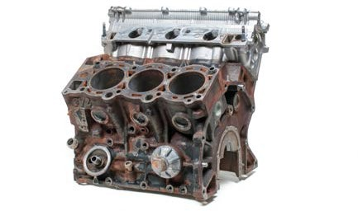
Figure 1—Cylinder block with head attached

Piston
A piston slides up and down a cylinder and pushes the crankshaft around. The piston connects to the crankshaft via the connecting rods.

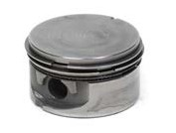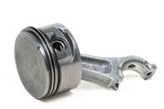
Figure 2—Piston Figure 3—Piston with connecting rod attached

Piston Rings
Each piston has two compression rings and one oil control ring to help seal the piston in the cylinder.

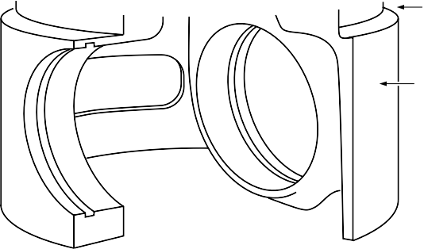First compression ring groove

Second compression ring groove
Oil control ring groove

Skirt

Figure 4—A piston with two compression rings and one oil control ring

Figure 5—Piston rings (compression rings and oil control ring, left to right)

Connecting Rods
Connecting rods connect the pistons to the crank. They utilize an I-beam construction for strength.

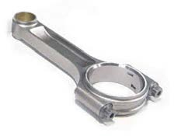

Figure 6—Connecting rod

Crankshaft
The crankshaft is bolted to the bottom of the engine block through bearings so it can rotate freely. It is sometimes referred to as the crank. The crankshaft converts the vertical motion of the pistons and connecting rods to rotational motion. One end of the crankshaft is connected to a flywheel that transfers the engine power to the wheels through a transmission (manual or automatic).

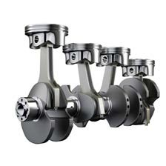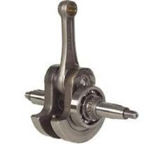

Figure 7—Crankshaft with pistons and connecting rods attached
Figure 8—Crankshaft of a 1-cylinder engine with connecting rod attached

Cylinder Head
The cylinder head is bolted to the top of the cylinder block. It serves as a cover for the cylinders and pistons. The cylinder head helps to create the top part of the combustion chamber. An engine “breathes” through the cylinder head. It lets an air/gas mixture into the engine and exhaust out of the engine. The valves and valve train control the breathing of the engine by opening and closing the valves at the appropriate time.

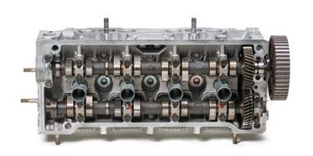
Figure 9—Top view of cylinder head with camshafts attached

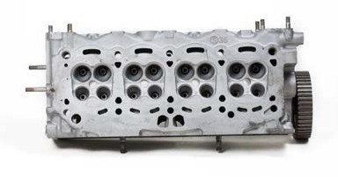

Figure 10—Bottom view of cylinder head showing where the valves sit
Note: This has four valves per cylinder (two intake and two exhaust).

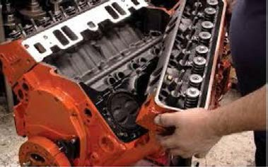

Figure 11—Cylinder head being attached to engine block

Valves
Valves can be divided into two groups:
  - Intake valves control the flow of the air/gas mixture into the engine.
  - Exhaust valves control the flow of exhaust out of the engine.

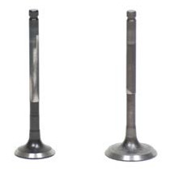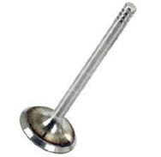
Figure 12—Exhaust and intake valves Figure 13—Valve

Camshaft
The camshaft controls the opening and closing of the valves. There is one lobe on the camshaft for each valve in the engine. Camshaft lobe design dictates three things:
    - How far the valve opens
    - How fast the valve opens
    - How long the valve opens

Depending on the engine type, the camshaft can be located either in the engine block or over the head (OHC) or double OHC (DOHC).

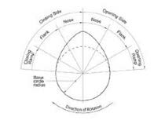
Figure 14—Cam lobe profile showing the opening and closing angles

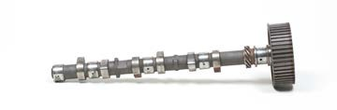

Figure 15—Camshaft

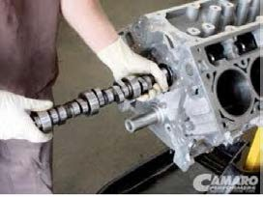

Figure 16—In-the-block camshaft

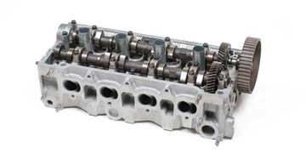
Figure 17—Camshaft located over the head

Lifters (Tapetts)
Lifters are the link between the cam and valves. They are so named because they actually lift as the cam lobe rotates and open the valves. There are two basic types of lifters:
  - The hydraulic lifter
  - The solid lifter

Timing Chain/Belt/Gears
These parts are used in different combinations and configurations to connect the crankshaft to the camshaft. They keep the valves’ opening and closing timed with the piston movement. Timing belts should be replaced every 100,000 km or every five years.

Valve Train
The valve train includes all the parts that are used to open and close valves. This may include parts like valve springs, keepers, lifters, cam followers, shims, rockers and push rods.

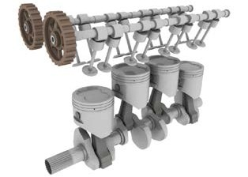
Figure 18—Diagram of an engine with overhead camshafts, demonstrating valve train components

Flywheel
The flywheel attaches to the crankshaft, and uses its momentum to power the engine through the three non-power strokes (intake, compression and exhaust). Because an 8-cylinder car has more power strokes than a 4-cylinder car, the flywheel will be smaller and lighter as there is less need for the momentum carry capabilities.
    - Flywheels are used in standard transmissions.
    - Flexplates are used in automatic transmissions. Flywheels and flexplates have a ring gear for the starter.

Basic Engine Terminology
Bore: the distance across the cylinder (or the diameter).

Bottom dead centre (BDC): the lowest point in the cylinder that the piston reaches.

Combustion chamber: the space left at the top of the cylinder when the piston is at top dead centre (TDC). This also includes any space in the cylinder head.
Compression: the squishing or squeezing of the air/fuel mixture from BDC to TDC. The more the mixture is compressed, the more power it can produce.
Compression ratio: the difference as expressed through a ratio of the space left in the cylinder when the piston is at TDC versus BDC. For example, 8:1 means that the space when the piston is at BDC is 8 times bigger than when the piston is at TDC.
Cubic inch displacement (CID): the engine size. For example, Chevy 350 (cubic inches), Mustang 5.0 (cubic litres) or Honda 1800 cc (cubic centimetres). Even though 5.0 L and 1800 cc are metric measurements, they are often referred to as the CID of an engine.
CID is a mathematical calculation that takes into account the bore and stroke of the cylinder times the number of cylinders in the engine. It basically measures how much volume or air a cylinder can displace or push out from BDC to TDC.
Engine types: engines can be classified in many different ways, but three basic engine types likely to be encountered in an automotive shop are:
  - Four-stroke cycle engine—takes four stokes of the piston to complete a cycle
  - Two-stroke cycle engine—takes two strokes of the piston to complete a cycle
  - Diesel—(two or four stroke) uses heat of compression rather than a spark plug to ignite the fuel that is directly injected into the cylinder
Each of these engines can come in several different configurations.

Four-stroke cycle: four movements of the piston equals one cycle.

Stroke: the distance the piston travels from TDC to BDC or from BDC to TDC.

Top dead centre (TDC): the highest point in the cylinder that the piston reaches.

Basic Four-Stroke Engine Theory
Regardless of its design, an engine needs four things in order to deliver a substantial amount of useful energy or work:
- Air
- Fuel to burn
- Ignition source to ignite the fuel
- Compression of the air/fuel mixture to maximize the power potential of the fuel

Take away any of these items and an engine will not run. Therefore all engine designs are based on allowing these key factors to work in harmony for a smooth, powerful and efficiently running engine.
Example: You could pour out some gas on a small plate and light it on fire. Although it would produce some light and heat, it would not be a great source of power. However, taking that same plate of gas and compressing the air around it by placing a bowl over it and igniting the gas would produce enough power to blow the bowl off the plate. This is the basics of how an engine works.

The Four-Stroke Cycle
Nickolaus Otto is credited with building the first four-stroke cycle engine in 1867, considered the basis of our modern engines. In his honour it is often called the Otto cycle engine.

Intake stroke
  - The piston moves from TDC to BDC (down).
  - The intake valve is open.
  - The exhaust valve is closed.
  - The piston creates a suction (vacuum) and air and fuel are sucked into the cylinder.

Intake valve open
Exhaust valve closed
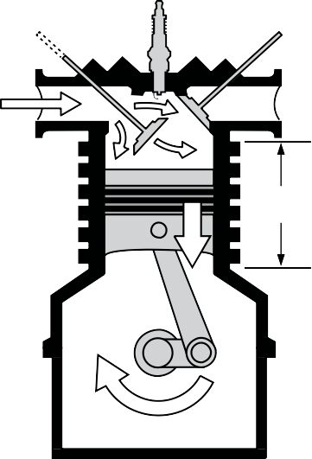Top dead centre (TDC)

Stroke

Bottom dead centre (BDC)

Figure 19—Intake stroke

Compression stroke
  - The piston moves from BDC to TDC (up).
  - Both valves are closed.
  - The piston compresses the air and fuel mixture.

Intake valve closed

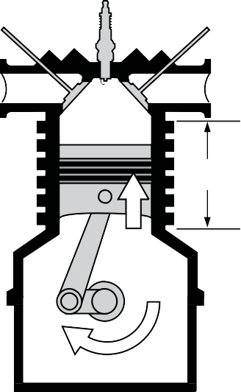Exhaust valve closed
Top dead centre (TDC)

Stroke

Bottom dead centre (BDC)

Figure 20—Compression stroke

Power stroke
  - The piston moves from TDC to BDC (down).
  - Both valves are closed.
  - The spark plug fires.
  - The fuel mixture burns rapidly. This expanding heated mixture forces the piston down.

Intake valve closed
Exhaust valve closed
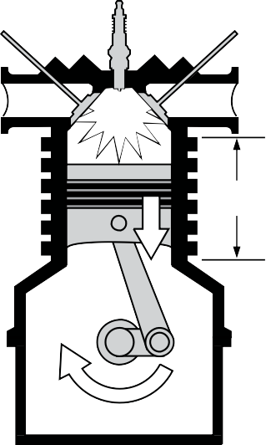Top dead centre (TDC)

Stroke

Bottom dead centre (BDC)

Figure 21—Power stroke

Exhaust stroke
  - Piston moves from BDC to TDC (up).
  - The intake valve is closed.
  - The exhaust valve is open.
  - The piston pushes the exhaust out.

Intake valve closed
Exhaust valve open
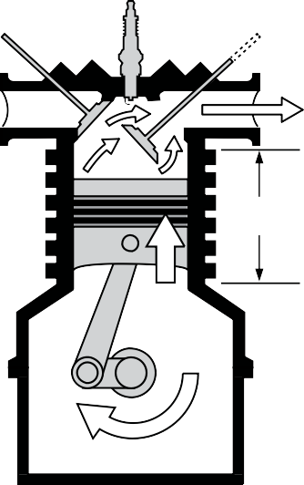Top dead centre (TDC)

Stroke

Bottom dead centre (TDC)

Figure 22—Exhaust stroke

The cycle repeats itself.

The four-stroke cycle is presented in chart form below. Note the following:
  - The piston direction has a distinct pattern.
  - The intake valve is only open during the intake stroke.
  - The exhaust valve is only open during the exhaust stroke.

 | Intake | Compression | Power | Exhaust
Piston Direction | Down | Up | Down | Up
Intake Valve | Open | Closed | Closed | Closed
Exhaust Valve | Closed | Closed | Closed | Open
Mixture Action | Sucked In | Being Squished | Ignited | Pushed Out

Remember ICPE: intake, compression, power, exhaust. The cycle repeats itself. This order cannot change!

Compression Testing

Description
This Activity Plan is designed as one among many through which students will rotate in small groups.
An automotive compression test is very important for determining the internal condition of an engine. In addition, the compression test allows automotive technicians to evaluate engine problems that may exist in a wide range of engine areas. The compression test gives the automotive technician vital information about engine health, performance and/or problems.

Lesson Outcomes
The student will be able to:
  - Properly use tools that are required to do a compression test
  - Remove and replace spark plugs in an effective manner
  - Retain an understanding of the proper steps or procedures required to do a compression test
  - Use compression testing equipment in a safe, effective, and accurate process.

Assumptions
The student will have a general understanding of basic four-stroke engine theory.

Terminology
Compression tester: a specific compression gauge used to determine how much pressure an engine can produce.

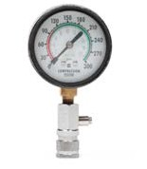
Figure 1—Compression tester

This work is licensed under a Creative Commons Attribution-NonCommercial-ShareAlike 4.0 International License unless otherwise indicated. 107

Fuel pump relay: the electrical component that energizes the fuel pump.

Ignition system: the electrical system within a vehicle that delivers spark or ignition to the engine.
Spark plug socket: a specific socket designed to remove and install a spark plug. Although it may look like a regular deep socket, it is different. Inside the cavity of the socket is a rubber sock that protects the spark plug from scratching, cracking or breaking. In addition, most spark plug sockets have a hex on the top of the socket so a wrench can be used on it for hard to reach or awkwardly-placed spark plugs.

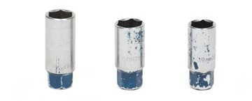
Figure 2—Spark plug socket

Spark plug wire pliers: pliers that are designed to remove the spark plug wire from the spark plug without causing any damage.

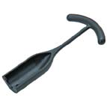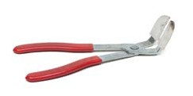
Figure 3—Spark plug boot puller Figure 4—Spark plug boot pliers

Wide open throttle: a condition where the maximum amount of air is allowed into the engine.

Estimated Time
1 hour

Recommended Number of Students
20, based on the BC Technology Educators’ Best Practice Guide

Facilities
Automotive shop or a technology education shop that will accommodate a vehicle

Tools
- Spark plug socket
- Spark plug wire pliers
- 12" 3⁄8" extension
- 3⁄8" ratchet
- Compression tester
- Oil squirt can

Materials
You will need a vehicle in order to do the compression test. Ideally the vehicle will be smaller and preferably a four cylinder. It is much easier to do a compression test with this type of vehicle.

Resources

Compression Testing and What You Can Learn from It
www.youtube.com/watch?v=X_tbksFYhl4

How to Do a Compression Test
www.youtube.com/watch?v=YnV 7FjLLt2s

Activity 1: Dry Compression Test

- The teacher will demonstrate how to correctly do a compression test. After the students have viewed the demonstration they will be given the opportunity to do the compression test. This is usually done in a lab-based format with instructor signatures required at various stages.
- Start the vehicle and warm it up until the engine is at normal operating temperature (approximately 5–10 minutes). Note: Only the instructor should operate the vehicle.

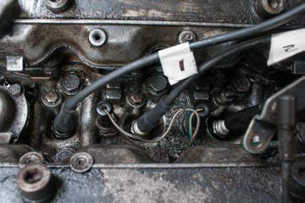
Figure 5—Spark plug wires attached to engine

- Remove all of the spark plug wires from the spark plugs. It is a good idea to label the spark plug wires so you know which cylinder they came from. Note: Grasp and twist the spark plug boot (not the wire) in order to remove. Sometimes due to the heat of the engine, spark plug boots get stuck on the spark plugs. In such cases it may be necessary to use spark plug boot puller/pliers.
- Disable the ignition system by removing and then grounding the high-tension lead.

- Remove the fuel pump relay. This relay is usually found in the fuse box under the hood and is labelled as such.

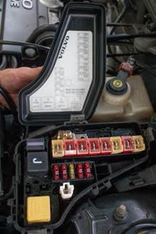
Figure 6—Typical fuel pump relay location

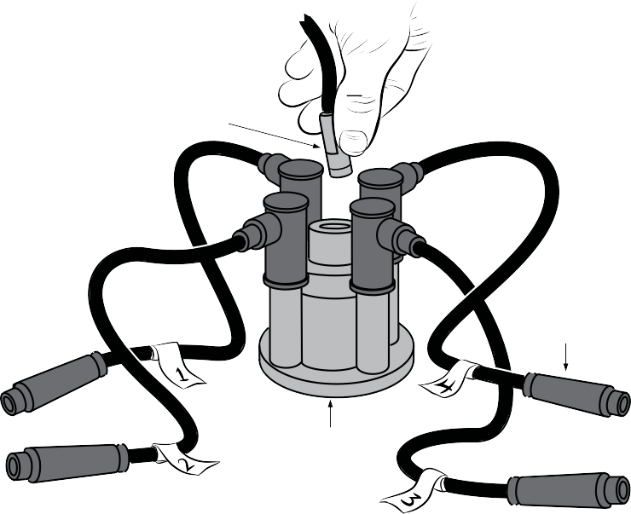
Connector to distributor cap
Plug cap
Distributor cap

Figure 7—Label the spark plug wires so they do not get mixed up. Then remove the centre wire and ground this high-tension lead.

- Remove all of the spark plugs using a spark plug socket.

- Insert the compression tester into one of the spark plug holes.

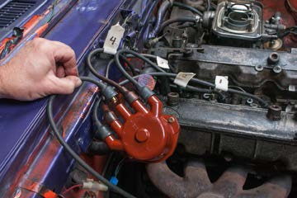
Figure 8—Remove centre wire

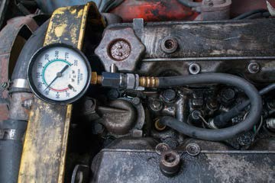

Figure 9—Compression gauge inserted into spark plug hole

- With a partner crank the engine over for 5 seconds. One person will be holding the compression tester and the other will be inside the vehicle cranking the engine over. Note: Make sure to have the gas pedal all the way to the floor when performing this operation, as this will allow for maximum air into the engine.
- Write down the reading and repeat for the rest of the cylinders.
- Compare all of the compression test results. They should be within 20% of each other.

Activity 2: Wet Compression Test

A wet compression test is similar to a dry compression test except it has the addition of oil placed in each cylinder. A wet compression test is done for two reasons:
  - One or more cylinders has a reading of less than 100 psi on the dry compression test.
  - One or more cylinders is more than 20% different from the other cylinders on a dry compression test.
The extra oil in the cylinder should temporarily seal the piston rings in the cylinder. The results can help diagnose possible engine problems.

Procedure:
  - Perform a dry compression test and record the results.
  - With an oil squirt can, place approximately one tablespoon of oil (15 mL) into the first cylinder—this is roughly two squirts of oil.
Note: Do not put excess oil in the cylinder!
  - Crank the engine approximately four times to move the oil around the cylinder.
  - Insert the compression gauge and check the compression as before.
  - Record the new reading.
  - Repeat this process on each cylinder. Note: Squirt oil into one cylinder at a time. Squirting oil into all the cylinders at once and then doing the compression test will skew the results, since by the time you get to the last cylinder the oil will have lost its effectiveness.
  - Compare the results of the wet test with those of the dry test. In particular, pay attention to the cylinders that were questionable from the dry compression test. One of two things should happen:
    - The results remain about the same. Example:
Dry test: 115
Wet test: 120
Diagnosis: The low compression is likely due to wear in the valves or valve guides.

    - The results improve significantly. Example:
Dry test: 115
Wet test: 135
Diagnosis: The low compression is likely due to wear in the piston rings.
Note: When starting the vehicle for the first time after a wet compression test, excess smoke may come out of the exhaust. This is perfectly normal and should only last for 2–5 minutes.

Evaluation Guidelines
- The students use the required tools in a safe and effective manner.
- The ignition system is disabled properly.
- The fuel system is disabled properly.
- The students can remove and replace the spark plugs correctly without damaging them.
- The compression test itself is carried out in a safe and effective manner.
- The student’s evaluation of the compression test data is a correct interpretation of the health of the engine.

Tire Change

Description
This Activity Plan is designed as one among many through which students will rotate in small groups. The activity involves dismounting and remounting a tire on a tire machine. Such operations are required in the automotive field whenever a different tire has to be installed on a rim/wheel or for a flat repair. Many entry- or apprentice-level mechanics are required to be
quite competent in this task. This activity would definitely be considered to be a “hook” exercise, designed to draw interest into the field.

Lesson Outcomes
The student will be able to safely and correctly dismount and then remount a tire onto and off of a rim.

Assumptions
Before trying themselves, students will have been given some theory and the instructor will have demonstrated the proper procedure for changing a tire.

Terminology
Bead: the area of the tire that seals or touches the rim.

Drop centre: the area of the wheel that is inset. This area enables the tire to be installed onto the rim.
Inflation: the installation of air into the tire.

Lubricant: a specialized tire lubricant that aids in tire installation.

Rim diameter: the diameter of the rim.

Tire size: how large or small the tire is. This is always defined by tire width, tire height and rim diameter. Example: 195/80/R14.
Tire table: the area of the tire machine that the tire lies on.

Valve stem: the valve that allows installation of air into the tire.

Wheel weight: a small weight that is hammered onto the wheel in order to equalize or balance the tire.
Wheel weight hammer: a small, specialized hammer that is used to install the wheel weights onto the rim assembly.

This work is licensed under a Creative Commons Attribution-NonCommercial-ShareAlike 4.0 International License unless otherwise indicated.
117

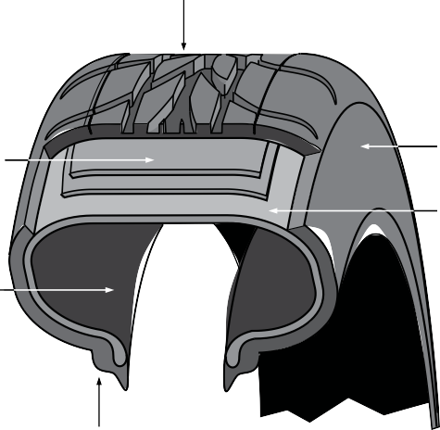Tread

Plies and belts

Rubber liner

Bead
Sidewall Carcass ply

Figure 1—Parts of a tire

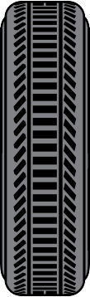

Section width
Aspect ratio or
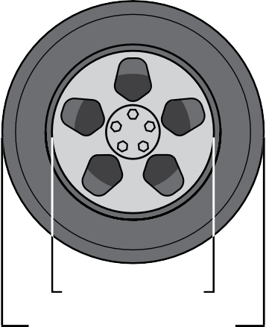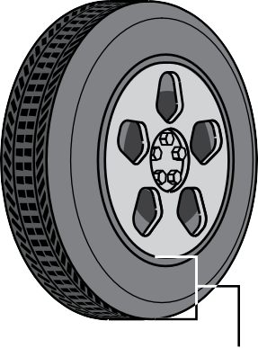sidewall height

Wheel diameter Outside tire diameter

Figure 2—Measurements supplied for tire size information

Estimated Time
30 minutes

Recommended Number of Students
20, based on the BC Technology Educators’ Best Practice Guide, 2–3 students per group

Facilities
Automotive shop

Tools
- Tire-changing machine
- Wheel weight hammer

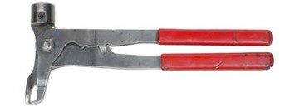Figure 3—Wheel weight hammer

Materials
A few loose tires and rims of various sizes

Optional
Initially this should be attempted with tires that have a high height (i.e., high-profile tires). Later, lower profile tire changes could be attempted (lower profile tires generally require more skill with this operation).

Resources for Both Activity Plans 12 and 13

Tire removal/Replacement—Andrada Polytechnic High School
https://www.youtube.com/watch?v=BsOUtR_lTeE

MSCTC Tire Changing Training Video
www.youtube.com/watch?v=tmW9YJpVwO4

Dismount and Mount Tire Demo
www.youtube.com/watch?v=m303xb2CUjw

How to Mount and Balance a Tire—Eric the Car Guy
www.youtube.com/watch?v=8hOZXIr1ujE

Tire Balancer Demo
www.youtube.com/watch?v=bC5p08jTTvo

Youth Explore Trades Skills 119

Activity
Note: Since each tire machine functions slightly differently, refer to the manufacturer’s instructions for your specific machine. The instructions given here are just a general guideline.

Safety Warning
Installing the wrong size tire on a rim could lead to disastrous results. The tire may blow off the rim during installation and injure the installer or the tire may come off/deflate while on the car, causing an accident.

- Deflate the tire (remove the valve core from the valve stem).
- Remove any old wheel weights from the tire assembly.
- Break the beads on both sides of the tires with the tire machine.
- Lubricate the bead areas of the tire with the proper bead lubricant.
- Place the tire assembly on top of the tire machine.
- Secure the tire assembly to the tire machine (clamp rim).
- Remove the outer tire bead (this is the bead on the valve stem side).
- Remove the inner tire bead.
- Inspect the bead area on the rim for damage and/or rust (the bead seals here). Clean the area with a wire brush if needed.
- Inspect the bead area of the tire (look for damage).
- Again lubricate both beads of the tire and the wheel rims.
- Install the lower bead of the tire back onto the rim using the tire machine.
- Install the upper bead of the tire back onto the rim using the tire machine.
- Inflate the tire, making sure both beads are set properly. (Do not overinflate. Follow the manufacturer’s instructions about releasing the hold-down cone.)
- Install the valve core back into the valve stem.
- Set the tire pressures to the manufacturer’s specification (or 10 psi under max. rating).

Evaluation Guidelines
Tire Change Rubric (see next page)

Name:

Tire Change Rubric

Criteria | Poor | Below Standard | Satisfactory | Good | Excellent
Are both beads fully broken free from the rim? | 1 | 2 | 3 | 4 | 5
Has tire been safely and completely removed from rim without damage? | 1 | 2 | 3 | 4 | 5
Has tire been safely and completely installed onto rim without damage? | 1 | 2 | 3 | 4 | 5
Were both tire beads properly lubricated during removal and installation process? | 1 | 2 | 3 | 4 | 5
Are tire pressures exactly set to manufacturer’s specifications? | 1 | 2 | 3 | 4 | 5
Total: /25

Wheel Balance

Description
This activity plan is designed as one among many through which students will rotate in small groups. The activity involves dismounting and remounting a tire on a tire machine. Such operations are required in the automotive field whenever a different tire has to be installed on a rim/wheel or for a flat repair. Many entry- or apprentice-level mechanics are required to be
quite competent in this task. This activity would definitely be considered to be a “hook” exercise, designed to draw interest into the field.

Lesson Outcomes
The student will be able to balance a single wheel and/or tire assembly so that each side of the tire is balanced to specifications.

Assumptions
Many of the terms used in this activity plan overlap with Tire Change. This activity should be introduced after the tire change activity. Before trying themselves, students should have been given some theory and the instructor should have demonstrated the proper procedures for balancing a tire.

Terminology
Aluminum mag: a wheel that is constructed of aluminum.

Bead area: the area of the tire that is sealed to the rim.

Rim centre: the middle of the wheel (the round opening in the centre).

Rim diameter: the diameter of the wheel, not the tire.

Rim width: how wide the rim is.

Steel wheel: a wheel that is constructed of steel.

Tire balancing machine: a machine that is used to calculate how much weight has to be installed on each side of the tire/rim assembly.
Wheel weight: a small weight that is hammered onto the wheel in order to equalize or balance the tire.
Wheel weight hammer: a small, specialized hammer that is used to install the wheel weights onto the rim assembly.
Zero: the reading that most wheel balancers state when both sides of the tire/rim assembly are balanced.

This work is licensed under a Creative Commons Attribution-NonCommercial-ShareAlike 4.0 International License unless otherwise indicated.
123

Estimated time
30–45 minutes

Recommended Number of Students
20, based on the BC Technology Educators’ Best Practice Guide, groups of 2–3 students

Facilities
Automotive shop or similar

Tools
  - Tire balancing machine
  - Wheel balance weight pliers
  - Wheel weight hammer

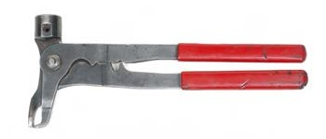
Figure 1—Wheel balance weight pliers

Materials
  - At least one wheel/tire assembly
  - Selection of wheel weights

Resources for Tire Change and Wheel Balance

Tire Removal/Replacement—Andrada Polytechnic High School
https://www.youtube.com/watch?v=BsOUtR_lTeE

MSCTC Tire Changing Training Video
www.youtube.com/watch?v=tmW9YJpVwO4

Dismount and Mount Tire Demo
www.youtube.com/watch?v=m303xb2CUjw

How to Mount and Balance a Tire—Eric the Car Guy
www.youtube.com/watch?v=8hOZXIr1ujE

Tire Balancer Demo
www.youtube.com/watch?v=bC5p08jTTvo

Youth Explore Trades Skills 125

Activity

- Make sure both the inner and outer beads of the tire are properly seated on the wheel.
- Ensure that the tire pressure is within manufacturer’s specifications.
- Mount the tire/wheel assembly onto the tire machine using the correct size centring cones.
- Make sure that the wheel assembly is properly mounted.
- Measure the rim diameter and enter this number into the wheel balancer.
- Measure the rim width and enter this number into the wheel balancer.
- Measure the distance the inside of the wheel assembly sits from the wheel balancer and enter this number into the machine.
- Start the machine and then wait until it stops.
- Most tire machines will give numbers for balancing both the left and right sides of the wheel/tire assembly.
- Rotate the wheel into the exact position that the balancer wants and install the required wheel weight onto the left side of the wheel.
- Rotate the wheel again into the exact position that the balancer wants and install the required wheel weight onto the right side of the wheel.
- Start the machine again and wait until it stops.
- If done correctly, both sides of the wheel should read to zeroes.
- If numbers other than zeroes appear, it is best to start the process again from step number 8.

Evaluation Guidelines
Wheel Balance Rubric (see next page)

Name:

Wheel Balance Rubric

Criteria | Poor | Below Standard | Satisfactory | Good | Excellent
Are the correct centring cones used? | 1 | 2 | 3 | 4 | 5
Are the correct rim diameter specifications entered into the balancer? | 1 | 2 | 3 | 4 | 5
Are the correct rim width specifications entered into the balancer? | 1 | 2 | 3 | 4 | 5
Is the correct distance that the tire sits from the balancer entered? | 1 | 2 | 3 | 4 | 5
Does the balancer read “Zero” on both sides to indicate that the tire is successfully balanced? | 1 | 2 | 3 | 4 | 5
Total: /25

Tire Repair

Description
This Activity Plan is designed as one among many through which students will rotate in small groups. The activity involves repairing damage to the tread part of the tire. Damage is usually incurred via nail, screw, tack puncture, etc. It is important to note that the only acceptable method of repairing a tire is via the patch method, not the plug method. The plug method is dangerous, out of date and not acceptable in today’s modern automotive world.

Lesson Outcomes
The student will be able to properly repair a puncture wound in the tread area of a tire.

Assumptions
Before trying themselves, students will have been given some theory and the instructor will have demonstrated the proper procedure for repairing a tire. In addition, this activity should be introduced after the tire change activity.

Terminology
Drill bit: a cutting tool used in conjunction with a drill to create a cylindrical hole.

Hand drill: a tool used in conjunction with a drill bit to create a hole.

Plug/patch material: usually a patch that also incorporates a small plug in the middle of the patch.
Puncture wound: a piercing of the tire tread usually caused by a foreign body (e.g., screw, nail or small piece of metal).
Side cutting pliers: a style of pliers that is useful for removing a foreign body from the tread of the tire.
Tire awl: an awl used to slightly enlarge the puncture in order to properly install the tire patch.

Tire buffer: a course circular wheel designed to prepare the inner surface of the tire.

Tire cement: the glue used to adhere the patch to the inside surface of the tire.

Tire chalk: a special type of chalk used to mark the tire.

Tire stitcher: a device used to ensure that the tire patch sticks onto the tire properly.

This work is licensed under a Creative Commons Attribution-NonCommercial-ShareAlike 4.0 International License unless otherwise indicated.
129

Estimated Time
30–45 minutes

Recommended Number of Students
20, based on the BC Technology Educators’ Best Practice Guide, groups of 2–3 students

Facilities
Automotive shop

Tools
- Tire changing machine
- Drill
- Tire stitching tool

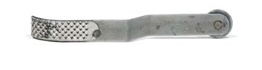
Figure 1—Tire stitching wheel

Materials
- A few loose tires that can be intentionally damaged to provide tire tread material to repair
- Assortment of patch plugs

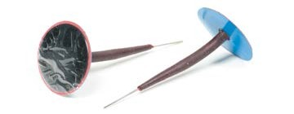

Figure 2—Patch plug (sometimes called a mushroom plug)

Optional
A typical plug repair kit could be presented to show students how tire repair used to be done. This type of repair is considered inferior to the patch repair.

Resources

Flat Tire Repair Plugging vs. Patching—This is why good shops will not plug your tire!
www.youtube.com/watch?v=iPRUdaxXgVw

How to Repair a Car or Light Truck Tire
www.youtube.com/watch?v=wi5uBUaMsrA

Youth Explore Trades Skills 131

Activity

- Remove the tire from the rim (or simply work with a loose tire).
- Intentionally pierce the tire tread using pliers and a typical foreign object (screw, nail, etc.).
- Mark the foreign object location with tire chalk on the inside of the tire.
- Remove the foreign object with pliers.
- Drill a 3/16" hole through both the inside and outside of the tire where it was punctured.
- Buff the inside of the tire around the puncture wound using a buffing wheel and drill. The buffed area should be slightly larger than the tire patch.
- Apply contact cement to the buffed area.
- Apply contact cement to the inside area of the puncture wound. This can be done by applying cement to the tire awl and then inserting the awl into the puncture wound.
- Let the area dry 3–5 minutes.
- Remove the protective film from the patch/plug repair component and insert the plug from the inside of the tire.
- From outside of the tire, pull the patch/plug repair component through as far as you can.
- From inside the tire, use the tire stitching tool to firmly stitch the tire patch/plug to the inside of the tire by rolling it over the patch for 1–2 minutes in multiple directions.
- Remove the protective plastic film from the tire patch/plug.
- Remount the tire and inflate it to the proper specification.
- Cut the protruding plug from the outside of the tire to approximately 1/8" above the tire surface.
- Reassemble the tire and wheel. Check to make sure the tire patch/plug is not leaking.

Evaluation Guidelines
Tire Repair Rubric (see next page)

Name:

Tire Repair Rubric

Criteria | Poor | Below Standard | Satisfactory | Good | Excellent
Is the 3/16" hole drilled from both the inside and outside of the tire? | 1 | 2 | 3 | 4 | 5
Is the buffed area consistent and buffed slightly larger than the patch? | 1 | 2 | 3 | 4 | 5
Has the plug/patch been installed properly? | 1 | 2 | 3 | 4 | 5
Has the tire been remounted properly and inflated to the correct specification? | 1 | 2 | 3 | 4 | 5
Does the repair hold air? | 1 | 2 | 3 | 4 | 5
Total: /25

Lifting Vehicles

Description
This Activity Plan is designed as one among many through which students will rotate in small groups. Students will learn how to safely lift and support a vehicle using a floor jack, safety stands and wheel chocks. This skill is fundamental for automotive mechanics. The safe procedure for lifting a vehicle on a hoist will also be demonstrated.

Lesson Outcomes
The student will be able to:
- Prevent a vehicle from moving or rolling
- Place a floor jack underneath a vehicle
- Place a safety stand
- Operate a floor jack
- Describe the correct operation of a vehicle hoist
- Operate a vehicle hoist

Assumptions
Before doing so themselves, students will have been given some theory and the instructor will have demonstrated the proper procedure for lifting a vehicle using both a floor jack and a vehicle hoist.

Terminology
Automatic transmission “park”: the “P” or park position as indicated on the gear shift lever.

Body on frame: an older style of vehicle in which the vehicle body is separate from the frame.

Cross member: a strong structural member of a vehicle that supports other vehicle components.
Emergency brake: a secondary brake in a vehicle that is designed to be used in an emergency situation. Often called a park or parking brake.
Floor jack: a device used to raise the axle of a vehicle off the ground to inspect the underside of the vehicle or change a tire.
Floor jack lift plate: a small plate at the end of a floor jack that supports the lift point of the floor jack.
Manual transmission “neutral”: the neutral position on a standard or manual transmission.

This work is licensed under a Creative Commons Attribution-NonCommercial-ShareAlike 4.0 International License unless otherwise indicated.
135

Hoist: apparatus used to lift a vehicle.

Hoist arms: the arms of the machine that go under the vehicle to support it as it is lifted into the air.
Rear wheel drive: a vehicle that has the engine power driving (or powering) the rear wheels. Often found on pickup trucks, larger vehicles and older cars
Rocker panel sill: a very strong lip of a vehicle that the manufacturer designs to support the vehicle if it has to be lifted into the air (e.g., when removing a flat tire).
Safety stand: a stand used to support a vehicle after it has been lifted with a floor jack.

Unibody: a newer style of vehicle construction that incorporates the body and frame into one unit.
Wheel chock: a wedge or block placed next to a wheel to stop the vehicle from moving.

Estimated Time
30 minutes

Recommended Number of Students
20, based on the BC Technology Educators’ Best Practice Guide, 2–3 students at one time

Facilities
Automotive shop

Tools
- Floor jack
- Safety stand
- Vehicle hoist
- Wheel chocks

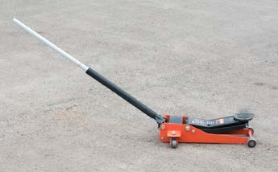

Figure 1—Trolley jack

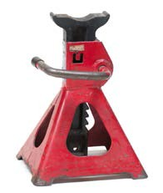
Figure 2—Jack stand

Materials
Small- to mid-size vehicle

Resources

Automotive Lift Institute
Use Automotive Lift Institute (ALI) materials as supplementary resources for safety instruction. www.autolift.org/

Automotive Lift Safety Awareness
www.youtube.com/watch?v=N3R_8889p3g

Activity 1: Placing a Car on Safety Stands

Front
Garage jack points

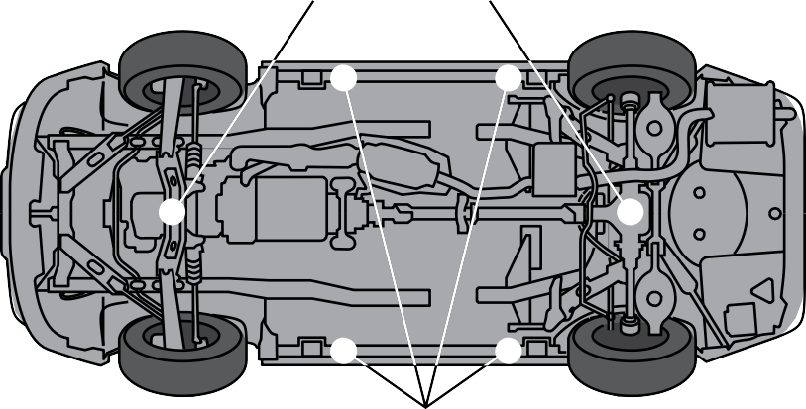Safety stand points

Figure 3—Garage jack points and safety stand points

Part 1: Prevent the Vehicle from Moving or Rolling

Warning
Choose a clean, flat and level spot. Little stones, rocks and debris can prevent the floor jack from rolling properly while lifting, which can cause extensive damage to the vehicle. Jacking is only permitted on concrete or pavement, never on asphalt (the stands or jack can sink into the soft asphalt).

- Apply the parking or emergency brake.
- Place the vehicle in the “Park” setting if the vehicle is equipped with an automatic transmission.
- Place the vehicle in the “Neutral” setting if the vehicle is equipped with a manual, floorboard transmission.
- Place wheel chocks at one of the wheels that will stay on the ground.

Part 2: Place the Floor Jack
- Raise the vehicle with the floor jack so that the safety stands have enough room to be placed underneath the vehicle.

Warning
Never place the floor jack underneath an oil pan, muffler, floor pan or any other vulnerable section of the vehicle.

Part 3: Place the Safety Stands
  - On unibody vehicles, place the safety stands underneath the rocker panel sill lips or a solid cross-member.
  - On body-on-frame vehicles, it is best to place the safety stands undrneath the frame.
  - On rear wheel drive vehicles, when jacking up the rear, place the safety stands under the rear axle tubes.
  - Lower the floor jack slowly and carefully so the safety stands fully support the vehicle.
  - Shake the car once it is on the safety stands to make sure nothing will shift. Readjust as necessary. Shake in both directions (side to side and fore and aft). Have the instructor check the security of the vehicle before doing any work on it.

Part 4: Lower the Vehicle to the Floor
- Place the floor jack underneath the vehicle in the same spot that was used during the lift.
- Slowly raise the vehicle only far enough so that both safety stands can be removed.
- Remove the safety stands, one at a time, from underneath the vehicle. It is not necessary to go right underneath the vehicle to remove the safety stands; instead, extend one arm in order to retrieve the stand.
- Slowly lower the vehicle and remove the floor jack.
- Remove the wheel chocks.

Activity 2: Placing a Car on a Hoist

- Students will be shown how to safely lift a vehicle on the hoist that exists in the shop. Refer to the manufacturer’s operational instructions, as every hoist is different.
- Students could then be asked to demonstrate their competency on the hoist.

Warning
This does not mean that a student be trusted to lift a vehicle unsupervised. Always supervise closely!

Evaluation Guidelines
Lifting Vehicles Rubric (see next page)

Name:

Lifting Vehicles Rubric

Criteria | Poor | Below Standard | Satisfactory | Good | Excellent
Is the emergency brake applied? | 1 | 2 | 3 | 4 | 5
For automatic transmissions, is the vehicle in Park?  For manual transmissions, is the vehicle in Neutral? | 1 | 2 | 3 | 4 | 5
Are wheel chocks placed beside the wheels that will stay on the ground? | 1 | 2 | 3 | 4 | 5
Is the floor jack properly positioned under a cross- member? | 1 | 2 | 3 | 4 | 5
Are safety stands placed in the correct locations? | 1 | 2 | 3 | 4 | 5
Are the safety stands safely removed and the floor jack correctly used when lowering the vehicle back to the floor? | 1 | 2 | 3 | 4 | 5
Total: /30

Solder Wire

Description
This Activity Plan is designed as one among many through which students will rotate in small groups. The students will be given some theory, and the instructor will demonstrate the proper procedure of joining two wires together using soldering techniques. The ability to join wires together using sound soldering techniques is an essential skill for an automotive technician.

Lesson Outcomes
The student will be able to:
- Join electrical wires together using a filler material
- Demonstrate competent soldering techniques
- Understand basic soldering terminology
- Understand why good soldering techniques are vital to being an automotive service technician

Assumptions
Before doing so themselves, students will have been given some theory and the instructor will have demonstrated the proper procedure of joining two wires together using soldering techniques.

Terminology
Cleaning sponge: a sponge used to clean the end of the soldering iron in order to allow the iron to function properly.
Electrical wire: wire that is designed to easily conduct electricity.

Needle-nose pliers: a style of pliers with a long, narrow end, designed to get into tight areas.

Safety glasses: glasses specially designed to protect the eyes in a workplace setting.

Solder: the metal-based filler material used to join wires together.

Soldering iron: a tool used to melt the solder.

Soldering iron holder: a tool used to support the soldering iron when not in use.

Wire cutters: a type of plier that is designed to cut electrical wire.

Wire gauge: the thickness of wire.

Wire strippers: a tool use to strip a wire of its insulation so that it can be soldered.

This work is licensed under a Creative Commons Attribution-NonCommercial-ShareAlike 4.0 International License unless otherwise indicated.
143

Estimated Time
30–45 minutes

Recommended Number of Students
20, based on the BC Technology Educators’ Best Practice Guide, 1–2 students per station

Facilities
Automotive or industrial education shop

Tools
  - Cleaning sponge
  - Heat gun for Activity 6: Heat Shrink (optional)
  - Needle-nose pliers
  - Safety glasses
  - Solder
  - Soldering iron
  - Soldering iron holder
  - Wire strippers/crimpers
  - Wire cutters

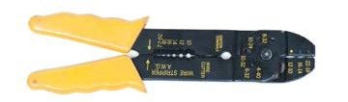
Figure 1—Heavy duty automatic wire stripper

Materials
Electrical wire in the 18–22 gauge category (1 foot per student)

Optional Materials
  - Electrical tape for Activity 5: Tape a Wire (optional)
  - Heat shrink tube for Activity 6: Heat Shrink (optional)
  - Electrical components such as resistors, capacitors, transistors, circuit boards or others. These would typically be found in an electronics class.
  - Splice connector
  - Butt connector
  - Terminal connectors

Resources

How to Solder—Intro/Joining Stranded Wires—Part 1
www.youtube.com/watch?v=Q9G9gaokqvM

How to Solder: The Basics
www.youtube.com/watch?v=BxeDkcAa4Fs

How to Solder Wires Together (Sort of)—Eric the Car Guy
www.youtube.com/watch?v=L61LJcz7H6g

Video of Heat Shrink Tube Before and After
http://commons.wikimedia.org/wiki/File:Video_of_Heat_shrink_tube_before_and_after.ogg

Heat Shrink Tubing Frequently Asked Questions—Allied Wire & Cable (AWC)
www.awcwire.com/faq-heat-shrink-tubing.aspx

Activity 1: Join Two Wires Using Solder

- Plug in the soldering iron and let it heat up for a few minutes.
- Cut the electrical wire into two 6" long pieces.

Note: If you are going to do Activity 6, Heat Shrink, then students could slide a piece of heat shrink tube over one of the wires at this time. This would more realistically reflect the fact that the heat shrink tube would have to be inserted onto a wire before making the solder connection, since the other ends of each wire would most likely be connected to other parts.

- If the soldering iron is new, then “tin” the soldering iron. “Tinning” is applying a small amount of solder directly to the soldering iron tip.
- Clean the tip of the soldering iron with a wet sponge.
- Cut a small 4" piece of solder off of the main solder roll.
- With the wire strippers, strip off approximately ½" of insulation from two separate wires.
- If the wire you are using is composed of many fine strands of wire, then spread the finer strands apart on two separate pieces of wire.
- Proceed to carefully intertwine the fine strands together. This technique attempts to make the two bare ends into one. It should not take a long time.
- If the wire you are using is a solid piece of wire, simply twist the two ends together as neatly as you can.
- Place the hot tip of the soldering iron on one side of the joined wires.
- With the needle-nose pliers, hold a small piece of solder onto the opposite side of the joined wires.
- After a few seconds the solder will begin to melt into the wire. You don’t want the tip of the soldering iron to melt the solder—rather you want the hot wire to melt the solder.
- Once a small amount of solder has melted, remove both the soldering iron and the solder.
- Let the joined wires cool for a few seconds.
- The soldering process is now complete.
- Lightly try to pull the joint apart; it should stay attached even under moderate strain.
- Optional: If electronic components such as resistors, capacitors, transistors, circuit boards or others are available, they could be also be soldered, although this is typically done in an electronics classroom.

Activity 2: Install Splice Connector (Optional)

- Cut 3" from one end of the previously soldered wire.
- Use a splice connector (sometimes called a Scotch lock) to connect the short wire you
just cut off the other wire. Use pliers to push the metal spade connector into the wires. The attachment point should be approximately 2" in from the end of the long side of the wire.

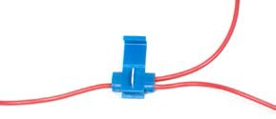
Figure 2—Quick splice connector, connecting wires together

- With pliers, squeeze the metal tab down into the wires.
- Close the plastic tab over the connector. Make sure it clicks into place.

Activity 3: Install Butt Connector (Optional)

- Cut the wire in a different spot.

- Strip ½" insulation of each end.

- Insert each end of the wire into the butt connector.

- Using the wire crimpers, crimp the butt connector near each end to connect the wires. Note: Most crimpers will have three different crimp areas depending on the gauge of wire you are using. These different sizes are designated by three colours: red, blue or yellow. Most connectors are colour-coded to the wire gauge, red, blue or yellow. Simply match up the colour of the connector to the coloured area on the crimper.

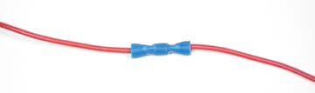
Figure 3—Solderless parallel butt connector

Activity 4: Install Male and Female Terminal Connectors (Optional)

  - Cut the wire in a different spot.

  - Strip ½" insulation of each end.

  - Insert one wire end into the female terminal and crimp it using the wire crimp tool.

  - Insert the other wire end into the male terminal and crimp it using the wire crimp tool.

  - Join the male and female terminals together.

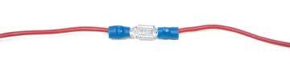
Figure 4—Solderless female and male disconnect

Evaluation Guidelines
Soldering Rubric (see next page)

Soldering Rubric
Name:

Criteria | Poor | Below Standard | Satisfactory | Good | Excellent
Has the soldering iron tip been properly cleaned? | 1 | 2 | 3 | 4 | 5
Have the wires been properly stripped? | 1 | 2 | 3 | 4 | 5
Has the wire been twisted together properly before the soldering procedure? | 1 | 2 | 3 | 4 | 5
Has the solder properly melted and sunk into the wire as opposed to simply sitting on top of it? | 1 | 2 | 3 | 4 | 5
Are the Scotch lock and butt connectors secured properly? | 1 | 2 | 3 | 4 | 5
Is the solder joint strong and unable to be pulled apart? | 1 | 2 | 3 | 4 | 5
Total: /30

Note: The next two activities should only be done once the solder joint has been marked. If you wish to do both activities, you will need to have two soldered joints.

Activity 5: Tape a Wire

After having the solder joint inspected and marked complete the following.

- Get a roll of electrical tape.
- Unravel approximately 2" of tape.
- Begin to wrap the solder joint by looping the tape securely once around the insulation of the wire, right beside the soldered joint.

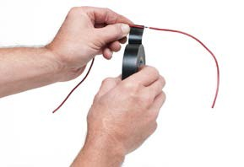

Figure 5—Wrap the solder joint by looping the tape securely.

- Continue to wrap the solder joint by angling the tape roll slightly. Keep tension on the tape roll so it wraps tightly. The tape should overlap itself by approximately half the width of the tape.
- When the solder joint is covered, finish the taping job by ending on the wire insulation on the other side, wrapping it completely around once. It should end approximately 1 tape width away from the soldered joint. Remember to hold tension on the tape roll.
Note: On this final loop of taping the tape roll should be straight, so there is no half width overlapping.

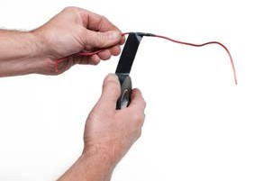

Figure 6—Finish by ending on the wire insulation on the other side.

- Cut the tape with scissors or a utility knife. Smooth over the cut end onto the wire.

Activity 6: Heat Shrink

After having the solder joint inspected and marked complete the following.

  - Cut the wire approximately 3" away from the solder joint.
  - Cut a small piece of heat shrink tube to just cover and extend past the soldered joint. Assuming that the solder joint is about an inch long, the heat shrink tube should be approximately 1.5" long.
  - Centre the heat shrink tube over the solder joint.
  - Evenly apply heat from a heat gun over the tube until it shrinks and fits tightly over the wire.
Caution: Heat guns and the hot air they produce can be extremely hot and burn.

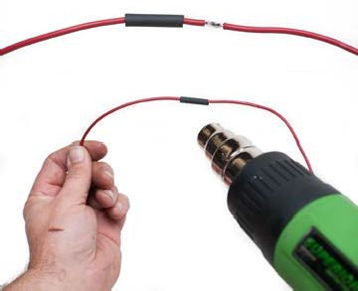

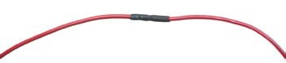
Figure 7—Applying heat shrink to a soldered joint

Safety Considerations

Description
This Activity Plan is designed as one among many through which students will rotate in small groups. Safety is extremely important and it is suggested that this be the first Activity Plan covered. Each automotive mechanic’s work environment is unique and comes with its own inherent safety risks.

Lesson Outcomes
The student will be able to:
- Safely use tools that are required to perform the associated automotive Activity Plans
- Distinguish between safety-related terms and requirements
- Know when different types of safety equipment are required for various automotive procedures

Assumptions
The students will have received:
- A basic understanding of general or generic technology education shop safety
- Some shop safety theory from the teacher prior to practically working in an automotive shop atmosphere

Terminology
Earmuffs: a type of hearing protection that is placed over the head and around the ears to dampen loud noises.
Face shield: a type of facial helmet that protects an operator’s full facial area.

Earplugs: a set of plugs, one of which is pushed into each ear to dampen loud noises.

Rubber gloves: a type of hand protection that is worn to protect the hands from harmful chemicals.
Particle mask: a mask that is worn around the mouth and nose area to protect the lungs.

PSI: an abbreviation for pounds per square inch.

Safety glasses: a special type of glasses worn to protect the eyes.

Estimated Time
60 minutes

This work is licensed under a Creative Commons Attribution-NonCommercial-ShareAlike 4.0 International License unless otherwise indicated.
153

Recommended Number of Students
20, based on the BC Technology Educators’ Best Practice Guide

Facilities
Automotive shop or a technology education shop that will accommodate a vehicle

Tools
Pen or pencil

Materials
- Students will need a vehicle in order to do this safety Activity Plan. The following Activity Plan is a type of lab that the students will do to strengthen their familiarity with the various specific hazards that the automotive mechanic can and will encounter. In addition students should have access to a computer where they can research the answers to the safety lab.
- Shop Safety (Handout)

- Safety Considerations in the Automotive Shop (Quiz)

- Safety Test

Activity

Have students complete the worksheet that follows the images on the next three pages. Encourage students to wander around the shop to help find their answers. The images supplied in this Activity Plan are designed to accompany discussion about the worksheet once it has been completed.

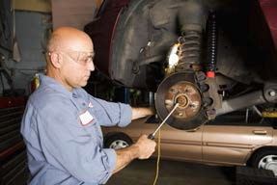

Figure 1—Wearing eye protection for a brake job

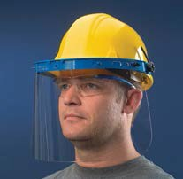
Figure 2—Protective face shield Figure 3—Hearing protection

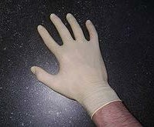
Figure 4—An automotive protective rubber glove Figure 5—Putting on a dust mask

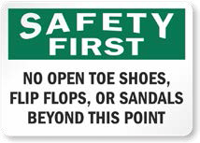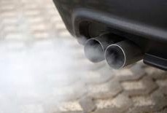
Figure 6—Open-toed shoes are unsafe! Figure 7—Vehicle exhaust

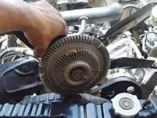
Figure 8—Radiator fans pose a serious hazard Figure 9—Thermal analysis of exhaust system and
manifold. Hot exhaust can seriously burn you.

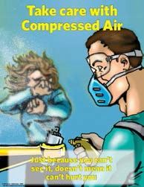

Figure 10—Never blow compressed air at someone else!

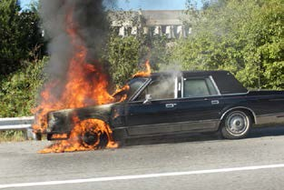
Figure 11—Car engulfed in flames

Evaluation Guidelines
- The students can attain at least 90% on this lab.
- The students can attain at least 90% on the additional attached safety quiz.

Shop Safety

Note
In order to be allowed in the shop area you must pass the safety test at a 90% competency rate (three incorrect answers or 27/30). Any failures must be rewritten outside of class time.

Contact Lenses
Be aware of other students even if you do not wear contacts.
- If dirt or acid gets in the eye, the contact must come out to clean the eye. Ask the student if they are wearing contacts or tell the student if you are wearing them.
- When arc welding, the flash or spark is bright enough to fuse or weld the contact to the eyeball. Always wear the proper dark eye protection when arc welding and warn other people around you that you are welding. (It is a natural instinct to turn toward a bright light and someone who wears contacts might do it unknowingly.)

Batteries
- Car batteries contain sulphuric acid and are therefore highly corrosive and explosive. The acid will eat through car paint, clothes and skin. Wash with water immediately. When carrying batteries, use the proper battery carrying strap to protect your clothing.
- No smoking, open flame or sparks should be around batteries.
- When working on batteries use the special lead pliers to eliminate the chance of spark (lead does not conduct electricity).
- A bad battery can give off a distinctive rotten egg smell. Never attempt to jump start a battery in this condition. It is likely to explode.

Compressed (Shop) Air
Absolutely no horseplay with compressed air. It is extremely dangerous. Pressure is between 140–160 psi.
- There is enough pressure to force air through the skin and into the bloodstream, and as doctors and intravenous drug users know, air in the bloodstream can cause death.
- The shop air can also create a siphoning effect where if you are pointing the air nozzle at someone it can pick up dirt off the floor and shoot it at them.
- Never spin bearings on your fingers with compressed air. They can seize up and then twist your fingers off.
- The pressure is strong enough to do internal body damage when placed up rectal, nasal or ear passages.

Creepers
Do not leave creepers lying down on the floor. Someone could slip on them. Lean them up against the car or hang them back on the wall.

Floor Area
Keep the area clean and tidy. Pick up any loose nuts or bolts and wipe up any spills. These can cause tripping and slipping, especially when carrying heavy engine parts.

Greasy and Oily Rags
Put any paper towels or rags that are saturated with gas, oil or grease into the special red container. If they are thrown into the regular garbage, spontaneous combustion may occur.

Gasoline and Fuel Tanks
Gas can combust or ignite at 40° Celsius (a very low temperature). Therefore:
- All gas tank work must be done outside (WCB regulations).
- NO open or exposed trouble lights can be used when working on gas tanks or around gas. (Gas is very cold and will burst the light bulb, creating a fire hazard.) Special enclosed safety lights are okay.
- Absolutely no flames, sparks or smoking around gasoline.

Driving Instructions
Only one person should give directions to a student driving in or out of the shop. Never stand directly in front of or behind the car while you are giving directions. There are many recorded accidents in which people mixed up the clutch and gas and brake pedals or their feet slipped.

Brake Dust
Asbestos/cancer concern. Older cars’ brakes were made with asbestos, which is a cancer- causing agent. Try not to breathe any. NEVER blow brake dust with the compressed air. It sends all the dust throughout the entire shop, and then we breathe in the fine particles. Instead, clean
a brake part by washing it down with water.

Electricity
Common sense says that electricity and water do not mix. Be especially aware of this on days when it rains or snows, as puddles form when water drips off the car.
- If any cords are damaged or need repair, tell the teacher so they can be fixed.

Lighters
Plastic butane lighters (BIC style) have been known to explode when a welding spark hits them. If you smoke, DO NOT bring lighters into the shop.

Fires and Extinguishers
The fire triangle is made up of heat, fuel, and oxygen. If one of these are eliminated, then the fire goes out. All extinguishers work on this principle. There are three basic types of fires:
- Class A fire: burnable solids like paper, cardboard and wood. The silver water extinguisher works great for this type of fire (by cooling).

- Class B fire: flammable liquids like gas, oil, grease and paint. Oil/gas and water do not mix, so using a Class A extinguisher would spread the fire and make it bigger! The Class B type extinguisher uses chemical foam to smother the fire (removes the oxygen).
- Class C fire: electrical equipment fires. Try to turn off the source of electricity (red safety button in the shop). Water and other liquid extinguishers are a definite No! This type of fire requires carbon dioxide or carbon tetrachloride extinguishers.
Some extinguishers are combined: A, B and C, or B and C. To use an extinguisher, apply the PASS
method:
- Pull
- Aim
- Squeeze
- Sweep

Always turn in a used or partly used extinguisher.

Note: You have prior permission to use a extinguisher if you feel the need arises. BUT YOU MUST TELL THE TEACHER so that the extinguisher can be recharged. This is in all cases, even if you did not emptied the extinguisher or the gauge still reads OK. There is a slow leakage of pressure once the seal has been broken, making it useless after a few weeks.

Antifreeze
This is an environmental and safety concern. Use the following procedures with antifreeze:
- Place used antifreeze in special containers. Do not pour it down the drain or onto the grass.

- Do not leave antifreeze lying around in open containers. It is poisonous to cats and dogs (they like the sweet taste of it).

Radiators
Do not open radiator caps when hot. It is quite easy to get third degree burns from them. You should be able to keep your hand comfortably on the radiator for 10 seconds for it to be considered not hot. This is because a radiator works on the principle of pressurization for its cooling abilities.
When liquid is under pressure, it increases the liquid’s boiling point. So if the radiator contains water, which normally boils at 100° Celsius, under pressure it will stay a liquid even up to temperatures of 130–140° without boiling. But once you release the pressure by turning the radiator cap, the liquid water turns instantly to a superheated steam. The pressure also increases because it has turned into a gas (gases like to take up more space or volume than a liquid). So instead of
a normal radiator system having about 15 psi pressure, it could go as high as 100 psi. It becomes virtually impossible to close the radiator cap once it has been opened.

Wheel Lug Nuts
Make sure that the tapered side of the nut points in toward the car (goes toward the wheel).

All lug nuts must be checked by the teacher after the tire is replaced.

Exhaust Fumes
Look out for yourself and other people. There are over 100 different chemicals that come out of the tailpipe. In Canada, four come under federally regulated law:
- Pb or lead: Lead has been linked to many health hazards, but this threat has been totally eliminated by the advance of unleaded gasoline. However, leaded gas is still available in the USA.
- HC or hydrocarbons: This is raw, unburned gas that goes from the gas tank, through the engine and out the tailpipe without being burned. This often causes stinging and irritation to the eyes.
- CO or carbon monoxide: Probably the most deadly of all the gases. When it enters our bodies, it tries to rob oxygen out of our bloodstream to make carbon dioxide (the natural stuff we exhale). Thus, if exposed long enough, we become dizzy, unconscious and die.
- NOx or nitric oxide: A natural by-product of burning fuel that has been linked to general health hazards.
There are two other fumes that are cause for concern and will most likely be federally regulated in the upcoming years:
- SOx or sulphur oxide: Thought to be the cause of turning evergreen trees brown. As well, sulphur poses some general health hazards for humans.
- Mg or magnesium: This substitute for lead in unleaded gasoline is thought to be connected with several health risks, but little research into its effects has been done.
With the exception of HC, most of these gases are silent killers. You cannot:
- Taste them
- Feel them
- Smell them
- See them
- Hear them

Also, some of these exhaust fumes are heavier than air, so watch out if you are under another car in the next bay. Either have the bay doors open or hook up the exhaust hose and fan system.

Name:

Safety Considerations in the Automotive Shop
- List five items in the shop that could potentially pose a risk to your eyes.

- When would you need to wear a face shield—and not just safety glasses—in an automotive shop?

- List three places in the automotive shop where hearing protection would be required.

- What is one example of when you should wear protective rubber gloves in the automotive shop?

- What is one example of when lung or breathing protection should be worn?

- Why are open-toed shoes not allowed in the automotive shop?

- Give one example where long hair could pose a hazard in the automotive shop.

- Why is it a safety hazard to run a vehicle in an automotive shop?

- Describe one major safety hazard that can be found under the hood of a vehicle.

- List two separate areas in a vehicle where you could get burned.

Safety Test

TOTAL /30

Name Date
  - List two hazards connected with contact lenses.

  - List one hazard with batteries.

  - Shop privileges will be suspended if you are caught horseplaying with the compressed air.
    - True
    - False
  - Which choice best describes a Class A fire?
    - Burnable solids like paper and wood
    - Electrical devices like electric motors
    - Burnable metals like magnesium and potassium
    - Burnable liquids like gasoline and oil
  - Which choice best describes a Class B fire?
    - Burnable solids like paper and wood
    - Electrical devices like electric motors
    - Burnable metals like magnesium and potassium
    - Burnable liquids like gasoline and oil
  - Which choice best describes a Class C fire?
    - Burnable solids like paper and wood
    - Electrical devices like electric motors
    - Burnable metals like magnesium and potassium
    - Burnable liquids like gasoline and oil
  - What should you never do with brake dust?

  - What are the two dangerous gases that are emitted from the exhaust pipe? (Abbreviations are accepted.)

  - When, where, why and how are exhaust gases dangerous?

  - What should you do after you use a fire extinguisher?

  - It is OK to throw antifreeze down the sewer drain.
    - True
    - False

  - What two things make a hot radiator dangerous?

  - When discussing the use of fire extinguishers, what does the acronym PASS stand for? P
A

S

S

  - When giving driving instructions, where should you stand?
    - In front of the car
    - At the back of the car
    - In the passenger seat
    - To the side of the car
  - List two safety rules when working with fuel tanks.

  - On wheel lug nuts, which way does the taper side of the nut go toward?

  - Butane lighters and welding do not mix.
    - True
    - False
  - On wheel lug nuts, what must be done after you have tightened them?

  - Where should greasy and oily rags go?

  - Why should the floor be kept clean and spill-free?

Micrometers

Description
This Activity Plan is designed as one among many through which students will rotate within the Automotive Service Technician component of Skills Exploration 10–12.
A micrometer is a detailed measuring instrument capable of making very exact measurements even to 1/1000 of an inch. Automotive technicians use micrometers in order to ensure that the work they do is extremely accurate.
Note: Micrometers are expensive, sensitive measuring instruments. Not all schools can afford to purchase them. This activity should be considered a secondary supplementary activity to be introduced only if tools and facilities exist.

Lesson Outcomes
The student will be able to measure a variety of objects and obtain precise measurements to within very exact specifications.

Assumptions
Prior to doing the activity themselves, students will have been given some theory, and the instructor will have demonstrated the proper procedure of using a micrometer.

Terminology
Anvil: the shiny part of the micrometer that the spindle moves toward and that the sample is set against.
Frame: the main supporting structure of the micrometer.

Index line: the horizontal line on the sleeve that is used as an indicator line for which mark to read on the thimble.
Micrometer: a detailed measuring instrument used to measure very fine, exact measurements.

Spindle: the shiny cylindrical part of the micrometer that the thimble moves toward the anvil.

Ratchet screw: found on the end of the thimble, used for “final tightening” on an object to get a consistent measurement from person to person.
Thimble: the part of the micrometer that is usually turned with the thumb. The thimble has graduated markings.

Estimated Time
45–60 minutes

This work is licensed under a Creative Commons Attribution-NonCommercial-ShareAlike 4.0 International License unless otherwise indicated.
167

Micrometers Automotive Service Technician

Recommended Number of Students
20, based on the BC Technology Educators’ Best Practice Guide, 1–3 students per micrometer. If not enough micrometers are available, students could work in small groups with each group member measuring a different object.

Facilities
Automotive shop

Tools
Micrometers (as many as possible)

Materials
A variety of solid objects of various thicknesses. Ideally the objects should be some sort of metal material.
Note: Before proceeding through the activity, the instructor should be thoroughly familiar with the included Resources section of the Activity Plan, in particular the Micrometer Simulator website.

Resources

Micrometer Caliper—Merriam-Webster Visual Dictionary Online
http://visual.merriam-webster.com/science/measuring-devices/measure-thickness/micrometer-caliper_2.php

How to Use a Micrometer
www.youtube.com/watch?v=oHqaLMEHlnE

Micrometer Simulator
www.stefanelli.eng.br/en/aka-micrometer-caliper-outside-inch-thousandths.html

Worksheets
- Micrometer Measurement Exercise
- Reading a Micrometer
- Measurement Quiz
- Micrometer Test

Evaluation Guidelines
Included is a worksheet that students can be given to record their micrometer measurements.

168 Youth Explore Trades Skills

Activity: Using a Micrometer

- Find 10–12 metal objects around the automotive shop and set them up in an organized, distributed manner.
- Have each student measure the thickness of each object and record it on the worksheet provided.
- Begin by holding the frame with one hand and slowly turning in the thimble with the other until the anvil and spindle almost touch the object.
- Slowly turn the ratchet screw until it tightens around the object and begins to ratchet (makes a clicking sound).
- Lock the thimble in place and read the micrometer setting. Note: Refer to “How to Read a Micrometer” on page 5.
- Record your findings on the Micrometer Measurement Exercise worksheet on the next page.
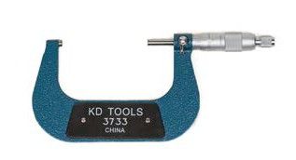Thimble

Sleeve
Ratchet screw

Lock nut Spindle Anvil
Frame

Figure 1—Micrometer parts

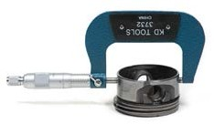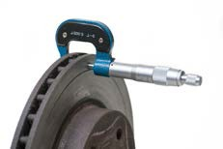
Figure 2—Measuring a piston Figure 3—Measuring a brake rotor

Micrometer Measurement Exercise

Name
Date

Thickness of Object 1 ( ) Thickness of Object 2 ( ) Thickness of Object 3 ( ) Thickness of Object 4 ( ) Thickness of Object 5 ( ) Thickness of Object 6 ( ) Thickness of Object 7 ( ) Thickness of Object 8 ( ) Thickness of Object 9 ( ) Thickness of Object 10 ( )

How to Read a Micrometer

Reading a micrometer takes practice.

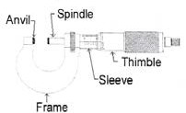
Spindle
Anvil
Thimble
Sleeve
Frame

To learn to read the mike you need to understand the thimble and the sleeve.

Here we are going to learn to read the micrometer by figuring out the markings on the thimble and the sleeve.

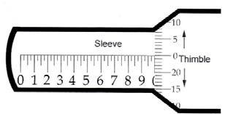10

Index Line Sleeve
5
0 Thimble
20

15
10

The sleeve does not move. It looks like a ruler with 10 numbers. The space between each number is divided into quarters. As the thimble rotates around this sleeve it covers up or reveals the numbers marked on the sleeve.
The thimble has numbers and markings on it from 0 to 24. One complete revolution of the thimble (from 0 all the way around to 0 again) moves the micrometer exactly 0.025 inches. Thus each revolution of the thimble moves it to the next “quarter” line on the sleeve.

Micrometers Automotive Service Technician

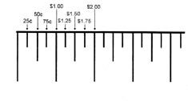It is easy to read a micrometer if you think of t markings on the sleeve as dollars and quarter and the thimble as “pennies”.
he
s

Sleeve

1 2 3 4 5

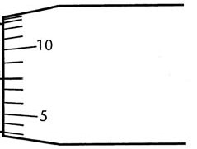Now it gets a little easier to read the mike.

0.014
0.013
0.012
0.011
0.010
0.009

0.008
0.007
0.006
0.005
0.004
0.003

To read the micrometer, simply add up the “dollars”, “quarters” and “pennies” in the correct order. See example below.
The reading is composed of:
4 Large graduations or 4 × 0.100 = 0.400
2 Small graduations or 2 × 0.025 = 0.050 8 Graduations on the thimble or 8 × 0.001 = 0.008
= 0.458"

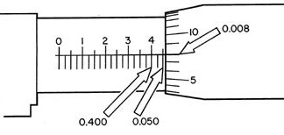
10
0.008
0 1 2 3 4
5
0.400
0.050

172 Youth Explore Trades Skills

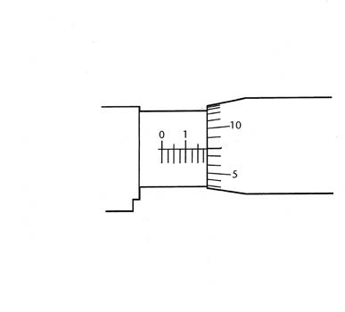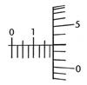Name:

Reading the Micrometer

- Write down the last visible number before the thimble edge on #1.

5

0

- Count the number of small lines between the number identified in #1 and the thimble edge. Multiply the number of lines by .025. Write the answer down on #2.

Index line

Sleeve

Thimble

- Find the closest number to the index line on the thimble.
Note: The number must be below the Index Line. Each line is worth
  - Write the number down in #3.

#1
+
#2
+
#3 Total

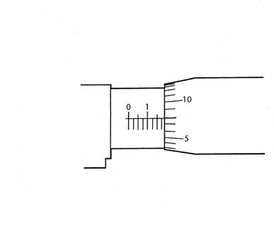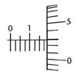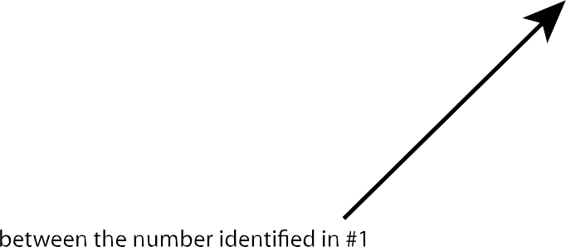Reading the Micrometer Answer Key
    - Write down the last visible number before the thimble edge on #1.

5

0

    - Count the number of small lines

and the thimble edge. Multiply the number of lines by .025. Write the answer down on #2.

Index line

Sleeve

Thimble

    - Find the closest number to the index line on the thimble.
Note: The number must be below the Index Line. Each line is worth
0.001. Write the number down in #3.

#1 0.100

+
#2 0.075

+
#3 0.003

Total
0.178

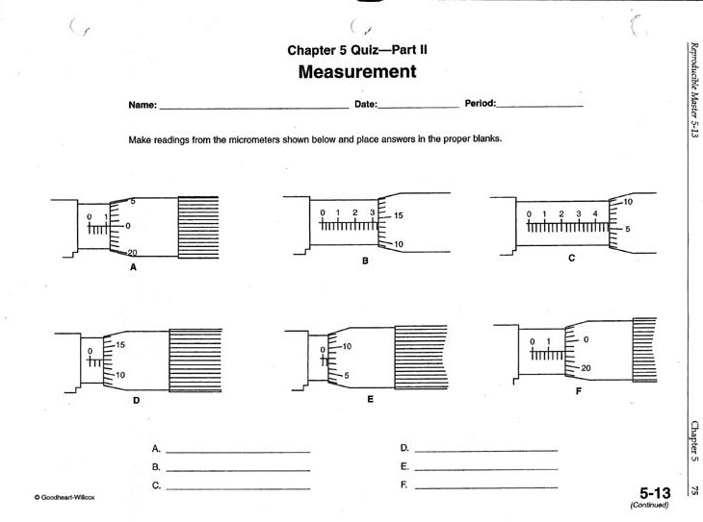
Measurement Quiz

1. 2. 3.

4. 5. 6.
1. 4.
2. 5.
3. 6.

Measurement Quiz Answer Key

1. 2. 3.

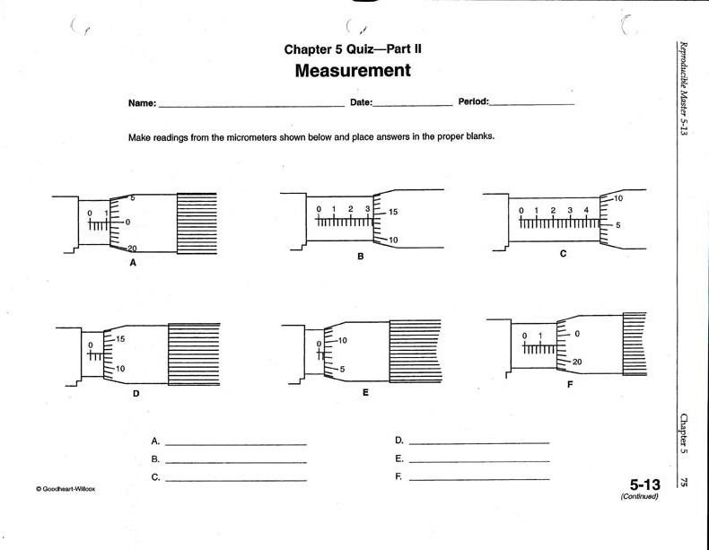4.
1. 0.125
2. 0.339
3. 0.481
5. 6.
4. 0.063
5. 0.033
6. 0.198

Micrometer Test

1 2 3
15 5

0 1 2
15
10 ANS
2 3 4 6
10 ANS
5
0 0

ANS
10

4 5 6

7 8 9

10 ANS
5

2 3 4
10
5 ANS
0

4 5 6

5 ANS
0

7 8 9
0

1 2 3
5
0 ANS
20

3 4 5
20 ANS
15

2 3 4
0
20 ANS
15

10 11 12

0 1 2 0
20
15

ANS
6 7 8 15
10

ANS

3 4
5 ANS
0

13 14 15

4 5 5
0 ANS
20

0 10

5

ANS
8 9 0
20

ANS

16 17 18
5

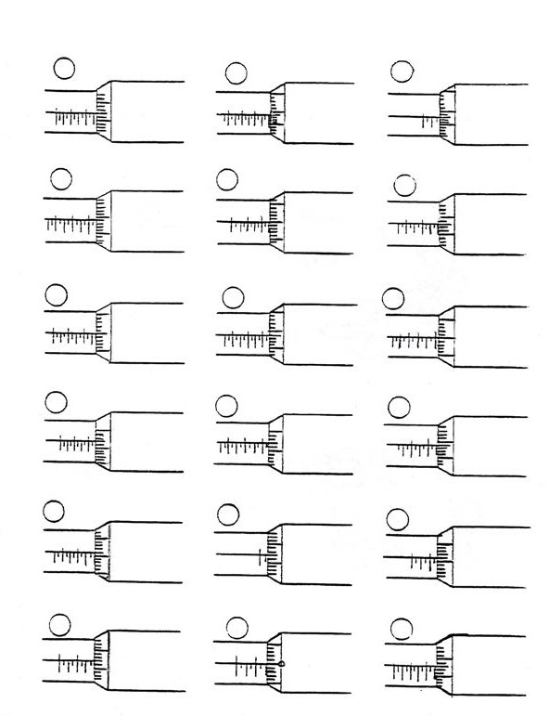1 2 20

15

ANS
6 7 7 8 9
0 ANS
20
10

ANS
5

Micrometer Test Answer Key

1 2 3
15 5

0 1 2
15 .262
10

ANS
2 3 4 6
10
5

.609

ANS
0 .098 ANS
10
0

4 5 6

7 8 9
10 .934 ANS
5

2 3 4
10
5 .455 ANS
0

4 5 6 5
0

.603

ANS

7 8 9
0

1 2 3
5
0 .375
20

ANS

3 4 5

20 .544
15

ANS

2 3 4
0
20 .420
15

ANS

10 11 12

0 1 2
0

.248

6 7 8
15 3 4

20 ANS
15

.837
10
ANS
5 .454
0
ANS

13 14 15

4 5 5

0 10
8 9 0

.601 .032 .946

0 ANS
20
ANS
5
20 ANS

16 17 18
5

1 2 20
6 7 7 8 9 10

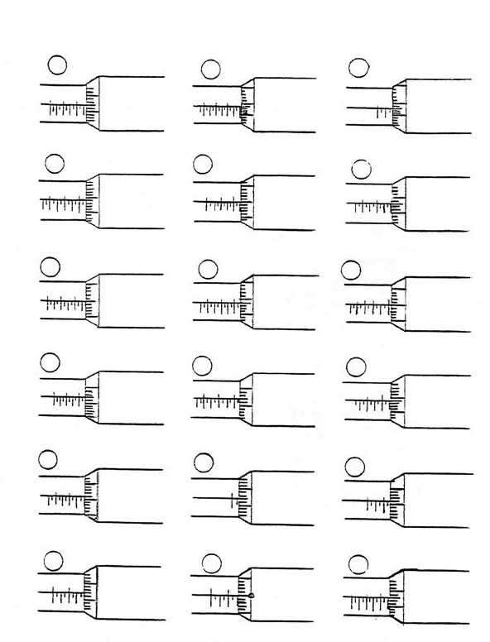.292
15
ANS
0 .750
20
ANS
.958 ANS
5

Becoming an Automotive Service Technician

Description
Becoming an automotive service technician requires physical and mental perseverance, ambition, a willingness to work in adverse conditions and a willingness to take the necessary steps to eventually reach the level of a certified tradesman. For this Activity Plan it is suggested that the students work on a small library research assignment.
This assignment should not take more than two classes; the goal is for students to have some idea of the wide variety of options and working conditions that an automotive service technician may face.

Lesson Outcomes
The student will be able to:
- Recognize that becoming an automotive service technician takes years of hard work and effort
- Have a good idea of the working conditions of an automotive service technician
- Understand what is required, and the order of events necessary to become an automotive service technician

Assumptions
The students will have been informed in advance that this Activity Plan material involves completing a small research assignment.

Terminology
Apprenticeship: the term used to describe the graduated step-like progress in becoming an automotive service technician.
Automotive parts store: an automotive business that primarily concentrates on selling various parts from a wide variety of manufacturers.
Automotive specialty shop: a repair facility that specializes mainly in one type of repair, such as a muffler and exhaust shop, oil change shop or tire shop.
Car dealership: a business that sells vehicles, repairs vehicles and sells parts for specific brands of vehicles.
Flat rate: today’s mechanics are primarily paid on a flat rate system. This means they are paid for the quantity of work that they can produce, not based on an hourly wage.

This work is licensed under a Creative Commons Attribution-NonCommercial-ShareAlike 4.0 International License unless otherwise indicated. 179

Fleet maintenance: a contract to a repair facility that maintains and repairs a fleet of vehicles owned by another business (e.g., a taxi fleet or trucking fleet).
Independent garage: a business that primarily repairs vehicles of various different manufacturers.
Quick lube centre: an automotive business that sells regularly scheduled maintenance requirements (e.g., “McQuick” lube centres).
Red Seal Interprovincial Trades Ticket: the qualification designated to allow a person to work as a journeyman automotive service technician in any province in Canada.
Repair facility: a vehicle dealer, independent garage or service station.

Service station: a business that primarily repairs vehicles of various different manufacturers but also sells gas. It is owned by the oil or gas company.
Vehicle dealer: a business that sells vehicles, repairs vehicles and sells parts for specific brands of vehicles.

Estimated Time
1–2 hours

Recommended Number of Students
20, based on the BC Technology Educators’ Best Practice Guide

Facilities
Computer lab or library lab

Resources

Automotive Mechanic—Working in Canada
https://www.youtube.com/watch?v=kHORanjPxQc

Red Seal Program
www.red-seal.ca

WorkBC
www.workbc.ca

Trade National Occupational Analysis (NOA)—Automotive Service Technician
http://www.red-seal.ca/trades/autoservtech/2011n.4.1_.4v.2rv.3.2w-eng.html

By the Numbers: 2013 WSIB Statistical Report (Workplace Safety & Insurance Board)
www.wsibstatistics.ca/WSIB-StatisticalReport_S1.pdf

Trades and Apprenticeship—Employment and Social Development Canada (ESDC)
http://www.esdc.gc.ca/eng/jobs/trades/index.shtml

Careersintrades.ca
www.careersintrades.ca

Additional Resources
- Bring in a guest speaker from the automotive trades.
- Organize a field trip: Bringing the class into an industry setting such as a busy dealership or independent garage would be a great optional activity.

Activity

The teacher will give a brief explanation of the computer lab activity. The worksheet provided is designed to take approximately 1–2 hours. There are several websites listed on the sheet that students are directed to for answers. Some reflective questions are also asked. These answers are not found on any particular website. They are designed to get students thinking a little deeper about working as an AST and what they have learned in this assignment.

Preparing to Become an Automotive Service Technician
- What type of shop courses would you take in high school if you were interested in becoming an automotive service technician?

- What type of academic courses would you take in high school if you were interested in becoming an automotive service technician?

- Do you need your grade 12 graduation in order to become an automotive service technician?

- List three different activities or hobbies at home that would help you become an automotive service technician.

- What type of people would you talk to or question if you were interested in becoming an automotive service technician?

- List three different part-time jobs that would assist you in becoming an automotive service technician.

- List three different full-time jobs that would assist you in becoming an automotive service technician, other than full-time automotive mechanic positions.

- What qualities, skills or talents would a prospective employer want to recognize in you if they were to consider giving you an apprenticeship to become an automotive service technician?

Automotive Service Technician Apprenticeship Training

Answers to questions 1 and 2 can be found at
www.careersintrades.ca/index.php?page=what-is-an-apprenticeship&hl=en_CA

- What is an apprenticeship?

- Are you interested in a career as an AST? Explain your answer.

Answers to questions 3–5 can be found at
https://skilledtradesbc.ca/automotive-service-technician and click on Program Profile
- How many years of apprenticeship does it take to become an automotive service technician?

- How many weeks of technical training do I need to do during my apprenticeship to become an automotive service technician?

- How many hours of on-the-job training do I need to do during my apprenticeship to become an automotive service technician?

Answers to question 6 can be found at
www.tradestrainingbc.ca/

- Where in British Columbia can I complete the technical training portion of the apprenticeship training? (List four separate locations.)

National Occupational Analysis (NOA) and Red Seal Certification

Answers to questions 1–4 can be found at
www.red-seal.ca, including the information specifically for students.

    - What are the five objectives of the National Occupational Analysis (NOA)?

    - List three out of the eight categories of information that the NOA outlines as vital for every tradesperson.

    - What is the NOA’s code number (NOC) for the automotive service technician?

    - Name five benefits of having a Red Seal Certification.

    - In your own words, what advantage would there be to your having a Red Seal Trade Certification?

Answers to questions 6 and 7 can be found at
http://www.red-seal.ca/trades/autoservtech/2011n.4.1_.4v.2rv.3.2w-eng.html and click on Appendix A: Tools and Equipment.
Question 7 is Appendix B.

    - Scroll through the standard tool kit in Appendix A: Tools and Equipment. On the basis of this list, what important commitment would you need to make if you decide to become an AST?

    - Scroll through Appendix B: Glossary. How many of these terms do you already know? This is a small number of the acronyms an AST comes in contact with. Find out what the following additional acronyms stand for:
CVT: ABS: SAE: HC: VIN: TSB:

Automotive Service Technician

Answers to questions 1–10 can be found at
www.workbc.ca (including the video)

(Hint 1: Type in the correct NOC code in the Career Profiles box partway down the page.) (Hint 2: Click on the plus sign once you are into the profile to expand the information boxes.)
- What are the responsibilities of an automotive service technician?

- As an AST, other than inside an automotive garage, what environments could you possibly end up working in?

- List several ways you think that cold could have a negative effect on an AST, if he or she is not working inside a heated automotive garage.

- Besides working on vehicles and having knowledge about them, what are three personality traits that are important to be successful as an AST?

- List four different areas where an AST might work.

- What kind of salary does an AST make?

- Discuss in a sentence or two what you think the AST work environment might be like.

- Describe each of these required skills for an AST.
  - Manual dexterity

  - Spatial perception

  - Detail-oriented

  - Object-oriented

  - Motor coordination

Answers to question 9 can be found at
www.careersintrades.ca/index.php?page=transportation&hl=en_CA

- List five other careers related to AST.

- Choose any two of the five careers you listed in question 9 and compare/contrast them with an AST. Include skills, environment and wages in your answer.

Questions on WorkSafeBC Statistics
- Read page 12 of the WCB report. What is the number one injury?

- How many people can this affect?

- According to the chart on page 14, what is the next most vulnerable body part prone to injury?

- List three different activities where you think an AST might get injured.

- Do you think that working as an AST is a safe job? Give a reason for your answer.

Examine the injury statistics for motor vehicle mechanics in the WorkSafeBC document, “Claim Counts by the 1991 Standard Occupation Classification (SOC), Accident Type and Year, Injury Years 2003–2012.”
The list for motor vehicle mechanics starts toward the bottom of page 14 and continues to page 17.

- Compare the total number of claims between 2003 and 2012.

Motor Vehicle Mechanic

 | 2004 | 2012
Total number of accidents

- In 2012, how many motor vehicle mechanics overexerted themselves while lifting objects?

- In 2012, how many motor vehicle mechanics suffered accidents from being struck by an object?

- In 2012, how many motor vehicle mechanics injured themselves while bending, climbing, crawling, reaching or twisting their bodies?

- What basic lesson can you take away from examining these statistics?

Answer Key

Preparing to Become an Automotive Service Technician
- What type of shop courses would you take in high school if you were interested in becoming an automotive service technician?
  - Any shop course would be of benefit (working with your hands and tools) However the following courses would be particularly beneficial:
    - Power Mechanics 9, 10,
    - Automotive 11, 12
– Metalwork 9, 10, 11, 12
– Drafting 9, 10, 11, 12
- What type of academic courses would you take in high school if you were interested in becoming an automotive service technician?
• Math 11, 12
  - Chemistry 11, 12
  - Physics 11, 12
  - English 11, 12

- Do you need your grade 12 graduation in order to become an automotive service technician?
  - Grade 12 is recommended

- List three different activities or hobbies at home that would help you become an automotive service technician.
  - Answers may vary. Possible answers include:
- Working on the family car or boat engine
- Working on lawnmowers or edge trimmers (weed wackers)
- Fixing anything that needs fixing (toaster, RC car, etc.)

- What type of people would you talk to or question if you were interested in becoming an automotive service technician?
  - Parents, shop teacher, school counselor, school career counsellor, mechanic at a local garage

- List three different part-time jobs that would assist you in becoming an automotive service technician.
  - Answers may vary. Possible answers include:
- Pumping gas
- Car wash
- Lawnmower repair shop

- List three different full-time jobs that would assist you in becoming an automotive service technician, other than full-time automotive mechanic positions.
  - Answers may vary. Possible answers include:
- Mr. Lube/Jiffy Lube
- Car sales lot
- Auto body shop

- What qualities, skills or talents would a prospective employer want to recognize in you if they were to consider giving you an apprenticeship to become an automotive service technician?
  - Answers may vary. Possible answers include:
    - Good communicator—verbal and written
    - Good with tools
    - Some kind of related experience/interest
    - Punctuality and commitment

Automotive Service Technician Apprenticeship Training

Answers to questions 1 and 2 can be found at
www.careersintrades.ca/index.php?page=what-is-an-apprenticeship&hl=en_CA

- What is an apprenticeship?
Apprenticeship is a form of post-secondary training that teaches the skills and competencies necessary to perform tasks to an industry standard. Apprenticeship training provides the opportunity for hands-on learning under the direction of a certified journeyperson, with
the ability to earn while you learn. The training combines alternating periods of on-the-job (80 to 85%) and technical training (15 to 20%). Technical training can occur at a college,
a union training centre, a private trainer or online. Once the apprentice has completed the required hours and/or modules for the trade, the apprentice can write a certification exam. Apprenticeship is regulated by the provinces and territories, with 13 unique systems geared to the labour market needs and conditions in each region of Canada.
- Are you interested in a career as an AST? Explain your answer.
  - Answers will vary.

- How many years of apprenticeship does it take to become an automotive service technician?
- Four years

- How many weeks of technical training do I need to do during my apprenticeship to become an automotive service technician?
- Level 1: 210 hours (7 weeks)
- Level 2: 180 hours (6 weeks)
- Level 3: 210 hours (7 weeks)
- Level 4: 180 hours (6 weeks)
- Total: 780 hours (26 weeks)

- How many hours of on-the-job training do I need to do during my apprenticeship to become an automotive service technician?
- Level 1: 1500 hours
- Level 2: 3000 hours
- Level 3: 4500 hours
- Level 4: 6000 hours
- Total: 15,000 hours

Answers to question 6 can be found at
www.tradestrainingbc.ca/

- Where in British Columbia can I complete the technical training portion of the apprenticeship training? (List four separate locations.)
- Lower Mainland:
  - Vancouver Community College
  - BCIT (Burnaby campus)
  - UFV
  - Kwantlen Polytechnic
- Vancouver Island:
  - Camosun College (Interurban Campus)
  - Vancouver Island University (Nanaimo)
- Southern Interior:
  - Okanagan College (Kelowna)
  - College of the Rockies (Level 4 only)
  - Thompson Rivers University (Level 4 only)

- Northern Interior:
  - Northern Lights College
  - College of New Caledonia
  - Northwest Community College

National Occupational Analysis (NOA) and Red Seal Certification Questions

Answers to questions 1–4 can be found at
www.red-seal.ca, including the information specifically for students.

- What are the five objectives of the National Occupational Analysis (NOA)?
  - To identify and group the tasks performed by skilled workers in particular occupations
  - To identify those tasks that are performed by skilled workers in every province and territory
  - To develop instruments for use in the preparation of interprovincial standards, Red Seal examinations and curricula for training leading to the certification of skilled workers
  - To facilitate the mobility, in Canada, of apprentices and skilled workers
  - To supply employers and employees, and their associations, industries, training institutions and governments with analyses of the tasks performed in particular occupations
- List three out of the eight categories of information that the NOA outlines as vital for every tradesperson.
- Trade activities (tasks and sub-tasks)
- Skills and knowledge requirements
- Essential skills
- Safety information
- Trends affecting the trade
- Technical terms
- Names of tools and equipment
- Acronyms
- What is the NOA’s code number (NOC) for the automotive service technician?
• NOC: 7321

- Name five benefits of having a Red Seal Certification.
  - The Red Seal is the national standard of excellence for skilled trades in Canada.
  - The Red Seal is a leading endorsement for skilled workers in Canada and provides a tradesperson with a competitive hiring advantage.
  - A Red Seal endorsement is a nationally recognized standard that helps tradespeople obtain good, well-paying jobs across Canada.

  - In many cases, achieving a certificate of qualification in a Red Seal trade is equal in value to the completion of college certification in terms of trade knowledge and skill.
  - Red Seal–endorsed tradespeople obtain easily transferable skills, ideal for new workers interested in career development and industry mobility.
- In your own words, what advantage would there be to your having a Red Seal Trade Certification?
- Answers will vary.

- Scroll through the standard tool kit in Appendix A: Tools and Equipment. On the basis of this list, what important commitment would you need to make if you decide to become an AST?
- You need a lot of tools that cost a lot of money.
Note: When discussing this question with the class you should clarify the following: most tools in the standard kit would be bought by the AST. Most shop tools and equipment would be supplied by the repair facility. Not all tools required by the AST need to be bought right away. Tools bought by an AST currently are tax deductible.
- Scroll through Appendix B: Glossary. How many of these terms do you already know? This
is a small number of the acronyms an AST comes in contact with. Find out what the following additional acronyms stand for:
CVT continuously variable transmission ABS antilock braking system
SAE Society of Automotive Engineers HC Hydrocarbon
VIN vehicle identification number DVOM digital voltage ohmmeter TSB technical service bulletins

Automotive Service Technician
Questions from the WorkBC website Answers to questions 1–10 can be found at www.workbc.ca (including the video)
(Hint 1: Type in the correct NOC code in the Career Profiles box partway down the page.) (Hint 2: Click on the plus sign once you are into the profile to expand the information boxes.)
- What are the responsibilities of an automotive service technician?
  - ASTs inspect, diagnose and repair vehicles, including mechanical, electrical and electronic components.

- As an AST, other than inside an automotive garage, what environments could you possibly end up working in?
  - Outside in all weather conditions. On the street or side of road, on a boat, in the dirt or mud.
- List several ways you think that cold could have a negative effect on an AST, if he or she is not working inside a heated automotive garage.
  - Working outside on vehicles that a) will not start or b) will not fit into the garage because it is full of other cars
  - Working on a cold floor (bad for the back)
  - Working with cold metal tools or cold metal parts (bad for the hands)
  - Drafty and windy conditions
  - Dressing properly—cannot be too bulky, still need flexibility of hands and body
  - Melting snow and ice dripping onto you

- Besides working on vehicles and having knowledge about them, what are three personality traits that are important to be successful as an AST?
- Need to be able to troubleshoot and solve problems
- Must be able to work independently or as part of a team
- Need customer service and communication skills

- List four different areas where an AST might work.
  - Vehicle dealerships
  - Independent garages
  - Fleet maintenance companies
  - Service stations
  - Automotive specialty shops (e.g., muffler or tire shops)
  - Transportation companies

- What kind of salary does an AST make?
  - Provincial average salary $44,000–$53,000 (Source: Census, 2006)
  - Provincial average full-time hourly rate: $12.75/hr–$35.00/hr (Source: Working in Canada Wage Report)
  - Most ASTs are paid at a flat rate.

- Discuss in a sentence or two what you think the AST work environment might be like.
  - 35- to 40-hour work week; this may include evenings and/or weekends
  - Can be a drafty, noisy and dirty environment
  - Involves considerable bending, kneeling and lifting

- Describe each of these required skills for an AST.
- Manual dexterity
Can you move and turn objects skilfully with your hands?
  - The ability to skilfully use your hands. You can move and turn objects and use hand tools.
  - Use hands skilfully
  - Manipulate objects with your hands
  - Use hand tools
  - Move and turn objects
  - Sort objects

- Spatial perception
Can you draw things accurately?
  - The ability to perceive or react to the size, distance or depth of the environment
  - Recognize size, distance or depth
  - Can imagine a 3D form from a diagram
  - Awareness of surrounding environment
  - The ability to draw things accurately
  - Understand geometry

- Detail-oriented
Can you pick out differences in two similar pictures?
  - The ability to see fine details in objects
  - Eye for detail
  - Recognize small parts
  - See fine detail in objects
  - Visually perceptive
  - Inspect objects

- Object-oriented
Do you like to build and/or repair things?
  - You are interested in finding out how things operate and how they are built.
  - Interested in how things work
  - May work with tools, instruments and machinery
  - Like to build and repair according to specifications

- Motor coordination
Do you have good hand-eye coordination?
  - The coordination of large, small and fine motor movements using the body (arms, legs, hands, etc.)
  - Hand-eye coordination
  - Gross and fine motor movement
  - Can take things apart and put them back together

Answers to question 9 can be found at
www.careersintrades.ca/index.php?page=transportation&hl=en_CA

- List five other careers related to AST.
  - Agricultural Equipment Technician
  - Aircraft Maintenance Mechanic
  - Auto Body Repairer
  - Automotive Electrical Technician
  - Automotive Glass Technician
  - Automotive Painter
  - Heavy Duty Equipment Technician
  - Heavy Equipment Operator
  - Inboard/Outboard Mechanic
  - Motor Vehicle Body Repairer (Metal and Paint)
  - Motorcycle Mechanic
  - Parts person
  - Recreational Vehicle Service Technician
  - Small Engine and Equipment Mechanic
  - Transport Refrigeration Mechanic
  - Transport Trailer Technician
  - Truck and Transport Mechanic

- Choose any two of the five careers you listed in question 9 and compare/contrast them with an AST. Include skills, environment and wages in your answer.
  - Answers will vary.

Questions on WorkSafeBC Statistics
- Read page 12 of the WCB report. What is the number one injury?
  - Back strain injury

- How many people can this affect?
  - 1 in 5

- According to the chart on page 14, what is the next most vulnerable body part prone to injury?
- Fingers

- List three different activities where you think an AST might get injured. Answers may vary, but could include:
- Working with harsh chemicals such as solvents
- Burns from hot engine parts or exhaust
- Crushed, broken, pinched or bruised hands/fingers/legs/toes from heavy engine parts
- Broken or skinned knuckles and fingers from slipping tools
- Hitting your hand with a hammer instead of the tool
- Getting electrical burns from wearing jewellery and touching live wires
- Getting chemical burns from battery acid
- Getting arthritis in the fingers or wrist from overuse
- Being crushed by a car falling off a jack, jackstands or hoist
- Other answers as deemed acceptable

- Do you think that working as an AST is a safe job? Give a reason for your answer.
- Answers will vary.

Examine the injury statistics for motor vehicle mechanics in the WorkSafeBC document, “Claim Counts by the 1991 Standard Occupation Classification (SOC), Accident Type and Year, Injury Years 2003–2012.”
The list for motor vehicle mechanics starts toward the bottom of page 14 and continues to page 17.
- Compare the total number of claims between 2003 and 2012.

Motor Vehicle Mechanic

 | 2004 | 2012
Total number of accidents | 67 | 78

- In 2012, how many motor vehicle mechanics overexerted themselves while lifting objects?
• 88

- In 2012, how many motor vehicle mechanics suffered accidents from being struck by an object?
• 53

- In 2012, how many motor vehicle mechanics injured themselves while bending, climbing, crawling, reaching or twisting their bodies?
• 34

- What basic lesson can you take away from examining these statistics?
  - Answers may vary. Accidents can happen at any time. Always think of safety first.

Overview for the Automotive Component of Youth Explore Trades Skills

Overview
The Automotive component of Youth Explore Trades Skills will introduce students with little or no previous background in mechanics or automotive maintenance and repair . The intent of
this material is to challenge students as individuals and as a team . It will also allow students to experience several different aspects of the automotive field and jobs related to the automotive trade .
Some of the subjects covered in this course are as follows:
- Safe work practices, including maintenance and use of shop equipment
- Engine theory
- Preventive maintenance
- Inspections and minor diagnostics
- Record-keeping
- Ethics and work quality standards

To successfully achieve these goals a student will be required to:
- Successfully pass all required safety tests and procedures
- Maintain a portfolio of their tasks and experiences
- Display acceptable behaviour within a cooperative work environment (with an emphasis on teamwork)
Students will be proficient in these areas on completion of this course.
- Oil change and lubrication procedures
- Preventive maintenance checks and procedures
- Tire change and balance
- Boosting and starting of a disabled vehicle
- Work order and record-keeping processes
- Research and understanding of shop manual data, both printed and online
- Simple diagnostic procedures
- Parts identification
•

What Is Included in a Complete Brake Job

A complete brake job should restore the vehicle’s braking system and braking performance to “good as new” condition. Anything less would be an incomplete brake job.
- Brake components that should be replaced will obviously depend on the age, mileage and wear on the vehicle . There is no one answer as to which items need to be replaced and which ones don’t. It is a judgment call made from knowledge and experience of a professional .
- A complete brake job should begin with a thorough inspection of the entire brake system: the lining condition, rotors and drums, calipers and wheel cylinders, brake hardware and springs, flexible hoses and steel lines, and master cylinder.
- Any hoses that are found to be age cracked, swollen, leaking or damaged in any way must be replaced. Any replacement hoses must have the proper fittings of the same type as the original, with double flare or ISO fitting. Do not mix different types of fittings.
- Steel lines that are rusty, kinked, leaking or damaged must also be replaced . Only approved steel line is to be used as replacement with the proper double flare or ISO fittings.
- Any caliper or wheel cylinder that is leaking must be replaced . The same applies to a seized or poorly operating caliper or cylinder . It is best practice to replace either type as a pair .
- Master cylinder leaks will usually show externally but can also be identified by a brake pedal that slowly sinks to the floor under constant pressure.
- Brake rotors must be inspected for heat cracks, warpage or uneven wear . If the rotors are in a usable condition, they can be turned (machined) and reused if they meet tolerance specifications detailed by the manufacturer.
- Rust, heat and age have a detrimental effect on most brake hardware components . If there is any doubt about their condition, they should be replaced on both calipers and drum brake assemblies, as they are a minimal expense . Never use regular chassis grease on caliper contact points and floating pins. A good-quality silicone brake or high temperature synthetic grease should be used .
- Repacking and inspection of front wheel bearings on a rear wheel drive vehicle is highly recommended . Unless bearings are sealed they need to be cleaned, repacked and adjusted on a regular basis. During a brake job is an ideal time for good maintenance.
- Every two to five years, depending on the use and driving conditions of a vehicle, the brake fluid should be flushed and replaced.

Hazard Assessment: Batteries and Boosting

Hazards
- Battery explosion
- Acid
- Poor ventilation

Controls
- Use the manufacturer’s specifications
- Use appropriate personal protective equipment

What is important to know about batteries?
Lead-acid batteries contain sulphuric acid, and only trained and authorized personnel should handle them . When talking about lead-acid batteries, people usually call sulphuric acid “battery acid” or the “electrolyte .” Electrolyte is a general term used to describe a non-metallic substance like acids such as sulphuric acid or salts that can conduct electricity when dissolved in water .
  - Use extreme care to avoid spilling or splashing the sulphuric acid solution . It can destroy clothing and burn the eyes and skin .
  - Always wear splash-proof goggles and protective clothing (gloves and aprons) . A face shield may also be necessary .
Batteries can weigh 30 to 60 lb . (about 14 to 27 kg), so practise safe lifting and carrying procedures to prevent back injuries. Use a battery carrier to lift a battery, or place hands at opposite corners.

What do I do if I splash some battery acid in my eyes or on my skin?
If acid splashes into one or both eyes:
  - Use an emergency eyewash/shower station .
  - Immediately flush the contaminated eye(s) with clean, lukewarm, gently flowing water for at least 15–20 minutes, by the clock, while holding the eyelid(s) open .
  - If irritation persists, repeat flushing. Neutral saline solution may be used as soon as it is available.
  - DO NOT INTERRUPT FLUSHING . If necessary, keep the emergency vehicle waiting .
  - Take care not to rinse contaminated water into the unaffected eye or onto the face .
  - First aid attendants should avoid direct contact . Wear chemical protective gloves, if necessary .
  - Quickly transport the victim to an emergency care facility . Flush any area of your body contacted by battery acid immediately and thoroughly .

If the skin is splashed with acid:
    - As quickly as possible, flush the contaminated area with lukewarm, gently flowing water for at least 15–20 minutes, by the clock .
    - If irritation persists, repeat flushing. DO NOT INTERRUPT FLUSHING. If necessary, keep the emergency vehicle waiting .
    - Under running water, remove contaminated clothing, shoes and leather goods (e .g ., watchbands, belts) .
    - Transport the victim to an emergency care facility immediately .
    - Discard contaminated clothing, shoes and leather goods .

What should I do after handling batteries?
  - Rinse off your gloves well before removing them . Then rinse the apron to remove any battery acid that may have contaminated it .
  - Wash yourself with soap and water immediately after servicing a battery .
  - Neutralize spilled or splashed sulphuric acid solution with a baking soda (sodium bicarbonate) solution, and rinse the spill area with clean water .
  - Keep tools and other metallic objects (including jewellery) away from the tops of batteries.

What should I know when charging a battery?
  - Charge batteries in a designated, well-ventilated area .
  - Do not attempt to recharge a frozen battery .
  - Follow the manufacturer’s recommendations for charging rates, connections and vent plug adjustment.
  - Unplug or turn the charger off before attaching or removing the clamp connections . Carefully attach the clamps in proper polarity to the battery .
  - Rinse off batteries and clean terminals before recharging .
  - Fill sulphuric acid (electrolyte) to the prescribed level before charging to reduce the possibility of the electrolyte heating up excessively . If water is added, use distilled water, not tap water .
  - Turn off the charger before disconnecting the cables from the battery .

What are some safety tips to know when servicing batteries?
  - Inspect for defective cables, loose connections, corrosion, cracked cases or covers, loose hold- downs and deformed or loose terminal posts .
  - Replace worn or unserviceable parts .
  - Tighten cable clamp nuts with the proper size wrench. Avoid subjecting battery terminals to excessive twisting forces .
  - Use a cable puller to remove a cable clamp from the battery terminal .
  - A variety of ways can be used to remove corrosion on the battery terminal posts, hold-down tray and hold-down parts:

- Automotive shops (e .g ., Nappa, Lordco and Canadian Tire) sell a chemical spray can that can be used to neutralize the acid . Another spray can then be applied to help prevent corrosion from reoccurring .
- Industry is starting to use hot water steamers to steam clean batteries .
- An old, effective, cheap and perfectly acceptable method to remove corrosion is using baking soda .
- Once all the corrosion is gone, all three methods still require you to remove the battery terminals and physically clean or scrape them with a knife or scraper, sandpaper, a file, wire brush or proper battery post cleaning tools .
  - Use a tapered brush to clean dirt from the battery terminals and the cable clamps .
  - Use a battery carrier to lift a battery, or place hands at opposite corners .
  - Do not lean over a battery .

Can batteries explode?
Yes, hydrogen gas is produced during normal battery operation . This easily ignitable gas can escape through the battery vents and may form an explosive mixture in the atmosphere around the battery if ventilation is poor .
  - Keep sparks, flames, burning cigarettes and other ignition sources away at all times.
  - Do not break “live” circuits at the terminals of batteries .

What should I know about filling batteries?
  - Keep battery deposits off your body when cleaning terminals by brushing debris away from the body .
  - Do not fill battery cells above the level indicator. Use a self-levelling filler, which automatically fills the battery to a predetermined level .
  - Do not squeeze the syringe so hard that the water splashes acid from the cell opening .

What are some tips for handling battery solutions?
  - Pour concentrated acid slowly into water: Do NOT add water into acid—the water tends to sit on top of the heavier (more dense) acid . The water can become hot enough to spatter .
  - Use non-metallic containers and funnels .
  - Recap any electrolyte container and store it in a safe place at floor level.
  - Do not store acid in hot locations or in direct sunlight .
  - Do not store electrolyte solution on shelves or any location where the container can overturn .
  - Do not squeeze or puncture a container with a screwdriver or other instrument . The acid solution may splash on face, hands or clothing .
  - Do not fill a new battery with electrolyte solution while it is in the vehicle. Fill the battery while it is on the floor, before installation.

Youth Explore Trades Skills 211

What should I know about using booster cables?
Sparks created from booster or jumper cables can ignite a flammable mixture of hydrogen in the air, causing an explosion .
Before using jumper cables:
  - Wear eye protection .
  - Make sure that the two vehicles are not touching each other .
  - Turn off the ignition switches of both vehicles .
  - Extinguish all cigarettes, cigars and other sources of flame or ignition. Remember, explosive mixtures of hydrogen are always present in the cells of batteries .
  - Remove the filler caps from both batteries to vent the dangerous hydrogen gas. This is not necessary if the vehicles are equipped with maintenance-free batteries .
  - Do not charge or jump a frozen battery.
  - Check the vehicle/equipment service manual for specific requirements.

WARNING:
- When connecting or disconnecting jumper cables, use extreme care in handling the clamps.
- Do not allow cables to touch each other, nor to touch the frame or body of either vehicle. This will prevent sparks that can cause an explosion.
- Avoid contact with the revolving cooling fans when disconnecting the cables.
- After removing the booster cables, replace the filler caps on both batteries.

How do I boost a negatively grounded battery?
The vehicle is NEGATIVELY grounded when the cable attached to the NEGATIVE post of the “dead” battery is also attached to the engine block .
To connect cables:
  - Clamp one end of the red cable onto the positive post of the “dead” battery .
  - Clamp the other end of the red cable onto the positive post of the booster battery .
  - Clamp one end of the black cable onto the negative post of the booster battery .
  - Clamp the other end of the black cable onto the engine block below and away from the “dead” battery .
  - Start the engine of the booster vehicle, then the engine of the “dead” vehicle . To disconnect cables:
  - Remove the black negative clamp from the engine block of the vehicle with the “dead” battery .
  - Remove the black negative clamp from the booster battery .
  - Remove the red positive clamp from the booster battery .
  - Remove the red positive clamp from the “dead” battery .

