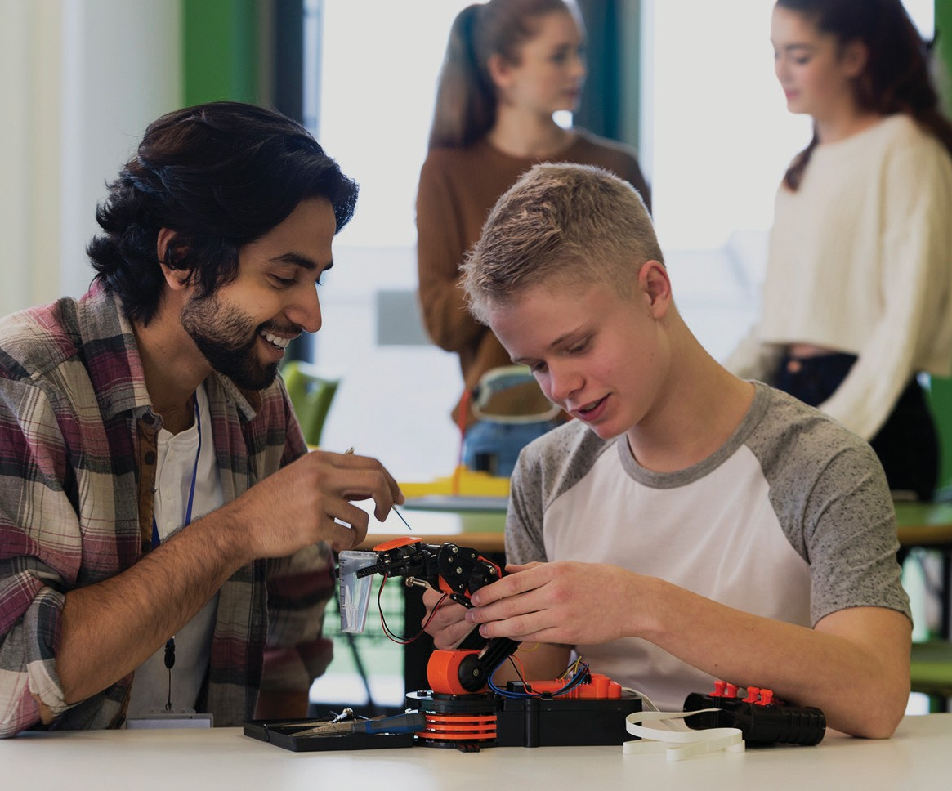

Electronics and Robotics Cover goes here

ELECTRONICS AND ROBOTICS
Activity Plans

Electronics and Robotics

Table of Contents

Acknowledgements . . . . . . . . . . . . . . . . . . . . . . . . . . . . . . . . . . 3
About This Resource . . . . . . . . . . . . . . . . . . . . . . . . . . . . . . . . . 7
Robot Applications in the Real World . . . . . . . . . . . . . . . . . . . . . . . . . 9
Essential Principles of Robotics . . . . . . . . . . . . . . . . . . . . . . . . . . . . 15
Rolling Platform Driver Challenge . . . . . . . . . . . . . . . . . . . . . . . . . . . 23
Robot Mask Challenge . . . . . . . . . . . . . . . . . . . . . . . . . . . . . . . . 29
Anatomy of a Robot . . . . . . . . . . . . . . . . . . . . . . . . . . . . . . . . . . 49
Robot Golf: Autonomous Challenge . . . . . . . . . . . . . . . . . . . . . . . . . . 55 Effective Robotics Team Communication . . . . . . . . . . . . . . . . . . . . . . . 61 Program Your Robot to Perform a Task . . . . . . . . . . . . . . . . . . . . . . . . 67 Solve a Problem Using Design Thinking . . . . . . . . . . . . . . . . . . . . . . . 73 Design Thinking Worksheet . . . . . . . . . . . . . . . . . . . . . . . . . . . . . . 79
Robot Hill Climb . . . . . . . . . . . . . . . . . . . . . . . . . . . . . . . . . . . . 81
Robot Arm Challenge . . . . . . . . . . . . . . . . . . . . . . . . . . . . . . . . . 89
Robot Arm Answer Key . . . . . . . . . . . . . . . . . . . . . . . . . . . . . . . 121
Multi-Bot Challenge . . . . . . . . . . . . . . . . . . . . . . . . . . . . . . . . . 129
Play the Game . . . . . . . . . . . . . . . . . . . . . . . . . . . . . . . . . . . 135

Youth Explore Trades Skills Electronics and Robotics

Acknowledgments and Third Party Copyright

Youth Explore Trades Skills Learning Resources Development
Open School BC, the Custom Programs work unit of the BC Ministry of Education, and SkilledTradesBC are grateful to the following individuals and organizations for their contributions to the Youth Explore Trades Skills Learning Resources Development Project.

Resource Development Planning Session (April 25–27, 2016)
Todd Ablett, SD 45 (West Vancouver Schools) Jason Brett, British Columbia Institute of Technology
Patience Cox, Career and Skills Education Coordinator, BC Ministry of Education Adrian Hill, Project Manager, Open School BC
Tyler Kuhn, SD 36 (Surrey)
Jason Leber, Youth Program Manager, SkilledTradesBC Tracey Peever, Project Manager, Open School BC
Scott Richmond, SD 54 (Bulkley Valley) Brian Yu, SD 39 (Vancouver)

Writing
Todd Ablett, SD 45 (West Vancouver Schools) Jason Brett, British Columbia Institute of Technology Tyler Kuhn, SD 36 (Surrey)
Scott Richmond SD 54 (Bulkley Valley) Brian Yu, SD 39 (Vancouver)

Review
Jason Brett, British Columbia Institute of Technology Scott Richmond, SD 54 (Bulkley Valley)
2013 Curriculum Advisory Committee
Brian Campbell, District Principal, Careers and International Education, SD 60 (Peace River North)
Larry Espe, Superintendent of Trades and Student Transitions, BC Ministry of Education Colleen Hannah, Aboriginal Agreements Coordinator, BC Ministry of Education
Rodger Hargreaves, Career Programs, SD 62 (Sooke)
Mike Howard, President, BC Technology Education Association, SD 19 (Revelstoke) Erin Johnston, Manager, Labour Supply Initiatives, SkilledTradesBC


This work is licensed under a Creative Commons Attribution-NonCommercial-ShareAlike 4.0 International License unless otherwise indicated. 3

Acknowledgments and Third Party Copyright Electronics and Robotics

Eleanor Liddy, Director, Open School BC
Eric MacNeil, President, BC Culinary Arts Specialist Association
Jim Pelton, former Director, Training Delivery, SkilledTradesBC
Glenn Rowan, Education Officer, Graduation, Dual Credit, Industry Training, BC Ministry of Education
Tim Winkelmans, Lead, Graduation Standards, Educational Technologies, Learning Alternatives, BC Ministry of Education

2013 Resource Development Planning Session (July 10, Victoria BC)
Dick Brouwer, SD 63 (Saanich) Jeff Dickson, SD 35 (Langley) Brad Edmondson, SD 36 (Surrey)
Adrian Hill, Project Manager, Open School BC
Mike Howard, President, BC Technology Education Association, SD 19 (Revelstoke) Tom Hoyme, SD 42 (Maple Ridge-Pitt Meadows)
Eleanor Liddy, Director, Open School BC
Erin Johnston, Manager, Labour Supply Initiatives, SkilledTradesBC Ken Jorgensen, SD 57 (Prince George)
Karen Larsen, Career Programs Coordinator, SD 39 (Vancouver)
Martin Lim, Vice-President, BC Technology Education Association, SD 36 (Surrey) David Olsen, SD 69 (Qualicum)
Stu Rhodes, SD 63 (Saanich)
Glenn Rowan, Education Officer, Graduation, Dual Credit, Industry Training, BC Ministry of Education
Rhonda Stangeland, SD 38 (Richmond)
Chris Teskey, Project Manager, Open School BC
Cory Williams, Manager, Program Standards, SkilledTradesBC

Open School BC Production Team
Copyright: Shannon Sangster Editing: Keith Learmonth
Graphics: Max Licht (http://www.maxlicht.com) Graphics Coordination: Christine Ramkeesoon Photography: Dennis Evans
Project Managers: Adrian Hill, Tracey Peever, Chris Teskey
Project Supervision: Monique Brewer (Director), Jennifer Riddel (Manager, Instructional

Services)
Production Technicians: Brian Glover, Beverly Hooks Website Construction and Design: Christine Ramkeesoon

Third Party Copyright
Every effort has been made to contact copyright holders for third party works included in the Youth Explore Trades Skills learning resources. If you have any questions or concerns, please contact openschoolinfo@gov.bc.ca

Electronics and Robotics

Rolling Platform Driver Challenge
Figure 1—Three simple VEX-based "rolling chasis" using "skid" steering. Image courtesy of Jason Brett, BCIT, used with permission.

Robot Mask Challenge
The following images were used with permission and courtesy of Jason Brett, BCIT: Figure 2—Various kinds of multi-conductor stranded wire
Figure 3—Two styles of control board - front Figure 4—Two styles of control board - back
Figure 5—Control board with custom-built switches Figure 6—Perfboard - front
Figure 7—Perfboard - back
Figure 8—Wood LED mount - front Figure 9—Wood LED mount - back
Figure 10—Wood board in cardboard mask Figure 11—Perfboard in cardstock mask
Figure 12—The BCIT TTED Class of 2012 shows off their robot masks Figure 13—The BCIT TTED Class of 2013 shows off their robot masks Figure 14—A robot mask created fro a cardboard box

Robot Arm Challenge
Figure 1—Syringes. Image courtesy of Jason Brett, BCIT, used with permission.

Multi-bot Challenge
Figure 2—Clear the field arena. Image courtesy of Brian Yu, Vancouver School Board, used with permission. Additional robotics resources from Brian Yu can be found here:
www.vsbrobotics.wordpress.com

Youth Explore Trades Skills 5

Acknowledgments and Third Party Copyright
Electronics and Robotics

About This Resource

Open School BC’s Youth Explore Trades Skills resource development project involves creating learning resources to support the implementation of the BC Ministry of Education’s Youth Explore Trades Skills Program Guide.
In April 2016 an electronics and robotics resource development planning session took place in Vancouver, BC, among Ministry of Education staff, industry trade professionals and five electronics and robotics teachers. The purpose of the planning session was to articulate key competencies of electronics and robotics professionals, to develop an instructional design plan and to draft a range of Activity Plans for a Youth Explore Trades Skills electronics and robotics module. This was a process that united unique, personalized teaching, professional backgrounds and industry evolutions that have been rapidly evolving organically. This module marks some of the first formal curriculum in this field for the grade 10–12 student body in BC.
These resources have been designed to meet a range of students’ and teachers’ skill levels and learning needs. This module introduces students to essential concepts in electronics and robotics, from beginner to advanced levels.
The Activity Plans are designed to be flexible and customizable, to allow for standalone use or followed in sequence at the teacher’s discretion and comfort level with the material.
The planning team created activities for multi-platform use, depending on the kits available to students, such as FIRST LEGO League, VEX EDR, VEX IQ or VEX Robotics Competition. The activities are sequenced from beginner level to advanced, depending on the knowledge level of both the teacher and the student.
In this resource you will find:
- A description of each activity
- A time estimate to complete each activity
- Assumptions, materials and tools required to complete the activity
- Detailed lesson plans with activities, images and related resources
- Suggestions for demonstrating the activity to the class
- Detailed terminology related to the activity and the robotics field

All Activity Plans are available in both PDF Format and Word formats on the Youth Explore Trades Skills website: http://www.mytrainingbc.ca/skills-exploration/index.html

Levels of Experience
It is anticipated that the students and teachers who engage in these activities will have varying levels of electronics and robotics knowledge. Each activity outlines any prior knowledge or available equipment necessary to complete the activity.

The Activity Plans are arranged into three levels of ability for you to choose from:
  - Beginner level: activities 1–8
  - Intermediate level: activities 9–11
  - Advanced level: activities 12–14

Assessment
At the end of each activity there is a suggested assessment table to complete for each student. These may include a combination of self-assessment, peer-assessment and teacher assessment, depending on the learning outcomes and difficulty level of the activity.
Most activities include an assessment table consisting of learning outcomes that are tailored to the activity, as well as common core learning outcomes that include teamwork, error handling and use of key terminology. Each objective is ranked on a six-point scale from exemplary (6) to not attempted (0) or basic (1).
Teachers may use their discretion in evaluating performance based on the needs of their students and module completion criteria (for credit or not-for-credit).

Stewarding Future Experts
We hope that this module opens the door for our students to contribute to this vast and rapidly evolving field, and encourages innovative ideas, new applications and unforeseen career paths.
“We make the path by walking it.” By supporting our youth to walk this path of study in electronics and robotics, we enable them to quite literally create it. We hope that teachers accompany their students as they explore this field, using this module as just enough of a framework to allow the messy process of innovation and creativity to expand.

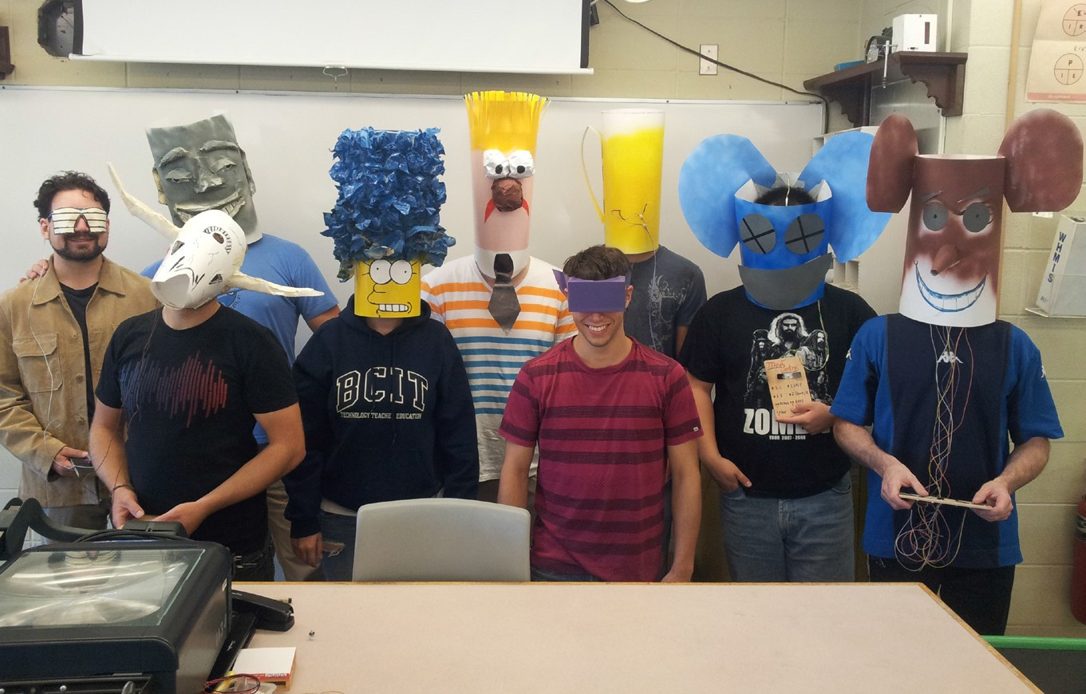

BCIT students with their completed super cyborg robot masks

Robot Applications in the Real World

Description
It is recommended that this be one of the first activities to be tackled as a part of the Electronics and Robotics Module within Skills Exploration 10–12.
In education and entertainment robots are often viewed as mobile and autonomous. Although there is definitely an exciting future for mobile robots, the vast majority of robots in use around the world are stationary machines performing mundane tasks. In order to give a broader understanding of the current state of robotics, students will research the diversity of robots and the breadth of their application in the real world.

Lesson Outcomes
Students will:
- Be able to effectively communicate and collaborate with others
- Expand their background knowledge of the robotics field
- Gather information on a robotics category and present it to other students

Assumptions
Students will:
- Have little experience working with robots
- Know how to conduct research using the internet
- Are able to evaluate web pages for relevance

Key Terminology
Autonomous: the ability to act independently; being able to perform an action without human intervention.
Industry: the process of manufacturing goods by using raw materials or related services.
Manufacturing: to make something with machines.
Robot: a machine that can be programmed to execute instructions, perform tasks repeatedly and interact with the world around it.

Estimated Time
60–120 minutes, depending on the depth of the research assignment

Recommended Number of Students
Up to 30 students working in pairs, based on the BC Technology Educators’ Best Practice Guide

Facilities
Students will need access to the internet through mobile devices, tablets, or computers.

Materials
The included Research Organizer

Resources
A webpage that outlines the various types of robot applications. for example, All on Robots lists a few different types of robot configuration:
http://www.allonrobots.com/types-of-robots.html

British Columbia has many world-class robotics companies: http://www.inuktun.com/ is located in Nanaimo.
http://www.oceanworks.com/ is located in Burnaby. http://www.actuonix.com/ is located in Victoria.
http://www.bctia.org/Member-Network/Member-Network-Directory lists the members of the BC Technology Industries Association. Search for “robot.”
Adrienne LaFrance of The Atlantic magazine published an interesting article entitled “What Is a Robot” on March 22, 2016. Although the length (and some language) may not be suitable for unedited use in class, it is an interesting read in preparation for this lesson. http://www.theatlantic.com/technology/archive/2016/03/what-is-a-human/473166/
The Tesla car factory uses many industrial robots to build their cars. This excellent five-minute video might help start your discussions:
https://www.youtube.com/watch?v=8_lfxPI5ObM

Of course robot arms aren’t always used for making cars: https://www.youtube.com/watch?v=CoA-m5iHG9s
If that looks like fun, students may want to check out Dynamic Attractions, a BC-based company leading the world in robotic amusement park rides:
http://www.dynamicattractions.com/our-adventures/

Or West Coast Robotics, which installs agricultural robots. Yes, they even have a robot for shovelling cow poop:
http://www.westcoastrobotics.ca/

Demonstration
Start by asking students to define robot. A typical definition might be “a machine that performs a task.” There are no “right or wrong” answers… there is definitely a lot of ambiguity in what, exactly, a robot is. This is a great opportunity to encourage debate and discussion.
Areas of discussion might include:
- Does it have to be autonomous, or can it be controlled by a person?
- Does it have to detect and respond to changes in its task or environment?
- Does it have to be able to move? Are there stationary robots?

Based on the discussion, which of the following would the students class as “robots”? Why?
- A 3D printer
- Elevators
- A washing machine or dishwasher
- Quadcopters and other “UAV” (Unmanned Aerial Vehicles)
- A tablet or phone with Siri or Google Voice
- IBM’s “Watson,” the computer that won at “Jeopardy”
- A PC that wins at chess
- A pre-programmed arm on an assembly line
- A self-driving car
- A vending machine
- A rice cooker or bread machine

Procedure
- Ask students to pair up and brainstorm for 2 minutes about the types of robots they would like to research.
- Share the categories with the class and fill in any that they might have missed. This is a nice list to work from:
http://www.allonrobots.com/types-of-robots.html

- Students can decide which category most interests them. They will then conduct research on their chosen category to find information using the research organizer provided.
- Allow for at least 40 minutes for students to conduct their research so that they get a sense of the breadth of the world of robotics.

- Have students share their findings either through small-group presentations or concentric circles (inside/outside circle). The following pages give a description of the concentric circle technique:
http://www.movingbeyondicebreakers.org/includes/activity.php?video=concentricCircles http://www.theteachertoolkit.com/index.php/tool/inside-outside-circles
If concentric circles are used, it is recommended that anywhere from 3 to 5 minutes per turn would be sufficient.

Assessment
The evaluation of this lesson is based on the three learning outcomes outlined above.

Prior to teachers using the evaluation grid it is recommended that students perform some form of peer-assessment and self-assessment.

 | Outcome To Be Assessed | 6 | 5 | 4 | 3 | 2 | 1 | 0
Outcome 1 | Be able to effectively communicate and collaborate with others.
1.1 | Identifies and shares relevant information and remains “on topic” during discussion and presentation.
Outcome 2 | Expand their background knowledge of the robotics field.
2.1 | Able to describe a variety of robotics applications.
2.2 | Separates fictional robots from “real” robots.
Outcome 3 | Gather information on a robotics category and present to other students.
3.1 | Performs quality research to gain information.
3.2 | Presentation was accurate and in-depth.

Total Points:

6 | Completed successfully at the exceptional level | Exemplary
5 | Completed successfully at higher than the expected level | Accomplished
4 | Completed successfully to the expected level | Emerging
3 | Attempted successfully at the minimum level | Developing
2 | Attempted - Unsuccessful - Close to Successful | Beginning
1 | Attempted - Unsuccessful | Basic
0 | Not Attempted | N/A
Comments:

Extension Activities
Fictional robots often demonstrate Artificial Intelligence. With computers and software continuing to advance, there may be real breakthroughs in AI during the student’s lifetime.

Students may wish to conduct further research into Artificial Intelligence. Is it possible for a machine to be “alive”? How would they know the difference between a human and an AI? Would it matter?
At a more basic level, how will intelligent machines affect the economy? What do self-driving vehicles mean for the job market? What if someone made a machine to flip burgers and serve fries?

Electronics and Robotics Robot Applications in the Real World

Robot Applications in the Real World Research Organizer

Name:

Robotics Category:
Robotics Category:
Robotics Category:

What is it?
What is it?
What is it?

What does it do?
What does it do?
What does it do?

Benefits:
Benefits:
Benefits:

Estimated cost to build and operate:
Estimated cost to build and operate:
Estimated cost to build and operate:

What is the most beneficial robotics category of these three and why?

Essential Principles of Robotics

Description
This activity is intended to give students an overview of the key principles that are often applied in robotics. Students will work with partners and in groups at an open table to sort words under various headings.
Once the group task has been completed to the best of their knowledge, students will use their prior knowledge to add what they already know about the topic and predict how the principle might be applied in robotics both outside and inside the classroom. The teacher will then reveal what the completed table looks like and briefly discuss the rationale for each word being placed where it is.
Groups will then share what they already know with the class to pool their knowledge of the concepts. The groups will each be assigned to a core robotics principle from the headings that were distributed and conduct additional research for the purpose of teaching other small groups what they’ve learned.

Lesson Outcomes
Students will review or learn about:
- The basics of classical mechanics:
– Friction, force, torque, speed, rotational speed
- Power transmission using gears, ratios and reductions
- Ohm’s law
- Components of a circuit
- Direct current motors

Assumptions
Students will:
- Have little background knowledge in classical mechanics, using gears and working with DC motors
- Have some background knowledge of electricity, circuitry and Ohm’s law from Science 9 in the BC curriculum
- Have worked in teams throughout this and other Youth Explore Trades Skills modules
- Know how to effectively perform an internet search to conduct research

This work is licensed under a Creative Commons Attribution-NonCommercial-ShareAlike 4.0 International License unless otherwise indicated. 15

Key Terminology
Current: the measurement of the flow of electric charge.
DC motor: short for direct current motor. These are used in classroom robotic applications by converting voltage to mechanical power to spin and produce torque.
Electrical resistance: impedes the flow of electrons through a circuit. It relates voltage to current.
Force: a push or pull upon an object by another object.
Friction: heat caused by opposing forces acting on a surface. OR a force that resists motion between two surfaces sliding against each other; strength of the force is determined by their textures.
Power transmission: the transfer of energy to the place where work is performed.
Torque: also known as moment. The force of a moving object connected to a single point.
OR the measurement of force causing rotation.
Voltage: the measurement of electric potential energy.

Estimated Time
60–90 minutes

Recommended Number of Students
Up to 30 students

Facilities
Any classroom with sufficient seating and tables for students to work at will do. A document camera or projector is needed to show students what the completed sort table looks like. A computer lab or set of tablets is needed for the research portion of the activity.

Materials
Essential Principles of Robotics Notes Organizer Essential Principles of Robotics Sorting Activity

Resources
Vex Robotics has an excellent set of resource pages that would work well with this activity. It is recommended that this and the other websites be shared with groups as they begin their research:
http://curriculum.vexrobotics.com/curriculum

Ohm’s law and circuits:
The Khan Academy has a series of online videos and documents at: https://www.khanacademy.org/science/physics/circuits-topic/circuits-resistance/v/circuits-part-1
AllAboutCircuits.com has an online electronics textbook available at: http://www.allaboutcircuits.com/textbook/

Gear ratios
An interactive gear ratio simulator is available at: http://geargenerator.com/
http://science.howstuffworks.com/transport/engines-equipment/gear-ratio.htm

An introductory 9-minute video is available at: https://www.youtube.com/watch?v=D_i3PJIYtuY
A series of videos, each about 2–3 minutes long and using VEX gears to demonstrate gear ratios:
https://www.youtube.com/watch?v=B4j2VPHVm6o https://www.youtube.com/watch?v=h1vfR9YvjMA https://www.youtube.com/watch?v=-q5FmanzCw4
Torque – a 10-minute video from Khan Academy: https://www.youtube.com/watch?v=QhuJn8YBtmg
DC motor torque, speed and current using VEX. Presented by AURA, the Auckland University Robotics Association, a well-known organization in VEX competition at the university level: https://www.youtube.com/watch?v=STdONYFI2C4

Procedure
- Prior to the lesson, the teacher should print off the sorted grid and cut them up so the headings and words are randomized.
- Have students pair up and give each pair an unsorted stack of headings and words. Ask them to do their best to determine which words go under the headings.
- Have them write any words or sketch symbols from what they might already know about the heading/topic/words.
- Once the class seems to have stalled in their sorting, pair each group with another group of two and have them compare their grids, sharing their rationale for the groupings.
- Have the groups of four discuss their prior knowledge they wrote in step three, and fill in the final box for each heading by predicting the possible applications and connections to the world of robotics.
- After a few minutes, put groups of four together so that they are in eights. They should briefly share their sorted words, background knowledge and connections.
- The teacher should show the arranged sorted grid and briefly discuss the rationale for each word in its heading, as well as how it connects to the world of robotics.
- Assign a “heading and associated words” to the groups of four, and have them conduct research on the topic for the purpose of presenting to their classmates in a method determined by the teacher.
- Prior to breaking to do their research, decide on the method of presentation (group to group, whole class, rapid fire, etc.), and communicate that to the groups.
- Tell the groups that they have 30–60 minutes to gather important information, visuals, videos, diagrams, examples and sample robotics problems they might encounter.
- Distribute the notes organizer for students to organize their notes during presentations.

- Have the groups present in the desired format.

- Once complete, students can revisit their sorted grids and decide which words can go in multiple columns based on what they’ve learned.

Assessment
The evaluation of this lesson is based on the learning outcomes outlined above.
Prior to teachers using the evaluation grid it is recommended that students perform some form of peer-assessment and self-assessment.

 | Outcome To Be Assessed | 6 | 5 | 4 | 3 | 2 | 1 | 0
Outcome 1 | Classical mechanics
1.1 | Demonstrates an understanding of classical mechanics.
Outcome 2 | Power transmission
2.1 | Demonstrates an understanding of power transmission involving gears.
Outcome 3 | Ohm’s law and circuitry
3.1 | Demonstrates an understanding of Ohm’s Law and the components of a circuit.
Outcome 4 | DC motors
4.1 | Demonstrates an understanding of DC motors.
Outcome 5 | Teamwork
5.1 | Division of work.
5.2 | Effort of each team member.
Outcome 6 | Understanding Key Terminology
6.1 | Demonstrate the use of Key Terminology.
6.2 | Apply terminology appropriately.

Total Points:

6 | Completed successfully at the exceptional level | Exemplary
5 | Completed successfully at higher than the expected level | Accomplished
4 | Completed successfully to the expected level | Emerging
3 | Attempted successfully at the minimum level | Developing
2 | Attempted - Unsuccessful - Close to Successful | Beginning
1 | Attempted - Unsuccessful | Basic
0 | Not Attempted | N/A
Comments:

Essential Principles of Robotics Notes Organizer

Name:

Use this worksheet to organize your thoughts for your presentation to the class about your topic. You may need these notes for future reference as you complete the Electronics and Robotics module.

Add the three headings of the principles that you did NOT research. Use this worksheet to capture your notes as your peers present their work.

Electronics and Robotics Essential Principles of Robotics

Essential Principles of Robotics Sorting Activity

Classical mechanics | Power transmission – gears, ratios and reductions | Ohm’s law and components of a circuit | DC motors
Speed | Teeth | Current | Mechanical output
Velocity | Newton-metre | Voltage | Electromagnetic field
Acceleration | Torque | Load | Wire coils
Force | Shaft | Power | Load torque
Torque | Input speed | Battery | Current draw
Isaac Newton | Pitch | Switch | Stall
Rotational speed | Diameter | Conductor | Electrical energy à  mechanical

Rolling Platform Driver Challenge

Description
In this activity, students will build a basic rolling platform robot that will serve as a chassis for additional activities listed in this module. This activity’s primary mission is to construct a robot that will move forward and backward and turn left and right. The chassis will illustrate key principles of traction, torque and battery power.
Students will conduct this activity in a team environment, develop their capacity for following instructions, make adjustments to improve robot performance and be exposed to concepts and terminology they can use to assess their design.
Novice students may consider constructing the rolling platform using instructions and information available directly from the robot manufacturer’s website. Use the following keywords along with the platform name to search the internet for examples: clawbot, rolling bot or tank.
For intermediate students, consult existing platforms and examples available online first. Next, augment these basic designs to construct a rolling platform that best suits your class’s needs.

Lesson Outcomes
Students will be able to:
- Construct and operate a robot that is able to make basic manoeuvres
- Follow instructions to complete a complex assembly task
- Understand and apply gear ratios to their design
- Apply design thinking to improve their rolling platform’s performance
- Demonstrate constructive teamwork skills

Assumptions
Students will have:
- Some knowledge of basic construction techniques
- Formed teams and partnerships within the classroom
- Access to robotics platforms and necessary equipment
- Some knowledge of gear ratios, robots and design
- Some experience with basic mathematics, friction, torque and elementary forces
- Some experience with relevant toys such as LEGO, bicycles, wagons and fictional robots from movies (e.g., R2D2, BB8)

This work is licensed under a Creative Commons Attribution-NonCommercial-ShareAlike 4.0 International License unless otherwise indicated. 23

Key Terminology
Center of gravity: a focal point where an object is standing at its design maximum without falling down.
Chassis: a physical structure that connects and holds the various components together to form the basic robot. In most cases it can be the outer shell or the internal skeleton structure.
Design Thinking: is an approach to solutions-finding that considers the desired end-result or experience. A Design Thinking approach is often iterative, starting with the definition of a problem, empathetically considering the experience or impact of that problem from multiple
perspectives, considering multiple approaches to potential solutions, then narrowing down the solution through prototyping or experimentation. The chosen approach to the solution is then selected and implemented.
Friction: heat caused by opposing forces acting on a surface. OR a force that resists motion between two surfaces sliding against each other; strength of the force is determined by their textures.
Gear ratio: the science of mechanical advantage using gears.
Scrub: the transverse (side-to-side) friction on a wheel in a skid-steer drivetrain.
Skid steering: turning a vehicle by driving the left side drive wheels at a different rate than the right drive wheels, similar to a tank or bulldozer.
Torque: also known as moment. The force of a moving object connected to a single point.
OR the measurement of force causing rotation.
Traction: the ability to grip a surface.

Estimated Time
3–4 hours or more (platform dependent)

Recommended Number of Students
Two to five students per robot, per team (ideal: three students) Two to five teams

Facilities
Robot testing area: a large table, approximately 120 cm × 240 cm (4 ft. × 8 ft.) Any classroom with tables
Storage space

Tools
Tools are platform-specific, depending on the robotics platform selected Stopwatch

Materials
Storage bins
Robot kits (e.g., VEX EDR, VEX IQ, LEGO Mindstorms)

Resources
“Simbotics” is also known as Team 1114, former World Champions of FIRST Robotics and one of the most famous high school robotics teams in Canada. They produce some excellent training materials that they share with the robotics community, including this presentation on robot drivetrains. It is, perhaps, more in-depth than needed for presentation to the class, but it
provides excellent background information on drivetrains for the teacher or advanced students in the class:
https://www.simbotics.org/files/pdf/drivetraindesign.pdf

VEX Robotics has curriculum on robot design. This section on drivetrain design is relevant to this activity, particularly the sections on traction, turning and gears. Much of it is written at a high school level.
http://curriculum.vexrobotics.com/curriculum/drivetrain-design

As important as it is for robots to be able to turn, it is also important to get them to go straight. This 15-minute video discusses how to get a LEGO robot to travel in a straight line. It also demonstrates good scientific practice in measuring and recording performance. https://www.youtube.com/watch?v=OlAO9Ho-N58

Demonstration
Ideally the teacher will have access to a working robot drivetrain to demonstrate how it works. Particular emphasis should be placed on the importance of keeping the centre of mass over the drive wheels, and dealing with “scrub” or “skid,” the sideways force acting on the front and rear wheels when a “tank style” or “skid steer” drive train changes direction (see Figure 1). It is also important to reference the relationship between drive wheel diameter, gear ratio and motor torque. In the event that a demonstration robot is not available, some of the videos below will help cover the relevant topics.

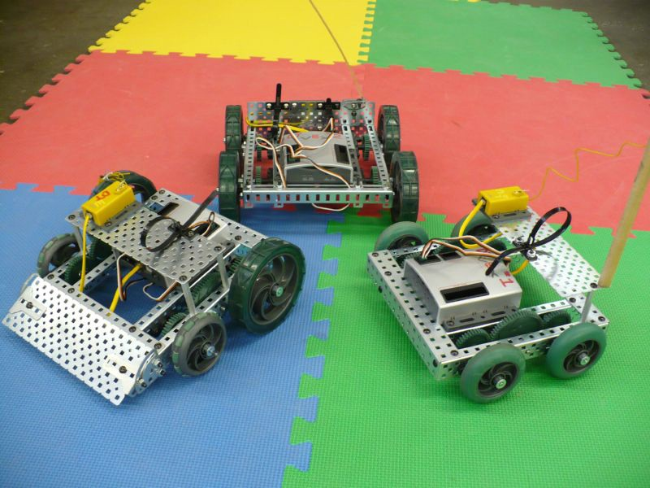

Figure 1—Three simple VEX-based “rolling chassis” using “skid” steering. The left-hand robot uses omni wheels on the front axle to help reduce “scrub” and make turning easier.

The following videos will provide an understanding of gear ratios. It is recommended that teachers preview the following videos before showing them to their students in class. Note that these are the same videos linked as a resource in Activity 3, “Essential Principles of Robotics.” Students who have completed that activity may already be familiar with this content.

Gear Ratios - Part 1
https://www.youtube.com/watch?v=B4j2VPHVm6o

Gear Ratios - Part 2
https://www.youtube.com/watch?v=h1vfR9YvjMA

Gear Ratios - Part 3
https://www.youtube.com/watch?v=-q5FmanzCw4

The following videos will provide an understanding of speed vs. strength (torque):
Understanding Gears: Speed Vs. Torque: a two-minute demo of simple gear ratios https://www.youtube.com/watch?v=UUfZnZ_0Cb8

LEGO Technic - Torque, Speed, Gearing
https://www.youtube.com/watch?v=KKQHqPIuEVc

Also, discuss centre of gravity as a concept and how it affects the construction and operation of your rolling platform.

Procedure
- Students build their rolling platform. They may follow these reference materials to build the basic rolling platforms:

VEX IQ (animated instructions)
http://www.vexrobotics.com/vexiq/animated-build/clawbot-iq#1

VEX IQ (build instruction PDF)
http://www.vexrobotics.com/vexiq/explore/robot-builds/

VEX EDR (build instruction PDF)
http://content.vexrobotics.com/docs/instructions/276-2600-CLAWBOT-INST-0512.pdf

LEGO Mindstorms/EV3 (build instruction PDF)
http://www.lego.com/en-us/mindstorms/build-a-robot

- After constructing the rolling platform, students should test their rolling platform to see if it performs according to plan.
- Introduce the following activity as a competitive challenge to get students accustomed to the arena of competitive robotics challenges. Be sure to have a stopwatch on hand to keep time.

Testing Your Robot Challenge—Navigate the Maze
The object of this challenge is to remotely control the rolling platform to travel from one side of the maze to the next. This activity is scored by a stopwatch.
The rolling platform starts in contact with the wall on one side of the maze, then crosses to the other side to touch the destination wall, at which point the timer is stopped. The rolling platform cannot simply climb over the wall(s) to get to the other side. The team with the shortest time wins the challenge.
Figure 2 shows one possible “maze” configuration. Slalom courses and “head-to-head” racing on parallel tracks also make for exciting activities.

Figure 2—One possible maze layout

Extension Activities
Extension activities may be found at the following website under Classroom Challenges at the bottom of the page:

Jr. Robotics: a place for teachers, students and parents:
https://vsbrobotics.wordpress.com/

Assessment
The evaluation of this lesson is based on the learning outcomes outlined above.

Prior to teachers using the evaluation grid it is recommended that students perform some form of peer-assessment and self-assessment.

 | Outcome To Be Assessed | 6 | 5 | 4 | 3 | 2 | 1 | 0
Outcome 1 | Robot Construction
1.1 | Construction of robot to specifications.
1.2 | Understands and applies gear ratios to the design.
1.3 | Follows instructions to complete a complex assembly task.
Outcome 2 | Perform the Technical Challenge
2.1 | Robot successfully navigates the maze(s).
2.2 | Applies design thinking to improve their rolling platform’s performance.
Outcome 3 | Teamwork
3.1 | Able to resolve challenges when encountered.
3.2 | Equitable division of work.
Outcome 4 | Understanding Key Terminology
4.1 | Demonstrates the use of Key Terminology.
4.2 | Applies terminology appropriately.

Total Points:

6 | Completed successfully at the exceptional level | Exemplary
5 | Completed successfully at higher than the expected level | Accomplished
4 | Completed successfully to the expected level | Emerging
3 | Attempted successfully at the minimum level | Developing
2 | Attempted - Unsuccessful - Close to Successful | Beginning
1 | Attempted - Unsuccessful | Basic
0 | Not Attempted | N/A
Comments:

Robot Mask Challenge

Description
In this activity, students are exposed to feedback loops and latency (the delay between command and response) by wearing a blindfold mask containing LED lights and using it as their only source of information while navigating through a complex set of obstacles. Students develop a communication protocol to allow one student (the “controller”) to direct the other (the “robot”) through the obstacles quickly and efficiently, using a code system to communicate instructions with only LED lights.
This activity helps students by:
  - Focussing attention on the wide variety of inputs and feedback mechanisms provided by human senses
  - Illustrating the challenge of operating in an environment where feedback is limited and subject to latency
  - Requiring teamwork and cooperation to accomplish a task
  - Giving them practice using the terms and tools needed to construct a simple electronic circuit

Lesson Outcomes
Students will be able to:
  - Describe the types of feedback loops provided by human senses
  - Describe the steps in a communication protocol and relate them to human conversations
  - Explain the challenges of latency in control loops
  - Create a simple electronic circuit
  - Use appropriate terminology to describe the components in their electronic circuit

Assumptions
Students will have basic understanding of the following:
  - Use of simple hand tools:
    - Wire strippers
    - Hot glue
    - Soldering iron
  - Online video games
  - Stripping and soldering wires

This work is licensed under a Creative Commons Attribution-NonCommercial-ShareAlike 4.0 International License unless otherwise indicated. 29

- Relieving strain on wires
- Constructing a mask
- Creating a circuit using an LED, resistor, battery and switch

Key Terminology
Anode: the “positive” side of an electrical component.
Cathode: the “negative” side of an electrical component, often marked with a distinguishing feature such as a flat side on LEDs, or a stripe on electrolytic capacitors.
Communication protocol: a set of rules for transmitting information.
Feedback loop: an iterative process in which an output signal is continually modified in response to the effect of the output signal. An example would be a car’s cruise control system, where the throttle position (the output) is modified based on the vehicle speed (the effect of the output).
Latency: the delay between the transmission and reception of a signal.
LED: Light Emitting Diode. A device that converts electricity into light when electrons cross a semiconductor P-N junction. The wavelength, or colour, of the light is determined by the energy drop across the P-N junction.
Loading Zone: the starting place where the payload will be found. Cyborgs will move the payload from the Loading Zone to the Objective Zone.
Objective Zone: the ending place where the payload should successfully end up to score points.
Payload: the object or objects that will be moved during the challenge from the loading zone (starting place) to the objective zone (ending place).
Sensor: a device that provides information about the environment to a device or robot.
Solder: a low melting point alloy for connecting metallic components. Typically used in electronics, plumbing and jewellery.
Strain relief: a design feature, component or mechanism intended to transfer stress into a flexible connection in such a way as to reduce fatigue and stress concentration in the connection.

Estimated Time
Total time 5–8 hours:
1–2 hours of lesson time
3–4 hours of build and testing time 1–2 hours of activity time

Recommended Number of Students
Two students per mask to a maximum of 20 students, based on BC Technology Educators' Best Practice Guide.

Facilities
  - Any classroom or large area such as a cafeteria or gymnasium
  - A multipurpose tech studies shop or lab with access to soldering irons
  - Space to navigate with variable hazards for navigation
  - Fixed obstacles: workbenches, desks, other permanent or heavy large objects
  - Random obstacle: garbage can, chair or other movable solid object

Tools
  - Soldering iron
  - Drill press (or suitable hand drill arrangement)
  - Whitney punch (if available)
  - Wire strippers
  - Screwdrivers
  - Scissors
  - Hot glue guns

Materials
  - LEDs
  - Multi-conductor stranded wire
  - Batteries and battery packs
  - Switches
  - Mask-making material (poster-sized card stock, tape)
  - Mask-decorating tools (felt pens, glue stick, hot glue, paint)

Resources
  - The “Super Cyborg” Robot Mask Challenge (on page 36)
  - Robot Mask Challenge Score Sheet (on page 35)
  - Instructions for Building the Control Board (on page 38)
  - Mask Examples (on page 43)
  - Sensors and Control Loops Discussion Suggestions (on page 45)
  - Communication and Control Loops Discussion Suggestions (on page 47)

Additional Support Materials
“Super Cyborg” Robot Mask Challenge handout

Procedure
Day 1: Lesson: Introduce activity
Explain the challenge
Demonstrate mask-building procedure
Activities: Put students into teams
Begin mask construction

Day 2: Lesson: Sensors and control loops (see “Resources” for discussion guide) Communication protocols (see “Resources” for discussion guide)
Activities: Complete mask construction and decoration Develop communication protocol
Day 3: Lesson: Building control board
- LEDs – anode and cathode
- Resistors
- Switches
- Batteries – positive and negative
- Strain relief: emphasize its importance to ensure reliable communication
Activities: Build control board
Install LEDs in mask
Connect board and LEDs using proper strain relief

Day 4: Lesson: Review the challenge
Activities: Assist students to complete unfinished masks Practice runs for students with completed masks
Day 5: Lesson: Review sensors, control loops, communication protocols Review challenge rules
Activity: Robot mask competition

Follow-up: Quiz on sensors, feedback loops, communication protocols and mask wiring. Teachers should customize their quiz based on classroom discussion and topics covered.

Assessment
The evaluation of this lesson is based on the learning outcomes outlined above.

Prior to teachers using the evaluation grid it is recommended that students perform some form of peer-assessment and self-assessment.

 | Outcome To Be Assessed | 6 | 5 | 4 | 3 | 2 | 1 | 0
Outcome 1 | Describe the types of feedback loops provided by human senses
1.1 | Can describe human feedback loops.
Outcome 2 | Describe the steps in a communication protocol and relate them to human conversations
2.1 | Understands and can describe communication protocol.
2.2 | Relates protocols to human interaction.
Outcome 3 | Explain the challenges of latency in control loops
3.1 | Understands the concept of latency.
3.2 | Can describe the issues latency presents in control loops.
Outcome 4 | Create a simple electronic circuit
4.1 | Can identify circuit components.
4.2 | Can assemble a functional circuit to achieve a goal.
Outcome 5 | Uses appropriate terminology to describe the components in their electronic circuit

Total Points:

6 | Completed successfully at the exceptional level | Exemplary
5 | Completed successfully at higher than the expected level | Accomplished
4 | Completed successfully to the expected level | Emerging
3 | Attempted successfully at the minimum level | Developing
2 | Attempted - Unsuccessful - Close to Successful | Beginning
1 | Attempted - Unsuccessful | Basic
0 | Not Attempted | N/A
Comments:

Extension Activities
Challenge the students to navigate the school using their masks.

Challenge the students to identify robots that use sensors to develop paths and navigate:
- Are self-driving cars “robots”?
- Do “Roombas” learn to navigate?

Robot Mask Challenge Score Sheet

 |  |  |  |  | Penalities
First Partner | Second Partner | Base Score  # of LEDS2 | Decoration Style | Try  # | Noise (10) | Mask (20) | Minor Obstacle (1) | Major Obstacle (1) | Random Obstacle (1) | Accuracy Score | Time in Seconds | Total Score
 |  |  |  | 1
 |  |  |  | 2
 |  |  |  | 3
 |  |  |  | 1
 |  |  |  | 2
 |  |  |  | 3
 |  |  |  | 1
 |  |  |  | 2
 |  |  |  | 3
 |  |  |  | 1
 |  |  |  | 2
 |  |  |  | 3
 |  |  |  | 1
 |  |  |  | 2
 |  |  |  | 3
 |  |  |  | 1
 |  |  |  | 2
 |  |  |  | 3
 |  |  |  | 1
 |  |  |  | 2
 |  |  |  | 3
 |  |  |  | 1
 |  |  |  | 2
 |  |  |  | 3
 |  |  |  | 1
 |  |  |  | 2
 |  |  |  | 3
 |  |  |  | 1
 |  |  |  | 2
 |  |  |  | 3

The “Super Cyborg” Robot Mask Challenge

One partner is the robot, and the other is the controller. Do your job. Do it well. Do it fast. Victory is yours!

The Challenge
Working together, you and a partner will:
- Create a “robot mask” that will turn one partner into a human-machine cyborg.

- Create a “control board” that will allow one partner to control the actions of the cyborg.

- Create a communication protocol to send information from the controller to the robot.

- Practise your communication and control systems to complete a task.

The Rules
- The mask must completely obscure all visual input from the surroundings.

- The only communication that the cyborg may receive shall be from the LEDs.

- The LEDs must be controlled by switches on a control board.

- The control board must be operated by the controller.

- The control board must be connected to the mask by a cable.

- The cable must remain slack at all times when controlling the cyborg.

- The “payload” will be provided by your teacher. At the beginning of your task the payload will be located in the “loading zone” as defined by your teacher.
- The start position will be indicated by your teacher with a mark on the floor.

- At the beginning of the task the cyborg must have a foot in contact with the start location.

- The “objective zone” will be defined by your teacher.

- The goal is to move the payload as quickly as possible from the loading zone to the objective zone.
- Placing the payload close to the objective will improve your score.

- You may not throw the payload. You must carry it from the loading zone to the objective zone.
- The “random obstacle” is moved by the teacher between each run. The random obstacle is moved after the cyborg is wearing the mask and is in the start location. Contacting the random obstacle results in a 10-point penalty.

Self-assessment Scoring
The following are the rules for self-assessment scoring. They can be used alongside the teacher evaluation grid.
The goal is to keep your score as low as possible. The score is calculated as follows:

Total Score = Base Score + Time Score + Accuracy Score + Penalty Score – Decoration Score

The base score is the number of LEDs, squared: 1 LED is a base score of 1; 6 LEDs is a base score of 36. Design your communication protocol wisely to use the minimum bandwidth, but beware: limited bandwidth might increase your latency!
Time score is the time in seconds from when the cyborg’s foot leaves the start position until the cyborg releases the payload and raises both hands above their shoulders to indicate they are finished.
Accuracy score is the square of the distance (in centimetres) of the nearest edge of the payload to the objective zone. If the payload covers any or all of the objective zone, the accuracy score is zero.
Penalty scores are assessed by the teacher according to the chart below. Penalties may be assessed even for “accidental” or “minor” offenses. It is the team’s job to ensure that they avoid penalties. Teams that intentionally take penalties may be disqualified. If a penalty gives a team an unfair advantage they may be disqualified or required to re-start their run.

Offense | Penalty Points
Making noise, even briefly and unintentionally, or any other attempt to communicate with the cyborg using something other than the LEDs. | 10
Having the mask “slip” or move for any reason such that it allows even the possibility of seeing outside the mask. | 20
Contacting a “fixed obstacle” such as a chair, desk or other obstacle. Minor offenses are unintentional contact where the cyborg backs off immediately. A major offense is where the cyborg follows the obstacle, obtaining position or orientation information. | Minor offense: 1  Major offense: 10
Contacting the random obstacle. This penalty is applied only once. | First offense: 10  Subsequent offenses: 0

Decoration score is: | 0 | For an undecorated mask
 | 5 | For a basic mask with simple artwork or decoration
 | 10 | For a mask with creative or detailed artwork or decoration

See Robot Mask Challenge Score Sheet on page 35

Instructions for Building the Control Board
The control board is a simple electronic circuit consisting of a number of LEDs, each with a current-limiting resistor and controlled by a pushbutton switch. The power source is typically a 9 V battery. Figure 1 shows the schematic for a control board with four LEDs. Students may choose to use as few or as many LEDs as they feel will be optimal for completing the challenge.

Note that the battery and switches will be located on the control board, while the LEDs and resistors will be located in the mask. This requires a cable to connect the control board to the mask. A typical cable length is roughly 2 m long— enough to allow a reasonable amount of slack in the cable during the competition.

BAT1 9V

Each team will require a cable with one conductor per LED plus one conductor to supply power to the LEDs. For a set- up with four LEDs, a five-conductor cable will be required. It is fine to use a cable with extra conductors and leave some unused.
There are a number of suitable cable types (Figure 2). The preferred cable type is the multi-coloured ribbon cable (sometimes called rainbow cable) at the right of the photo, as it is lightweight, flexible and can be easily separated to provide the correct number of conductors for each team.
The wire colours are useful for tracing connections between the control board and the mask.

LED1

LED2

LED3

LED4
R1 470R

R2 470R

R3 470R

R4 470R

SW1

SW2

SW3

SW4

Figure 1—Control board schematic

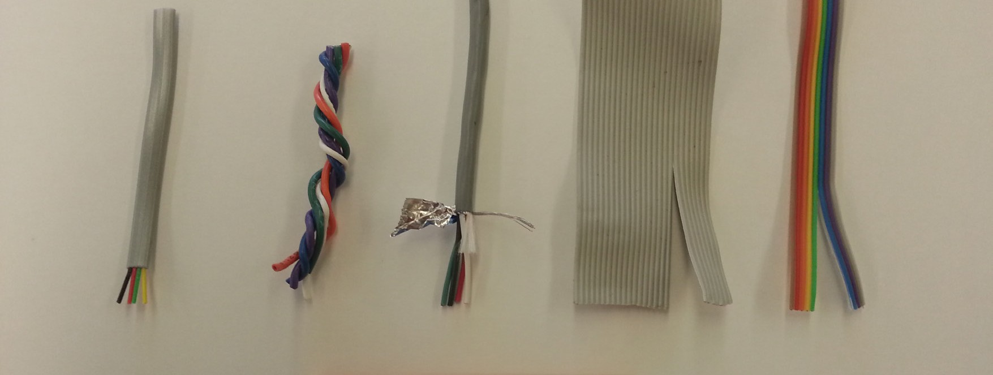

Figure 2—Various kinds of multi-conductor stranded wire
Ideally the cable will be made of stranded wire, as solid-core wire is less flexible and has a tendency to fatigue (break) at inopportune times. Students may notice that solid-core wire is commonly used in stationary or architectural applications, while stranded wire is used in mobile applications subject to flexing or vibration, such as vehicles and machinery.

There are a number of ways to create the control board, depending on the tools and resources available. Two different constructions are shown (Figures 3 and 4), one using ABS plastic, purchased switches (momentary, normally open (“N.O.”) pushbutton switches), and the other a “perfboard” prototyping board to hold the LEDs and resistors in place.
The other control board uses offcuts of wood and plywood along with screws and manufactured switches (Figure 5). The switches may be manufactured of any reasonably flexible sheet metal. In this case they use the metal strapping that is used to secure stacks of lumber. This strapping can usually be obtained for free from a local lumber supply store. (Note that the paint on the strapping must be sanded off in order to ensure an electrical connection with the screws.)

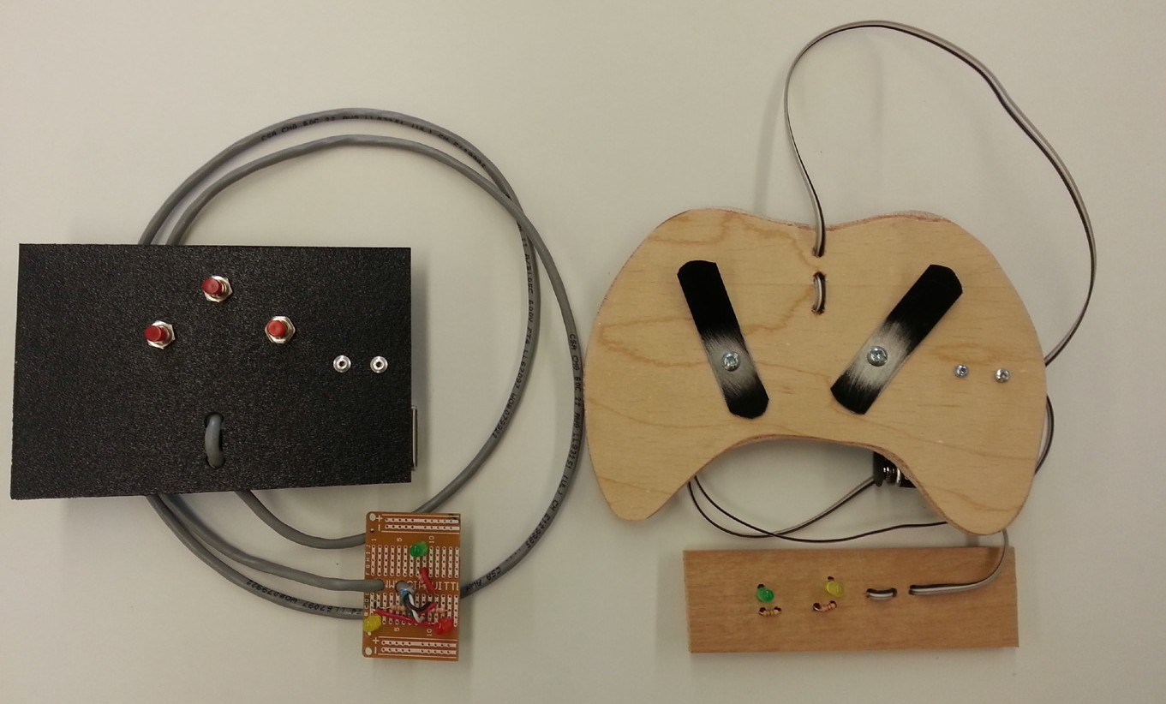

Figure 3—Two styles of control board - front

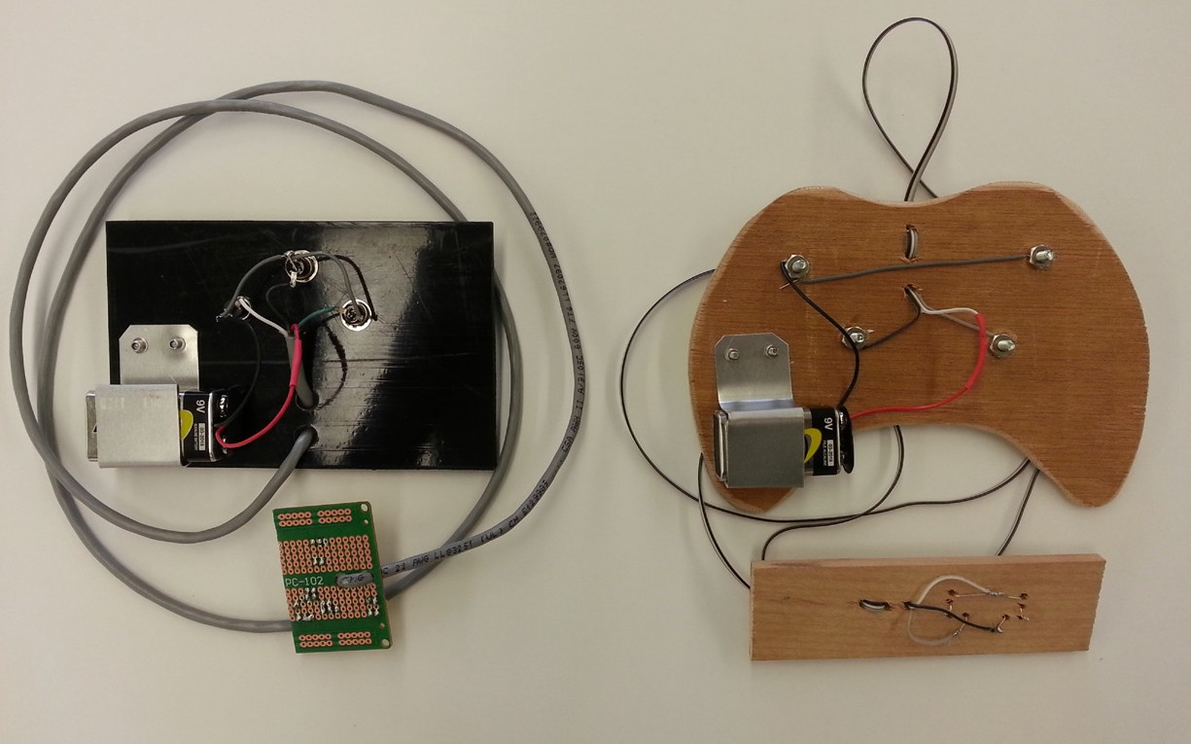

Figure 4—Two styles of control board - back

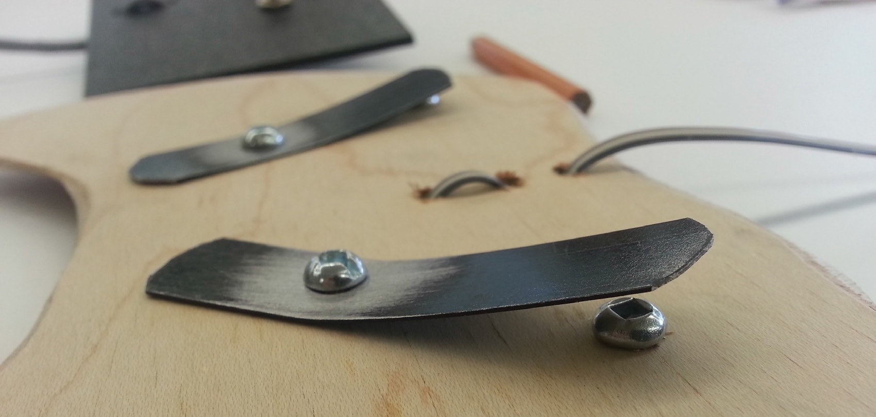

Figure 5—Control board with custom-built switches

Note the strain relief provided by weaving the cable through holes drilled or punched in the control board. While there are many ways to provide strain relief, it is essential for reliable robot operation. Cables that lack strain relief will pull on the electrical connections, causing them to fail.
The battery mount is made by bending an offcut of sheet metal to clip the battery in place. This prevents strain in the wiring between the battery and control board and allows batteries to be shared between teams or easily returned at the end of class. The batteries are one of the more expensive components in this project.
Electrical connections to the switches are made by soldering wires in place. Connections on the wooden board are made by wrapping the wire around the screw, then tightening the nut. This makes it easier to adjust the wiring should the students make a mistake.
For mounting the LEDs inside the mask it makes sense to build a board to hold the LEDs and resistors. This ensures that the cable can be strain relieved at the robot end and allows the LEDs to be tested before being installed in the mask. Again there are a number of options for constructing the LED mounting board, including perfboard (Figures 6 and 7) and a custom-built equivalent made of offcuts (Figures 8 and 9).

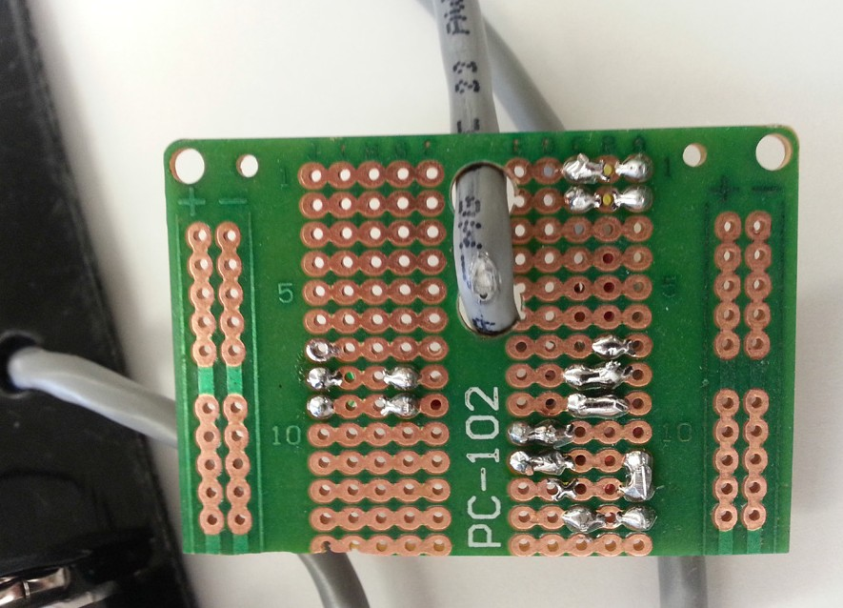

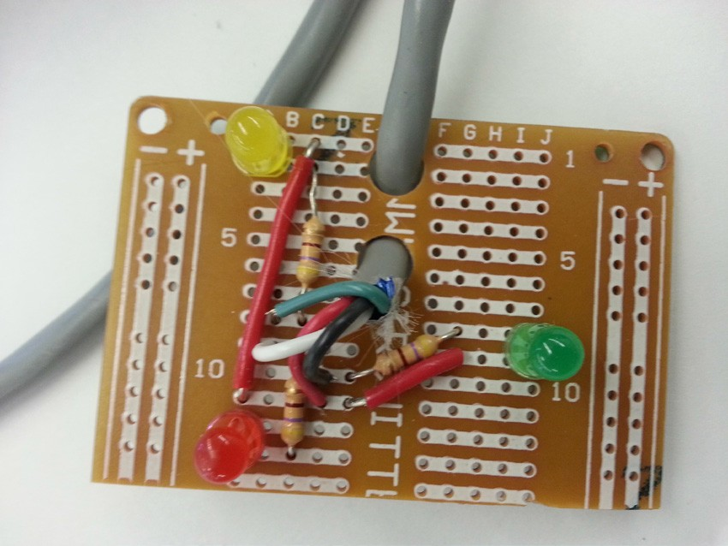
Figure 6—Perfboard - front |  | Figure 7—Perfboard - back

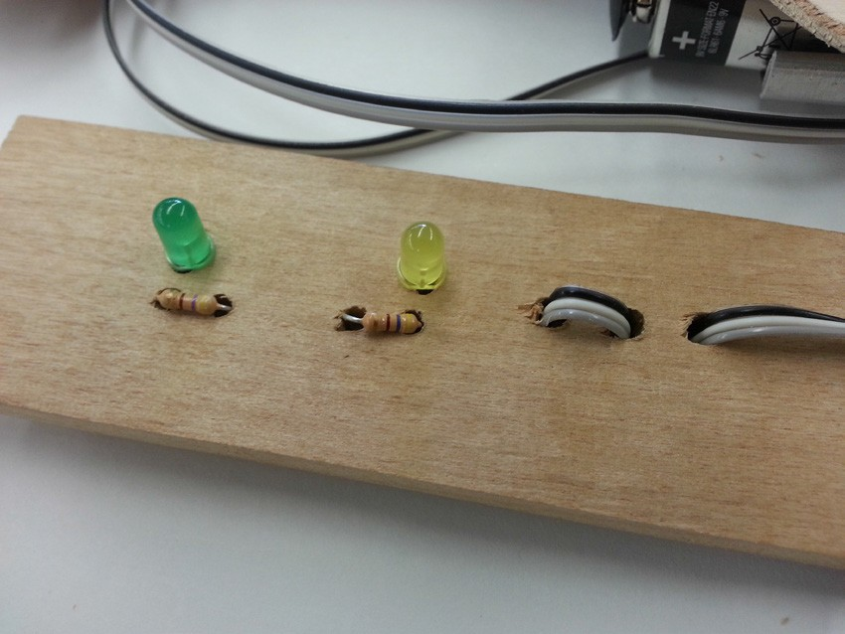 |  | 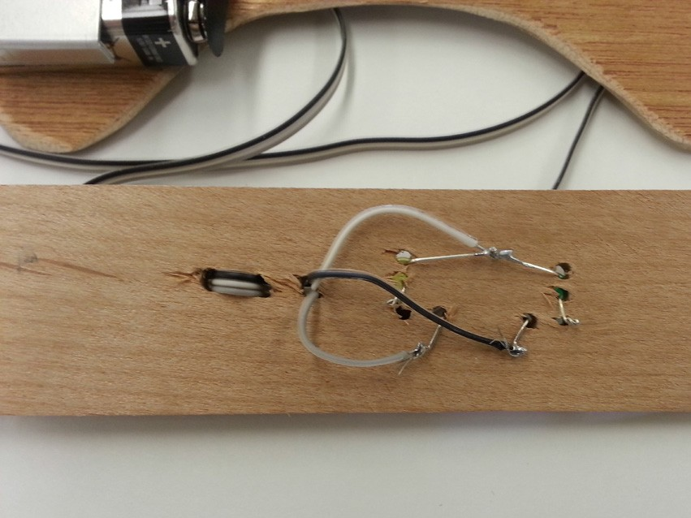
Figure 8—Wood LED mount - front |  | Figure 9—Wood LED mount - back

Building and testing the LEDs and control board before installing them in the mask also allows a team of two students to work in parallel: one can be working on the controls while the other works on building or decorating the mask.
Once the control board and mask are completed they can be joined together by inserting the LEDs into the mask (Figures 10 and 11) and holding them in place with tape or hot glue. Note that additional strain relief between the cable and the mask may need to be provided, usually by taping the cable securely to the mask.

Figure 10—Wood board in cardboard mask |  | Figure 11—Perfboard in cardstock mask

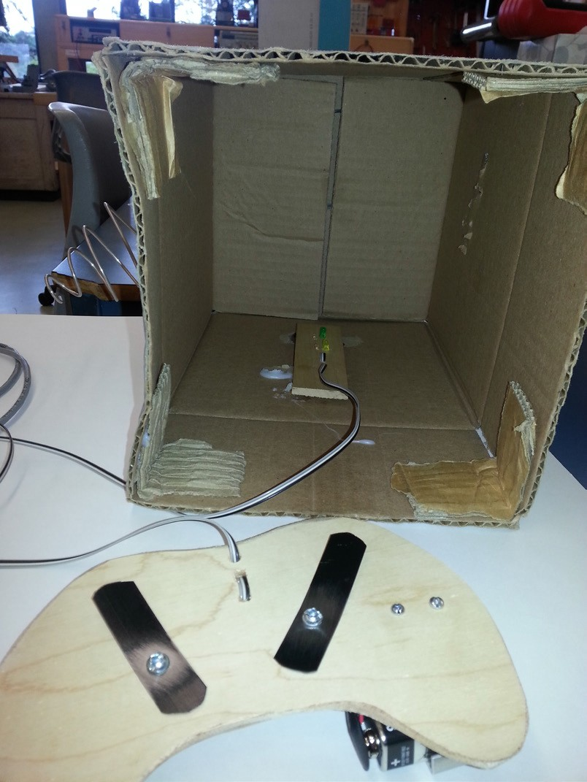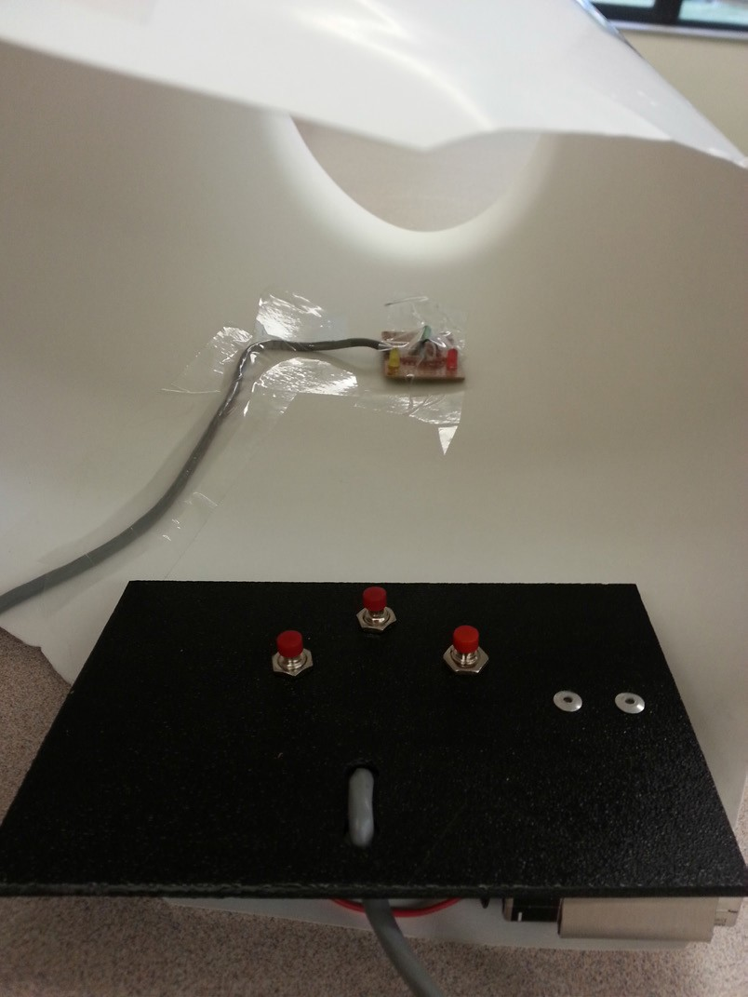The students may now don their masks and practise their communication protocol.

Troubleshooting
If there are problems, try the following:
- Check the LED polarity. The anode, or positive side, is the rounded side of a standard 5 mm LED and should be connected to the positive side of the battery. The cathode, or negative side of the LED, should have a flattened side and should connect (via a resistor and switch) to the negative side of the battery.
- Check the battery with a voltmeter. A 9 V battery should be delivering at least 8 V.

- Use a voltmeter to check the voltage across the LED and resistor when the switch is pressed “on.” If you see a voltage drop across the LED and resistor but the LED does not turn on,
it is possible that the LED has been burned out. This happens when an LED is connected to a power supply without a current-limiting resistor. Replace the LED. If you do NOT see a voltage drop, then investigate for a problem with the wiring or switch.

Using Different Batteries
There is no requirement to use a 9 V battery. Any battery or battery pack between 3 V to 12 V should work fine.

Using Different Resistors
Just about any resistor between 300 ohms and 2000 ohms should work okay. Ideally your resistor is chosen to work with your battery voltage and LED “forward voltage drop” to deliver 5–20 mA of current through each LED. For most LEDs the forward voltage drop is roughly 2 V. For blue or white LEDs the voltage drop is closer to 3 V. To determine the resistor value, use the following formula and select something that you have in stock that is close to this value:
(Battery Voltage – Forward Voltage Drop) × 100 = Resistor Value

It is necessary to use one resistor per LED to ensure equal current to each LED. If the circuit shares one resistor across all the LEDs, then all the LEDs will dim whenever more than one LED is turned on.

Mask Examples
The most basic mask consists of a cylinder of cardstock, taped to fit securely over the cyborg’s head with the LEDs mounted on the inside so they are visible to the robot. Graphics can be added to the exterior for personalization, depending on the time available and the creativity
of the students. Figures 12, 13 and 14 give some idea of the wide range of design options available. Note, however, that it does take additional time and resources to design and create unique masks.

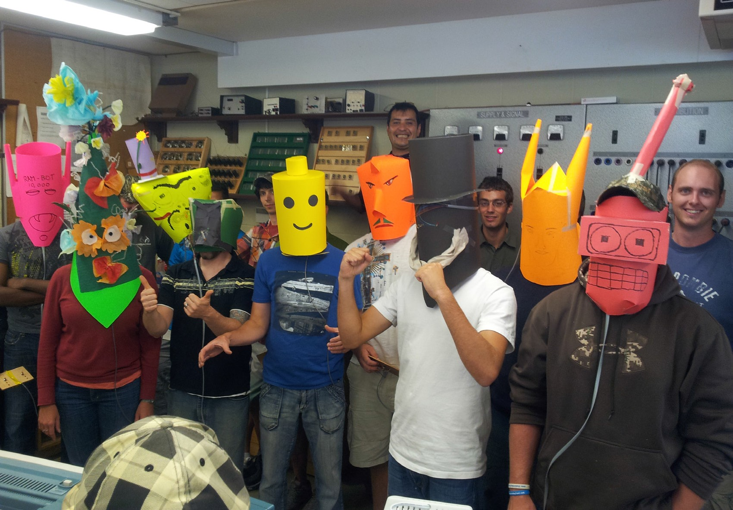

Figure 12—The BCIT TTED Class of 2012 shows off their robot masks

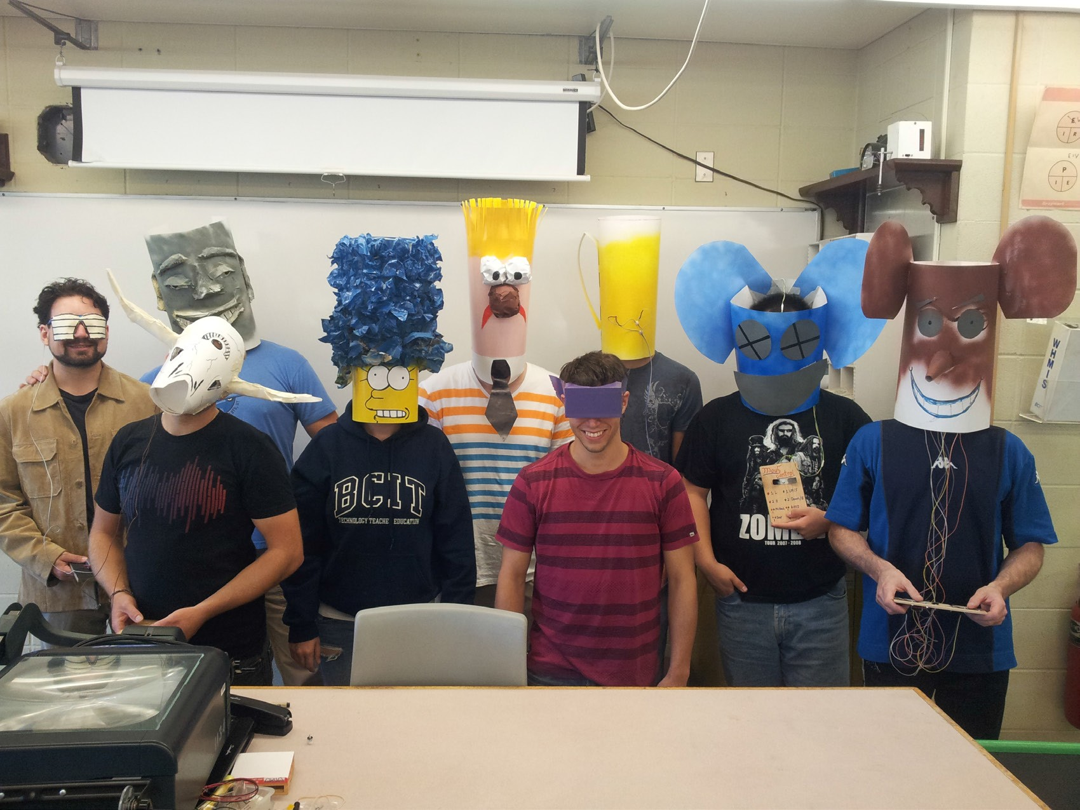

Figure 13—The BCIT TTED Class of 2013 shows off their robot masks

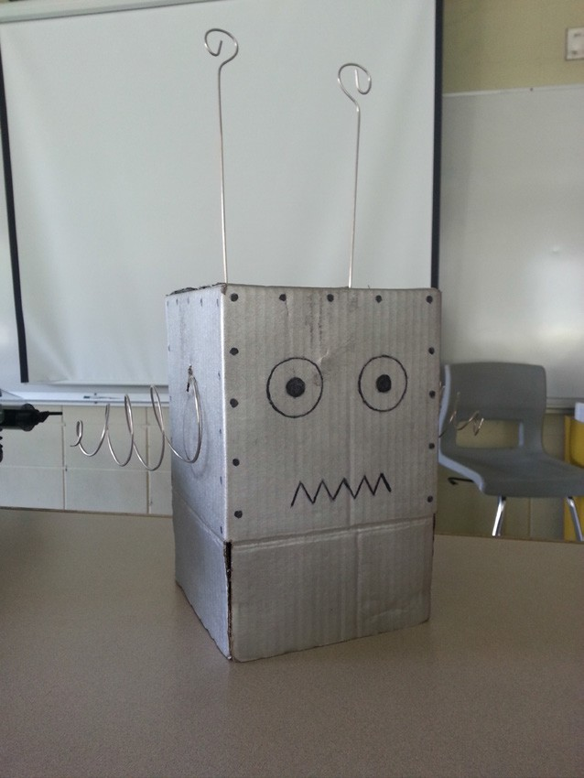

Figure 14—A robot mask created from a cardboard box

Sensors and Control Loops Discussion Suggestions

Human Senses
Ask students to describe what human senses they use to control their body:

How do they know where they are?
  - Sight: References known objects or locations. Provides distance information to objects.
  - Touch: In a dark room they can follow a wall. They stop when they hit an object.

How do they plan a path?
  - Sight: Identify goal and obstacles; plan shortest, safest route.
  - Memory: What path worked best last time?
  - Learning: What path worked best for the other people who tried to navigate this path?

How do they place an object precisely?
  - Sight: They can see where they are putting it in reference to other objects.
  - Touch: They can feel other objects and place the object in relation to those objects.
  - Proprioception: They can feel the position of their body, limbs and digits.

How do they receive feedback on their progress?
  - Sight: They can see how they are progressing.
  - Hearing: They can hear people yelling “Stop” or “Go Left”—low latency communication!

Robot Sensors
What sensors do robots have to control their “body”?

How do they know where they are?
Sight: Visual sensing is a big challenge for robots.

Simple “sight” sensors include:
  - Rangefinders: can identify the distance to an object.
  - Infrared
  - Ultrasonic
  - Laser: Colour sensors can identify colours at short range. Object sensors can identify the presence or absence of an object.
Complex “sight” sensors include:
  - Video cameras: image processing is a real challenge: How does a robot know what a “table” looks like?
  - LIDAR: scanning laser beams develop a 3D “point cloud” view of surroundings.
  - Structured light imaging: Xbox Kinect sensors.

Touch: Robots are good at simple touch sensing but poor at complex sensing.
- Mechanical switches: “Limit switches” are very common and reliable.
- Pressure sensors: Can detect how hard something is being touched.
- Texture sensors: Robots have real difficulty identifying rough, wet or fuzzy surfaces.

Triangulation: Sensing their location relative to known objects
- GPS: measures the distance to orbiting satellites.
- Other radio transmitters with known locations can also be used.
- Cell phone towers and Wi-Fi hotspots can be used.

Dead reckoning: Measuring distance travelled from a known point.
- Stepper motors used in CNC machines and 3D printers move a very precise distance.
- Encoders measure how far a wheel has turned.
- Accelerometers measure how fast a robot is moving.
- Gyros track whether a robot is turning.

How do they plan a path? This is a big challenge for autonomous robots and self-driving vehicles.
Sight: Robots can use visual sensors to identify objects. How do they recognize what the objects or obstacles are?
Memory: Can they relate the objects they sense to a map? Learning: Can they create their own map of an unknown area?

How do they place an object precisely?
Sight: Optical sensors can provide precise location relative to known markings. Touch: Switches and object sensors can place an object precisely.
Proprioception: Encoders and potentiometers can detect the position of joints and slides.

How do they receive feedback on their progress?
Sight: Optical sensors can measure final products for quality control.
Electrical current sensors: Can detect when motors are stalled, jammed or stuck. Human oversight: “Kill” switches and safety interlocks prevent serious damage.

Communication Protocol Discussion Suggestions

Human Communication

What are human communication protocols?
How do you initiate a conversation?
How does someone know you are talking to THEM?
How do you know the other person is ready to communicate? How do you check to ensure the other person heard you?
How do you check to make sure they understood you?
How do you avoid “cross-talk” (having more than one person talk at once)? Is security an issue?
How do you make sure no one else intercepts your communication? How do you terminate a conversation?
Do different cultures or language groups have different protocols?

Robot Communication
Robot communication protocols have to do many of the same things as human protocols. Each protocol has its own rules for initiating, terminating and confirming communications. These are some common protocols used in computer and robotic communications:
  - TCP/IP (Transmission Control Protocol / Internet Protocol)
  - RS-232 is a serial data communication protocol.
  - USB is a higher speed serial data communication protocol.
  - CAN is a communication protocol used in cars and robots.
  - I2C is a communication protocol used between microchips.

Latency and feedback
No message is transmitted instantaneously; even computers have delays.

In an online computer game “ping time” is the time it takes for a message to get from the player’s computer to the host computer and back. Slow pings are no fun.
Have you ever heard a delay when calling overseas on a phone or Skype? Fibre optic cables handle most data and have a low latency. Vancouver to Hong Kong is about 170 ms; Vancouver to Calgary is only about 13 ms. Satellites have longer delays because the signals have to travel further. Minimum latency for a geostationary satellite signal is 240 ms. Latency is a big deal when controlling space probes. It can take over half an hour for a signal to go to Mars and back!
Latency is a big deal in feedback loops. A feedback loop senses an event, then sends a command to adjust for the event. If the temperature goes up, a thermostat will turn off the heater. If a car goes downhill, cruise control will cut back the engine power. If your “robot” is about to walk into a desk, the “controller” will send a “stop” command.

Low latency is important for feedback loops. It allows the robot to move faster and position things more precisely. How does a high ping time affect your feedback loop when gaming? What is the feedback for your “robot” and “controller”? What controls the latency for your robot?

Design a Communication Protocol
You will design a communication protocol for your robot mask. It will be specific to you and your partner.
You will need to consider the following:
- What data do you need to communicate?
- How many LEDs will you need to communicate the data? Fewer LEDs means less work to wire, but it’s more difficult to learn the protocol!
  - Is it possible to create a communication protocol using just one LED?
  - Would it be a good idea to create a protocol using just one LED?
- How will you know that the message has been received?
- How will you know that the correct message has been received?

Write down your communication protocol and practise it by having the “controller” describe the LED pattern verbally and the “robot” respond.
Submit your communication protocol to your teacher for assessment.

Anatomy of a Robot

Description
This lesson is intended to familiarize students with the individual components that comprise a robot. Students will use a graphic organizer to identify the function of each component and the human biological equivalent. They will then categorize the components according to their function.

Lesson Outcomes
Students will be able to:
  - Identify robot components
  - Understand the function of robot components

Assumptions
Students:
  - Will have a basic knowledge of technical/machine parts (wheels, batteries, cables, gears, etc.)
  - Know how to use basic hand tools like allen keys, screwdrivers and wrenches

The teacher will:
  - Have a basic knowledge of constructing using simple fasteners
  - Have some experience using a relevant educational robotics platform
  - Have gone through the parts list of robot kits and be able to somewhat identify their functions

Key Terminology
The following outlines the general parts of the three most common education robot kits (LEGO Mindstorms EV3, VEX IQ, VEX EDR). These are the parts that students will identify and determine the biological equivalent of.
For in-depth definitions, please refer to the platform booklet that comes with the kit.
Bumper switch: allows a robot to detect an obstacle or limit the movement of a component.
Colour sensor: allows a robot to measure colours.
External control: a hand-held remote control device (VEX). iOS/Android app for LEGO Mindstorms programming software.
Gyro sensor: allows a robot to measure turn rate and angles.

This work is licensed under a Creative Commons Attribution-NonCommercial-ShareAlike 4.0 International License unless otherwise indicated. 49

Input devices: sensors that gather information from the physical world.

Limit switch: similar to a bumper switch but with a flexible lever arm triggering the switch. It allows for more flexible mounting options than the bumper switch.
Line tracker: allows a robot to follow a line over a surface.

Mechanical encoders: an encoder that works using a mechanical switch to generate the electrical pulses. Mechanical encoders may have a "click-click" feel to them and typically operate at lower speed and with lower resolution than optical encoders.
Output device: a device that allow the processing unit to affect the robot’s environment, through movement (motors, solenoids), light, sound or other means.
Power supply: the main source of electrical power for the robot.

Processing unit: also known as the brain or the brick, this is the part of the robot that stores the program information, receives instructions from the user, reads the sensors and controls the outputs.
Reflective object sensor: similar to a colour sensor, but includes a light source and detects the presence or absence of a reflective object at very short range (typically < 5 mm). An arrangement of two or more reflective object sensors can form a line tracker.

Estimated Time
45 minutes

Recommended Number of Students
Up to 30 students

Facilities
Sufficient workspace for teams of students to investigate the robot components. Ideally an arrangement of large desks, plus storage space for the robot kits.

Tools
No additional tools are required for this activity.

Materials
Each group of students will need a robot kit to explore. Graphic organizer on page 53

Resources
An unboxing video of the LEGO Mindstorms EV3 Education kit: https://www.youtube.com/watch?v=t6JVZ2W2KzY
A list of LEGO Mindstorms EV3 parts: http://brickset.com/inventories/31313-1
VEX and VEX IQ parts and documentation can be found on the VEX Robotics website: http://www.vexrobotics.com/
More specific references can be found in the VEX curriculum documentation:

For VEX IQ:
http://www.vexrobotics.com/vexiq/education/iq-curriculum/lets-get-started

For VEX EDR:
http://curriculum.vexrobotics.com/curriculum/intro-to-robotics/vex-robotics-design-system

Procedure
- To start this activity the teacher should briefly discuss the basics of constructing the platform to be used. There are differences between LEGO, VEX IQ and VEX EDR. LEGO and VEX IQ use a piece-to-piece, snap-together style of construction much like mainstream LEGO. The VEX kits use fasteners such as screws, rivets, nuts, couplers, universal joints and hinges. It should also be mentioned that, specifically with the LEGO and VEX IQ kits, the plastic should not be torqued unnecessarily or breakage might occur.
- Have students open their kits and identify the parts using the booklet provided. Teachers can have them read up on the components or give an explanation of each.
- Pass out the graphic organizer. Have students fill in the components and their biological equivalents. The third column asks for the function of both (wheels and feet allow for movement; bump sensor and skin allow for sensing objects; limit switch and joints allow for a given range of motion, etc.).
- Have students move on to the next portion of the graphic organizer. They are to categorize the components using their own headings. Ideally they will use categories like structures, sensors, wires/cables, fasteners, processing, output, etc.
- When finished, have students share their findings with another group.

Assessment
The evaluation of this lesson is based on the Lesson Outcomes outlined above.

Prior to teachers using the evaluation grid it is recommended that students should perform some form of peer assessment and self-assessment.

 | Outcome To Be Assessed | 6 | 5 | 4 | 3 | 2 | 1 | 0
Outcome 1 | Identify robot components
1.1 | Identifies the components of a robot.
Outcome 2 | Understand the function of robot components
2.1 | Understands the variety of component functions.
2.2 | Is able to categorize components.

Total Points:

6 | Completed successfully at the exceptional level | Exemplary
5 | Completed successfully at higher than the expected level | Accomplished
4 | Completed successfully to the expected level | Emerging
3 | Attempted successfully at the minimum level | Developing
2 | Attempted - Unsuccessful - Close to Successful | Beginning
1 | Attempted - Unsuccessful | Basic
0 | Not Attempted | N/A
Comments:

Anatomy of a Robot Graphic Organizer

Name:

Use the table below to define robot components and their biological equivalents.

Robotics Component | Biological Equivalent | What is their function?

When you are finished, please categorize the components as best as you can using your own headings.

Anatomy of a Robot
Electronics and Robotics

Youth Explore Trades Skills Electronics and Robotics

Robot Golf: Autonomous Challenge

Description
This activity is a programming challenge that puts the robot in autonomous mode to complete a task. Students will create a series of programmed instructions that will be installed in the robot. These instructions are then executed by the robot. Students are evaluated by the success of the robot’s task performance.
On a large sheet of paper, draw a short “golf course” consisting of four “holes.” Identify the four starting points (tee-offs) and four ending points (holes) as the golf course. See the example supplied in Figure 1.
Students will start their robot on the first tee and drive it to the hole without going off course. Repeat until the robot successfully completes all four of the golf course holes. Adjust the installed program accordingly.
This activity helps students to:
  - Apply mathematics to their robot design and computer program
  - Learn from their mistakes and course-correct
  - Apply iterative programming and testing to complete a task

Lesson Outcomes
Students will be able to:
  - Program a robot to navigate and complete the golf course
  - Test and improve robot performance
  - Work as a team to accomplish a goal

Assumptions
Students will have:
  - Knowledge and understanding of basic construction techniques
  - Access to robotics platforms and necessary equipment
  - Access to computers and programming software

Key Terminology
Boundary: a physical or non-physical barrier within which the robot operates.
Feedback: information from either the robot or a teammate with respect to actual performance.
Line tracker: allows a robot to follow a line over a surface.
Sensor: a device that provides information about the environment to a device or robot.

This work is licensed under a Creative Commons Attribution-NonCommercial-ShareAlike 4.0 International License unless otherwise indicated. 55

Estimated Time
Total time: 1¾ hours to about 3 hours:
    - 30–45 minutes to create the golf course (if not prepared ahead of time by teacher)
    - 15–20 minutes for demonstration and verbal instruction exercise
    - 60–120 minutes to write/test/improve program

Recommended Number of Students
Two to five students per robot, per team (ideal: three students) Two to five teams

Facilities
A large, flat surface in a cafeteria, gym or large classroom where the golf course can fit—ideally on a table or a clean floor

Tools
Tools are platform-specific based on the robotics platform selected.

A basic tool kit that includes pliers, wrenches, nail files (to round off sharp corners)

Desktop or laptop computer with programming software for the robot (e.g., FLOWOL, RobotC, EasyC, Modkit, etc.)

Materials
A large piece of paper with a golf course painted or drawn on it One robot per team

Resources
Search YouTube for robot programming demonstration videos.

You may also reference:

Jr. Robotics: a place for teachers, students and parents
https://vsbrobotics.wordpress.com/challenge-1a-robot-golf/

Website forums for team-to- team or peer-to-peer online discussions regarding programming their robot:

Vex IQ Forum
http://www.vexiqforum.com/

Vex EDR Community Forum
http://www.vexforum.com/

FIRST Forums
http://forums.usfirst.org/

Demonstration
This human demonstration helps students to develop a programming mindset before working with a robot.
First, have the students form teams and identify one person in the team to act as a robot, another to act as a programmer (gives instructions to the robot) and a third to act as a scribe.
The programmer gives exact instructions to the “robot” to walk to a specific destination while the scribe records the exact information.

Procedure
Ideally, students should first complete the robot golf challenge by using a hand-held remote control (driver). A partner(s) should take notes of the exact series of instructions to be given to the robot to perform the task, such as completing a golf course hole. Next, the students should write a computer program to do the same task autonomously. Repeat this process until all the golf course holes are completed.
The steps for the activity are:
- Have students form robot teams consisting of programmers and scribes. (Ideally two to three students per team)
- Draw a golf course consisting of four holes on a large piece of paper. Make sure the golf course holes are large enough for the robots to fit into the hole. See Figure 1.

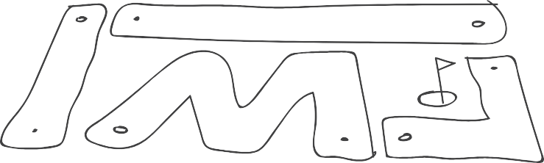

Figure 1—Example of a four-hole robot golf course

- Teams take turns driving their robot through the course using a remote control. It might be easier to have teams start on different holes so as to avoid congestion on the course. Team scribes take notes of the exact controller movements and robot behaviour for their first hole.
- Teams then begin writing their programs in order to complete their first hole.

- At this point, teams can start testing/rewriting their programs, working their way through all of the holes.

Assessment
The evaluation of this lesson is based on the learning outcomes outlined above.

Prior to teachers using the evaluation grid it is recommended that students perform some form of peer-assessment and self-assessment.

 | Outcome To Be Assessed | 6 | 5 | 4 | 3 | 2 | 1 | 0
Outcome 1 | Program a robot to navigate and complete the golf course
1.1 | Robot navigated the maze(s)/obstacle(s).
1.2 | Robot successfully avoided object(s).
1.3 | Computer program operated as expected.
Outcome 2 | Test and improve robot performance
2.1 | Uses field to test program.
2.2 | Uses information from testing to improve performance.
Outcome 3 | Teamwork
3.1 | Students able to resolve errors when encountered.
3.2 | Division of work.
3.3 | Effort of each team member.

Total Points:

6 | Completed successfully at the exceptional level | Exemplary
5 | Completed successfully at higher than the expected level | Accomplished
4 | Completed successfully to the expected level | Emerging
3 | Attempted successfully at the minimum level | Developing
2 | Attempted - Unsuccessful - Close to Successful | Beginning
1 | Attempted - Unsuccessful | Basic
0 | Not Attempted | N/A
Comments:

Extension Activities
Go to the Classroom Challenges section at the bottom of the following webpage to see possible extension activities.

Jr. Robotics: a place for teachers, students and parents
https://vsbrobotics.wordpress.com/

Robot Golf: Autonomous Challenge
Electronics and Robotics

Effective Robotics Team Communication

Description
Working with robotics often involves working in teams, with team members holding different roles and responsibilities in order to accomplish a given task. Effective communication between team members is critical in reducing wasted time and energy and accomplishing the task to the highest possible standards.
This activity builds team communication as a core competency while working with robots and highlights the importance of specificity in team communication.
Students work in teams of three with strict parameters around what each student can do and who they can communicate with.
Each student may choose from the following three roles:

Technician
Works on the robot. Can only communicate with the coordinator.

Programmer
Works on the programming of the robot. No one else is permitted to use the computer to change the program. Can only communicate with the coordinator.

Coordinator
Works as an intermediary between the technician and the programmer. The coordinator is the conduit for the group’s communication.
Depending on class size and group size you may choose to have multiple students fulfilling each role; these small teams must also learn to communicate and collaborate together for optimal task accomplishment.
The roles can be maintained throughout the duration of the activity or they can be changed every 30 or 60 minutes.
The task for this lesson may vary depending on the abilities of the class. Potential tasks might include:
- Drive your robot a predefined distance.
- Navigate your robot around the legs of a table or chair in a predetermined pattern.
- Perform a task that incorporates a sensor (e.g., use the touch sensor to bump into an object and then turn around).

This work is licensed under a Creative Commons Attribution-NonCommercial-ShareAlike 4.0 International License unless otherwise indicated. 61

Lesson Outcomes
Students will be able to:
  - Communicate effectively and efficiently with team members, highlighting the importance of specificity in their language
  - Work as a team to achieve a goal
  - Program a robot to solve a problem

Assumptions
It is also assumed that students:
  - Know how to use and program robots
  - Know how to build robots and implement sensors
  - Can communicate using technical language
  - Can work in teams with specific roles and responsibilities

Key Terminology
Bumper switch: allows a robot to detect an obstacle or limit the movement of a component.
Colour sensor: allows a robot to measure colours.
Distance sensor: allows a robot to measure distance using ultrasonic waves.
Encoder: allows a robot to monitor the position of a shaft or axle by monitoring pulses triggered by the rotation of the shaft. The software required to use an encoder is typically more complex than that used for a potentiometer, but the ability to monitor the position of continuously rotating shafts (such as axles) makes it a very useful sensor for tracking robot speed and position using dead reckoning.
Gyro sensor: allows a robot to measure turn rate and angles.
Limit switch: similar to a bumper switch but with a flexible lever arm triggering the switch. It allows for more flexible mounting options than the bumper switch.
Potentiometer: allows a robot to determine the position and direction of rotation of a shaft.
Reflective object sensor: similar to a colour sensor, but includes a light source and detects the presence or absence of a reflective object at very short range (typically < 5 mm). An arrangement of two or more reflective object sensors can form a line tracker.
Robot controller: the brain of a robot that can be programmed using software. A robot controller sends instructions to the components of a robot and receives input from sensors.

Estimated Time
2–3 hours, depending on chosen robot task

Recommended Number of Students
1 robot per 3 students but can be adjusted to suit class size and availability of robots

Facilities
This lesson ought to use two rooms to keep the programmer and the robot technician separate. Alternatively, workbenches and robots could be on one side of the lab and computers on the other.

Tools
- Appropriate sensors for assigned task/problem
- Computer with access to programming software

Materials
Paper for notes and diagrams
An assembled robot from a previous project or activity

Resources
Below are some examples of possible tasks for teams to work toward:
Learning Aid: Technical Terms for Describing Drawings Pipe inspector challenge https://www.youtube.com/watch?v=CiBCAXetZuE

Line follow
https://www.youtube.com/watch?v=BvChC6J6bNE

Demonstration
This simple exercise can give students an idea of the importance of specificity when working in teams and in robotics.
First, have students self-select into their groups of three and co-determine their group roles. The programmer and technician are not to speak to each other and should ideally be in separate rooms or on opposite sides of the classroom.
The technician is tasked with drawing a stick man or something quite simple but can ONLY take instructions from the coordinator. The coordinator is being instructed by the programmer. The coordinator can have some input as well, but ultimately they are listening to the programmer.
After many interactions between the members, they will begin to see how critical clear and concise instructions are to succeeding in their task.

Procedure
- Decide on the task that the teams will be performing with their robot and communicate this to the class.
- The groups will need some time to design or redesign their robots. The technician is the manager of this process while the other two are meant to be in a more supporting role.
- Once the redesign phase is complete, the groups are to be separated as much as possible so that the importance of communication can be emphasized.
- If you are opting for team members to switch roles at intervals, be sure to communicate this to the groups.
- The teams can start testing out the robot’s task only once the members have been separated from each other. This way the major bugs and inadequacies can be worked out first before the fine-tuning can begin.
- Once students feel that they have achieved the task to their satisfaction (or the allotted time has elapsed), they can begin the assessment process.

Assessment
The evaluation of this lesson is based on the four outcomes outlined above.

Prior to teachers using the evaluation grid it is recommended that students should perform some form of peer-assessment and self-assessment.

 | Outcome To Be Assessed | 6 | 5 | 4 | 3 | 2 | 1 | 0
Outcome 1 | Communicate effectively and efficiently
1.1 | Values the importance of specificity.
1.2 | Clarity of verbal communication.
1.3 | Uses technical language.
Outcome 2 | Teamwork
2.1 | Division of work.
2.2 | Effort of each team member.
2.3 | Works as a team to achieve a goal.
Outcome 3 | Program a robot to solve a problem
3.1 | Understands and uses appropriate software.
3.2 | Applies terminology appropriately.

Total Points:

6 | Completed successfully at the exceptional level | Exemplary
5 | Completed successfully at higher than the expected level | Accomplished
4 | Completed successfully to the expected level | Emerging
3 | Attempted successfully at the minimum level | Developing
2 | Attempted - Unsuccessful - Close to Successful | Beginning
1 | Attempted - Unsuccessful | Basic
0 | Not Attempted | N/A
Comments:

Effective Robotics Team Communication
Electronics and Robotics

Program Your Robot to Perform a Task

Description
In this activity, students gain hands-on experience with programming a robot to perform tasks.

This activity includes seven task challenges. Students will work in teams with a time boundary to perform as many task challenges as possible. Be sure to consult the “Materials” section before beginning the activity to ensure you have all that you need to complete the challenges.
Challenge 4 requires a ramp with balls inserted into holes along the ramp’s perimeter. See Figure 1 in the Procedure section for an example.
Students will be required to work with inputs and outputs under various conditions within the computer program.

Lesson Outcomes
Students will be able to:
- Use programming software to create a set of instructions for the robot to perform a task
- Upload the program to the robot
- Troubleshoot errors in the computer program code
- Adapt programming code to solve a challenge more efficiently
- Effectively communicate and work in a team
- Use appropriate terminology to describe the components in their electronic circuit

Assumptions
Students will have:
- Some experience with computer programming and sensors
- Some experience with computer interfaces, saving and opening files

Key Terminology
Rolling platform robot: a basic robot that can move from one location to another.

Estimated Time
3+ hours

Recommended Number of Students
2–3 students per robot team

This work is licensed under a Creative Commons Attribution-NonCommercial-ShareAlike 4.0 International License unless otherwise indicated. 67

Facilities
Any classroom with tables

Robot testing area: table that is 120 × 240 cm, 120 × 120 cm, etc. (4' × 8', 4' × 4', etc.)

Tools
Computers and programming software

Tools are platform-specific based on the robotics platform selected

A basic tool kit that includes pliers, wrenches, nail files (to round off sharp corners)

Materials
Robot kits (e.g., VEX EDR, VEX IQ, LEGO Mindstorms) A ramp with small balls (see Figure 1)
Objects of various sizes that the robot will pick up

Resources

VEX Robotics
http://www.vexrobotics.com/

LEGO
http://www.lego.com/en-us/mindstorms

Computer programming examples:

Program your LEGO NXT Robot
https://vsbrobotics.wordpress.com/program-your-lego-nxt-robot/

Program your VEX IQ Robot
https://vsbrobotics.wordpress.com/program-your-vex-iq-robot/

Program your VEX EDR Robot
https://vsbrobotics.wordpress.com/program-your-vex-robot/

Website forums for team-to-team or peer-to-peer online discussions:

VEX IQ Forum
http://www.vexiqforum.com/

VEX EDR Forum
http://www.vexforum.com/

FIRST Forums
http://forums.usfirst.org/

Procedure
First, teams will build a rolling platform robot on wheels that has components to pick up objects and release them.
Next, have various objects available for the robot to pick up and drop off. Students may make additional attachments such as a small arm or claw to help to help to complete the challenge.
Also, have a ramp built with balls inserted into holes along the ramp’s perimeter (Figure 1).

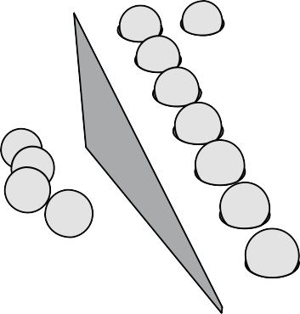

Figure 1—Ramp with balls inserted into holes

The following challenges are not intended as classroom competitions but rather as in-class exercises that will give a better understanding of how to use computer programs to enable robots to perform various tasks. Each activity should be demonstrated in front of the teacher and/or the entire class. The criteria for each activity can be decided based on available materials, space and student ability.

Challenge 1
Write a computer program to move the rolling platform robot forward for a few seconds and stop. Install the program into the robot and test your program; revise as necessary.

A video example of Challenge 1
http://youtu.be/5Wk3hXGlN-I

Challenge 2
Write a computer program to move the rolling platform robot forward for a few seconds, turn around and return to the starting position. Install the program into the robot and test your program; revise as necessary.

A video example of Challenge 2
http://youtu.be/D-Byf8K- -2Q

Challenge 3
Write a computer program to move the rolling platform robot forward for a few seconds, turn left or right, move forward for a few more seconds, then return to the starting position. Install the program into the robot and test your program; revise as necessary.

Challenge 4
Write a computer program to move the rolling platform robot forward and up a ramp (Figure 1) and knock the balls off, then return to the starting position. Install the program into the robot and test your program; revise as necessary. Each ball knocked off counts as a point toward this challenge.

Challenge 5
Write a computer program to move the rolling platform robot to pick up an object and return the robot to its starting spot. Install the program into the robot and test your program; revise as necessary.

Challenge 6
Write a computer program to move the rolling platform robot to pick up an object, deliver it to a specific location and return the robot to the starting spot. Install the program into the robot and test your program; revise as necessary.

A video example of Challenge 6:
http://youtu.be/xBZRK1NunFQ

Challenge 7
Write a computer program to move the rolling platform robot to pick up an object and deliver it to a specific location. Install the program into the robot and test your program; revise as necessary.
Next, have the robot pick up a second object, stack it on top of the first object, then return the robot to its starting spot.

Extension Activities
Additional activities that can be added as an extension of this activity can be found under “Classroom Challenges” at:

Jr. Robotics: a place for teachers, students and parents
https://vsbrobotics.wordpress.com/

Assessment
The evaluation of this lesson is based on the learning outcomes outlined above.

Prior to teachers using the evaluation grid it is recommended that students perform some form of peer-assessment and self-assessment.

 | Outcome To Be Assessed | 6 | 5 | 4 | 3 | 2 | 1 | 0
Outcome 1 | Using programming software
1.1 | Successfully writes programs to perform robot tasks.
1.2 | Robot responds as expected.
1.3 | Attempted a variety of task challenges.
Outcome 2 | Troubleshooting errors
2.1 | Effectively responds to errors and course-corrects.
Outcome 3 | Teamwork
3.1 | Division of work.
3.2 | Effort of each team member.
Outcome 4 | Understanding Key Terminology
4.1 | Demonstrates the use of Key Terminology.
4.2 | Applies terminology appropriately.

Total Points:

6 | Completed successfully at the exceptional level | Exemplary
5 | Completed successfully at higher than the expected level | Accomplished
4 | Completed successfully to the expected level | Emerging
3 | Attempted successfully at the minimum level | Developing
2 | Attempted - Unsuccessful - Close to Successful | Beginning
1 | Attempted - Unsuccessful | Basic
0 | Not Attempted | N/A
Comments:

Program Your Robot to
Perform a Task
Electronics and Robotics

Solve a Problem Using Design Thinking

Description
Design thinking is way of looking at the world in a way that sees possibilities and solutions rather than obstacles and problems.
This lesson introduces the idea of using design thinking to tackle real-world problems. By using this process, students will come to understand an effective way of finding solutions and how they can be implemented using robots. Ideally, students will be in groups of three to four per robot for this lesson, but this could be adjusted depending on class size.

Lesson Outcomes
Students will be able to:
- Understand and apply the iterative nature of the design process
- Effectively communicate and work in a team
- Apply their understanding of robotics systems and components

Assumptions
Students will:
- Have little experience using the design thinking process (empathize, define, ideate, prototype, test, repeat)
- Have some experience with solving problems in groups
- Have some experience with building and programming robots
- Understand the basics of robot sensors and their functions
- Hold a basic understanding of programming structures as they relate to robotics and their specific platform

Key Terminology
Bumper switch: allows a robot to detect an obstacle or limit the movement of a component.
Colour sensor: allows a robot to measure colours.
Design Thinking: is an approach to solutions-finding that considers the desired end-result or experience. A Design Thinking approach is often iterative, starting with the definition of a problem, empathetically considering the experience or impact of that problem from multiple
perspectives, considering multiple approaches to potential solutions, then narrowing down the solution through prototyping or experimentation. The chosen approach to the solution is then selected and implemented.

This work is licensed under a Creative Commons Attribution-NonCommercial-ShareAlike 4.0 International License unless otherwise indicated. 73

Distance sensor: allows a robot to measure distance using ultrasonic waves.
Gyro sensor: allows a robot to measure turn rate and angles.
Limit switch: similar to a bumper switch but with a flexible lever arm triggering the switch. It allows for more flexible mounting options than the bumper switch.
Potentiometer: allows a robot to determine the position and direction of rotation of a shaft.
Prototype: an early model of a product built to test a product or process.
Reflective object sensor: similar to a colour sensor, but includes a light source and detects the presence or absence of a reflective object at very short range (typically < 5 mm). An arrangement of two or more reflective object sensors can form a line tracker.
Robot controller: the brain of a robot that can be programmed using software. A robot controller sends instructions to the components of a robot and receives input from sensors.

Estimated Time
Approximately 4 hours:
  - 30–60 minutes for the design thinking process
  - 30–60 minutes to redesign/customize/build a robot that is tailored to the proposed solution
  - 2 hours to test the prototype and repeat the design process until an adequate solution is found

Recommended Number of Students
20–25 students

Facilities
A computer lab with programming software or reasonable equivalent is required to complete this activity.
It is also recommended that tables be arranged in pods so that groups of students can work together during the design thinking process.

Tools
Ideally there should be an assortment of standard classroom supplies that will aid the students in their problem solving.

Materials
Each small group should have:
- A design-thinking worksheet for each member to think through the process (see example at the end of this activity)
- A robot and associated sensors
- A computer with the appropriate programming software

Resources
A video that briefly explains what design thinking is: https://www.youtube.com/watch?v=a7sEoEvT8l8
A TED talk by Tim Brown that discusses design thinking and encourages designers to think bigger:
https://www.ted.com/talks/tim_brown_urges_designers_to_think_big?language=en

Procedure
- Divide the class into groups of three to four, or divide the class into the same number of groups as the number of robots available.
- The teacher can briefly introduce the idea of design thinking and how it makes peoples’ lives better. See videos in the “Resources” section for some suggestions.
- Hand out the Design Thinking Worksheet to each student. These will be handed back to the teacher for assessment at the end of the activity; it is recommended that the teacher communicate this to the class. This structured process is intended to honour all voices in a group, to hold each team member accountable for their creative contributions and for the teacher to have a record of the design process of each student for the purposes of assessment at the end of the activity.
- Using the Design Thinking Worksheet, students are to start with the first box, “Empathize/ Define,” and think about problems in everyday life that could be solved using the available robots. It may help to prompt students by asking, “Why is this a problem?” Teachers will likely need to encourage students to focus on defining the problem rather than jumping to solutions-finding at this point.
- Students should share the problems they identified in the group. Ensure that everyone’s ideas are given equal time. After each member’s problem ideas have been shared, groups can take approximately 10–15 minutes to discuss and decide which problems they would like to tackle for their robot design.
- The groups will then move on to the second box, “Ideate,” where they will brainstorm possible solutions to their problems. This can take anywhere from 10 to 20 minutes, depending on the creativity of the group. Students are encouraged to focus on why their

solution might work rather than why it might not, focussing their attention on possibilities rather than obstacles. Remember that it can be quite challenging to think creatively within a time boundary, so be aware that some students may struggle with this phase. Encourage each student have at least one idea to share at the end of the time period.
- Again, students will take approximately 10–15 minutes to share their potential solutions to
the chosen problem. If a group can’t decide which idea to move forward with, it is acceptable to advance to the Prototyping phase with more than one possible solution. Having multiple solutions to prototype can help trigger creativity.
- Each student should then come up with at least two if not three different prototypes. Students should consider the available robots and components when prototyping. Allow 15–30 minutes for this phase. Again, each student shares their ideas with the group; the group decides on the direction they will take.
- Allow for 30–45 minutes for groups to build and modify their robots according to their design.

- Once their machine is built, groups should begin testing their design for effectiveness. Steps 9 and 10 should be repeated in as many iterations as necessary until they have solved their problem to their satisfaction.
- To culminate the lesson, each group should present and demonstrate their chosen problem, their ideation process and the solution to the class.

Assessment
The evaluation of this lesson is based on the three outcomes outlined above.

Prior to teachers using the evaluation grid it is recommended that students perform some form of peer assessment and self-assessment after they have presented their work to the class.

 | Outcome To Be Assessed | 6 | 5 | 4 | 3 | 2 | 1 | 0
Outcome 1 | Understand and apply the iterative nature of the design process
1.1 | Produced ideas at all three stages of the design process.
1.2 | Contributed during the testing/modifying phase.
Outcome 2 | Effectively communicates and works in a team
2.1 | Contributes to a solution-oriented environment.
2.2 | Demonstrates effective communication and teamwork during prototyping and testing.
Outcome 3 | Apply their understanding of robotics systems and components
3.1 | Uses controller/motors/sensors to solve the problem.
3.2 | Uses software to modify program during testing.

Total Points:

6 | Completed successfully at the exceptional level | Exemplary
5 | Completed successfully at higher than the expected level | Accomplished
4 | Completed successfully to the expected level | Emerging
3 | Attempted successfully at the minimum level | Developing
2 | Attempted - Unsuccessful - Close to Successful | Beginning
1 | Attempted - Unsuccessful | Basic
0 | Not Attempted | N/A
Comments:

Solve a Problem Using Design Thinking
Electronics and Robotics

1
Electronics and Robotics
Solve a Problem Using Design Thinking

Design-thinking Worksheet

Name:

This will be handed in to your teacher.

Empathize with the people you wish to help and define the problem you wish to solve.

Ideate: without focussing on barriers, what are 4–6 creative solutions to the problem?

Prototype 3 Ideas

Solve a Problem Using Design Thinking Electronics and Robotics

80 Youth Explore Trades Skills

Robot Hill Climb

Description
Before you begin this activity you will need to assemble or construct an inclined hill course. Figure 1 in the Materials section shows an example.
This activity can be approached as a driver challenge and/or as a programming challenge.

Students will build a robot that will climb a number of different ramps or inclined hills at varying degrees of incline. Students will experiment with different-sized gear wheels to test and assess optimal performance in the various hill climbs. Once this activity has been completed as a driver challenge (using a driver with a remote control), it can be repeated as an autonomous challenge (using a computer program to control the robot).
This activity helps students to apply mathematics and science to their robot design and their computer program, allowing them to learn from their mistakes and course-correct to improve their performance.

Lesson Outcomes
Students will be able to:
- Construct and operate a robot to climb a number of ramps or inclined hills
- Follow instructions to complete a complex task
- Solve technical problems using prior learning from other courses such as Science and Math
- Understand and apply gear ratios to design
- Apply design thinking to improve their robot’s performance
- Understand the importance of teamwork

Assumptions
Students will have:
- Knowledge and understanding of basic construction techniques
- Formed teams and partnerships within the classroom
- Access to robotics platforms and necessary equipment
- Some knowledge of gear ratios, robots and design
- Some experience with basic mathematics and friction

This work is licensed under a Creative Commons Attribution-NonCommercial-ShareAlike 4.0 International License unless otherwise indicated. 81

Key Terminology
Center of gravity: a focal point where an object is standing at its design maximum without falling down.
Friction: heat caused by opposing forces acting on a surface. OR a force that resists motion between two surfaces sliding against each other; strength of the force is determined by their textures.
Gear ratio: the science of mechanical advantage using gears.
Torque: also known as moment. The force of a moving object connected to a single point.
OR the measurement of force causing rotation.
Traction: the ability to grip a surface.

Estimated Time
Approximately 16 hours:
  - Project overview and group formation – 1 hour
  - Build time to test phase – approximately 10 hours
  - Rebuild time and modifications – 5 hours

Recommended Number of Students
Two to five students per robot, per team (ideal: three students) Two to five teams

Facilities
Any classroom that fits the hill course you have constructed

Tools
Tools are platform-specific based on the robotics platform selected.

A basic tool kit that includes pliers, wrenches, nail files (to round off sharp corners)

Computer with programming software for the robot (e.g., FLOWOL, RobotC, EasyC, Modkit, etc.)

Materials
A construct that includes multiple ramps and inclines (see Figure 1)

Multiple-sized gear wheels to attach to the robots (included with the robot kits) Paper to draw diagrams and to track progress

Figure 1—Example of an inclined hill course.

Resources
An example of an inclined hill course made from cardboard: https://vsbrobotics.wordpress.com/challenge-1b-king-of-the-hill/

VEX Robotics
http://www.vexrobotics.com/

LEGO
http://www.lego.com/en-us/mindstorms

Website forums for team-to-team or peer-to-peer online discussions:

VEX IQ Forum
http://www.vexiqforum.com/

VEX EDR Forum
http://www.vexforum.com/

FIRST Forums
http://forums.usfirst.org/

Demonstration
It is recommended that teachers preview the following videos before showing them to their students.
The following videos provide an understanding of gear ratios: Gear Ratios - Part 1 https://www.youtube.com/watch?v=B4j2VPHVm6o

Gear Ratios - Part 2
https://www.youtube.com/watch?v=h1vfR9YvjMA

Gear Ratios - Part 3
https://www.youtube.com/watch?v=-q5FmanzCw4

The following videos provide an understanding of speed vs. strength (torque):
Understanding Gears: Speed Vs. Torque: a two-minute demo of simple gear ratios https://www.youtube.com/watch?v=UUfZnZ_0Cb8

LEGO Technic - Torque, Speed, Gearing
https://www.youtube.com/watch?v=KKQHqPIuEVc

Also, discuss centre of gravity as a concept, and how it affects the construction and operation of your rolling platform.

Procedure

Before beginning the activity:
  - Construct the inclined hill course using available materials or cardboard (see Figure 1).
  - Teacher should decide how students will best track their observations and findings, with the understanding that there will be an opportunity to present their findings. Suggestion: have students track their progress by creating a table, PowerPoint using slides, design notebook, etc.
- Create a rolling platform with driving wheels connected directly to the motor.

- Run the rolling platform up one of the ramps (inclined hill course) and observe the performance of the robot.
- Experiment with different sizes of gear wheels, as illustrated in Figures 2–5, below. Test the rolling platform on the ramp again and notice the changes (if any) to the overall performance. Some guiding questions for this experiment include: How will the performance of the robot improve if more gears of the same size are added? How might performance of the robot improve if more gears of different sizes are added?
- After experimenting with different-sized gear wheels, draw a conclusion as to which set of gears works best for this particular ramp. Repeat this process until the robot has completed all the ramps.
Students will take turns presenting to the class their understanding of speed vs. strength (torque), explaining how the different gear wheel sizes influence climbing performance.
- Complete the activity by testing the robot’s ability to climb the various inclines.

It is recommended that this activity be completed using a driver-controlled robot first and, if time permits, again using an autonomous controlled robot to demonstrate programming skills.

Figure 2 | Wheel Gear wheels | Motor attached to this gear wheel
Figure 3 | Wheel Gear wheels | Motor attached to this gear wheel
Figure 4 | Wheel Gear wheels | Motor attached to this gear wheel
Figure 5 | Wheel Gear wheels | Motor attached to this gear wheel

Assessment
The evaluation of this lesson is based on the learning outcomes outlined above.

Prior to teachers using the evaluation grid it is recommended that students perform some form of peer-assessment and self-assessment.

 | Outcome To Be Assessed | 6 | 5 | 4 | 3 | 2 | 1 | 0
Outcome 1 | Construction of a robot
1.1 | Constructs a robot to specifications.
1.2 | Robot performs to expectation.
Outcome 2 | Climbing a series of hills
2.1 | Understands/applies gear ratios.
2.2 | Understands external influences such as friction.
Outcome 3 | Use of design thinking to solve challenge
3.1 | Uses the design thinking cycle.
3.2 | Uses and applies prior learning from other courses such as Science and Math.
3.3 | Successfully adapts robot performance to different incline challenges.
Outcome 4 | Teamwork
4.1 | Able to resolve errors when encountered.
4.2 | Division of work.
4.3 | Effort of each team member.
Outcome 5 | Understanding Key Terminology
5.1 | Demonstrates the use of Key Terminology.
5.2 | Applies terminology appropriately.

Total Points:

6 | Completed successfully at the exceptional level | Exemplary
5 | Completed successfully at higher than the expected level | Accomplished
4 | Completed successfully to the expected level | Emerging
3 | Attempted successfully at the minimum level | Developing
2 | Attempted - Unsuccessful - Close to Successful | Beginning
1 | Attempted - Unsuccessful | Basic
0 | Not Attempted | N/A
Comments:

Extension Activities
Consult the ”Classroom Challenges” on the following website for additional activities as extensions of this activity:

Jr. Robotics: a place for teachers, students and parents
https://vsbrobotics.wordpress.com/

Robot Hill Climb
Electronics and Robotics

Robot Arm Challenge

Description
In this activity students are introduced to fluid power, articulated robot arms and end effectors. Students will work with a partner to design and construct an arm that allows them to move a number of small objects from one location to another.
This activity helps students by:
- Introducing them to fluid power (hydraulics and pneumatics)
- Introducing them to the concept of moment (torque)
- Developing design and manufacturing skills
- Demanding teamwork and cooperation to accomplish a task

Lesson Outcomes
Students will be able to:
- Describe the operation of a fluid power system, including:
- How pressure and piston area affect force
- The relationship between piston area, stroke length and force
- Why pistons are good at pushing but poor at pulling
- Identify live loads and dead loads and their impact on arm performance
- Apply techniques to reduce the impact of dead load on arm performance
- Describe the role of force and distance in calculating moment (torque)
- Use the tools and equipment provided to create a hydraulic robot arm
- Use the robot arm they create to accomplish a predefined task

Assumptions
Students will have basic understanding or background knowledge in the following areas:

- Use of simple hand tools:
- Wire strippers
- Hot glue
- Soldering irons
- Sharp knives
- Sketching and drawing

This work is licensed under a Creative Commons Attribution-NonCommercial-ShareAlike 4.0 International License unless otherwise indicated. 89

Foundational Learning
  - Fluid power transmission
    - Pressure / force / area relationship
    - Pushing vs. pulling (you can’t “pull”)
  - How pushing force and distance affect moment (torque)
    - Effect of pushing at an angle when calculating moment

Key Terminology
Area: a measurement of surface.
Cylinder: the outer container of a fluid power actuator.
Degrees of freedom: the number of axes upon which a device may move or rotate. For example the human arm has seven degrees of freedom: three at the shoulder joint, one at the elbow, and three at the wrist.
End effector: the tool at the end of a robot arm that accomplishes the desired task. Often used to grasp objects, it may be any type of tool, including a spray gun or welder.
Moment: a twist, or torque, created by a force acting at a distance from a pivot point.
Piston: the sliding component inside a cylinder.
Pressure: a force distributed evenly over a surface. Force: a push or pull upon one object exerted by a second object.

Estimated Time
Total time 8–12 hours:
  - 2–3 hours of lesson time
  - 5–7 hours of build and testing time
  - 1–2 hours of activity/competition time

Recommended Number of Students
Two students per arm to a maximum of 20 students, based on BC Technology Educators' Best Practice Guide
If time and resources permit, having each student build their own robot arm allows them to take the arm home at the end of the activity.

Facilities
A multipurpose tech studies shop or lab with access to:
  - Drawing or sketching resources
  - Drills (ideally drill presses)

- Fine-toothed saws or sturdy knives for cutting wooden sticks
- Ideally one or more band saws for cutting plywood pieces
- Hot glue area
- Water and “wet work space” with towels or paper towel for drying parts

Tools
- Drill press (or suitable hand drill arrangement)
- Whitney punch (if available)
- Wire strippers
- Screwdrivers
- Scissors
- Hot glue guns

Materials
- Syringes: available from medical supply stores or online. The “Luer-Lok” tip on the right in Figure 1 holds tubing much better. 10 cc syringes are about the right size for this project.
- Tubing: ¼" clear vinyl tubing from Home Depot works well. Test the tubing with a syringe first to ensure a good fit.
- Wood strips
- Plywood for robot base platform
- Assorted blocks of wood
- Dowels
- Screws, nuts, bolts
- Stiff wire or thin rod (1⁄16" and ⅛" welding rods work nicely)
- Cardboard and thumbtacks for “Cardboard Aided Design”
- ¼"–1" game elements for the robot challenge of moving small objects. You can use a range of sizes, giving more points for the little ones. Nuts and bolts work well. Other possibilities include:
- Marbles and ball bearings
- Empty aluminum cans
- M&M candies (The team can share as many M&Ms as they can place into a cup in 60 seconds.)
- You may want to use a plastic cup, about 10 cm high, as the “goal” where the robot will place the game pieces.

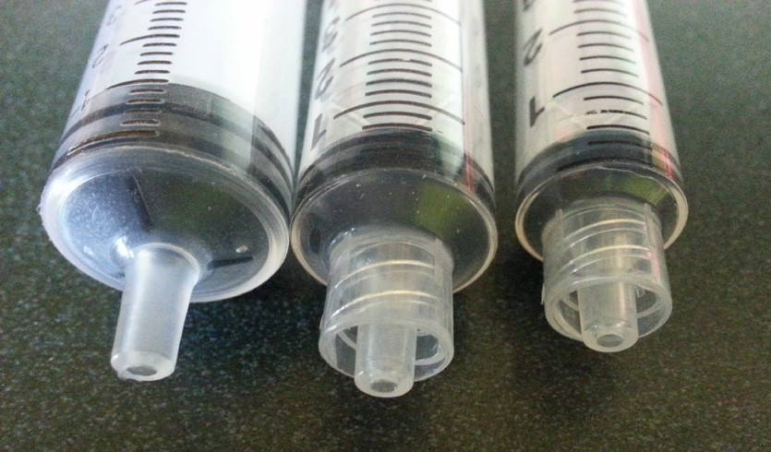

Resources
Figure 1—Syringes

This is a common STEM activity performed in slightly different ways in many different schools around the world. There are many excellent resources available by searching for “syringe robot arm,” “hydraulic robot arm” and similar combinations. Some current resources (as of 2016) include:
Tufts University “Teach Engineering” Educational Outreach is an excellent, alternative activity guide including a short video: https://www.teachengineering.org/activities/view/wpi_hydraulic_arm_challenge
The “Syringe Hydraulic Arm” at Ideas-Inspire.com is another excellent write-up with photos, videos and instructions for building arms:
http://ideas-inspire.com/syringe-hydraulic-arm/

A well-documented build of an articulated 3 DOF syringe arm with gripper, including plans, is available at:
http://jefenry.com/main/MechanicalArm.php

This site presents instructions for assembling a commercially prepared kit. The fine detail of these instructions may serve as a guide in the design of your students’ arms: http://www.copernicustoys.com/doc/COP-Arm-Instructions1.2.pdf
The Instructables site has a nice arm built from cardboard and duct tape: http://www.instructables.com/id/Hydraulic-robot-made-of-cardboard-and-scotch-duct-/
Commercially produced educational robot arm kits are available for purchase. However, they can be manufactured in-house for a fraction of the cost:
http://www.pitsco.com/T-bot_II_Hydraulic_Arm

There are also 3D printable robot arms on Thingiverse: http://www.thingiverse.com/thing:1328020 and http://www.thingiverse.com/thing:39803

Demonstration
If a sample syringe arm is available, use it to demonstrate the challenge. Otherwise you may wish to use one of the many videos available on-line. Links are provided above.

Procedure
Following is an outline of the procedures for this lesson. Detailed procedure guidelines are provided below in the Detailed Procedure Guidelines section on page 97. Items marked with an asterisk have supporting materials included in the Lesson Support Materials section of this activity guide.

Day 1: | Lesson: | Introduce Activity.*  Discuss types of robot arms.* Discuss types of end effectors.
 | Activities: | Put students into teams.  Begin drawing / modelling exercise to determine arm type and dimensions.*
Day 2: | Lesson: | Fluid power*
 | Activities: | Fill and bleed syringes.  Compare the force on different size syringes.  Compare the difference between pushing on a syringe and pulling on it. Where do the bubbles come from when pulling?  Finish design of robot arm if time allows.
Day 3: | Lesson: | Moments and counterbalances*
 | Activities: | Finish design of robot arm. Begin construction of robot arm.
Day 4: | Lesson: | Review fluid power and moment concepts
 | Activities: | Continue arm construction.
Day 5: | Lesson: | Quiz on fluid power and moment concepts*
 | Activity: | Continue arm construction.
Day 6: | Lesson: | Cable and tubing management
 | Activity: | Continue arm construction and test.
Day 7: | Lesson: | Review challenge
 | Activity: | Arm practice and refinement
Day 8: | Activity: | Robot Arm Challenge Day!

Lesson Support Materials
The following lesson support materials are provided in this activity:
  - Robot Arm Challenge page 95
  - Fluid Power Worksheet page 106
  - Moments and Counterbalances Worksheet page 113
  - Robot Arm Quiz page 116

The Robot Arm Challenge

Name: Date: Block:

Robot arms are used everywhere! From an excavator to a chocolate factory to the Canadarm2 on the International Space Station, the robot arm is one of the most practical applications for robotics. Many robot arms operate using motors for control, but some of the most powerful ones use hydraulics. In this challenge you will work with a partner to design and build a hydraulic robot arm and have it complete a task as efficiently as possible.

The Challenge:
The game object for your challenge will be:

The game objects will be placed on a 20 cm × 20 cm playing field.

The only thing that may enter the space above the playing field or touch the game objects shall be your robot arm.
The base of your robot arm must be at least 5 cm from the playing field at all times.

Your arm will have to pick up the game objects and place them in a container approximately 10 cm tall.
Your task will be to get as many game objects into the container as possible in : seconds.

Your Supplies:
You will be given a collection of building materials by your teacher. Your robot must be built from the materials supplied.
You will be given : plastic syringes and tubing to join them. These will form your hydraulic actuators.

Your Process:
You will need to start by designing your robot arm. The six common types of robot arm are shown below.
For this challenge the articulated robot arm is the most common solution. Your teacher will guide you through an exercise in designing your arm.
Once you have a design that works, sketch it at ½ scale using the back of this handout.

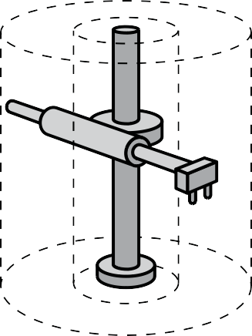
Rectangular coordinate robot Cylindrical coordinate robot

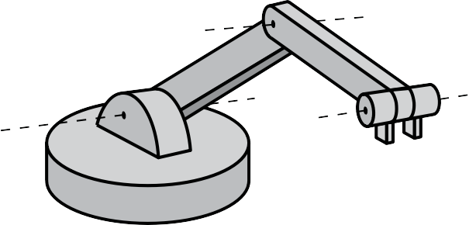

Spherical coordinate robot
Articulated arm robot

Gantry robot SCARA robot

Figure 2—Six most common types of robot arm

Detailed Procedure Guidelines
Day 1 Lesson: Arm Geometry: exercise and tips on designing an articulated arm Robot arms are often described in terms of “degrees of freedom” (DOF). A degree of freedom is provided by a joint that can either translate (slide) or rotate.
In the CNC world these are sometimes described as “axes” (plural of axis, not the tools for lumberjacks). A standard three-axis CNC router or 3D printer is a “3 DOF Cartesian” system.
You can see a 5 DOF CNC machine in action here: https://www.youtube.com/watch?v=KDPA06D1r_8.
Most of the six common robot arm designs have at least one DOF from a translational element. Unless you have provided the students with a way to build a linear slide, they will have a problem. They might be able to solve it—it’s up to them to figure it out.
Most of the arms built to solve this challenge are the articulated type. Using eight syringes allows for three DOF plus one end effector (“gripper”).
Typically they are referred to as the:
- base (rotation)
- shoulder joint (rotation)
- elbow joint (rotation)

To save on syringes you may want to allow students to turn the base by hand.

Designing an articulated robot arm is fairly easy; it’s connecting the hydraulics that is the challenge. 3D parametric modelling programs such as AutoDesk Inventor make this easier.
To help in the design, have your students use CAD: Cardboard Aided Design (credit to Randy Schultz at BCIT for the term). Students can mark out the baseline, playing field and “lifting line” at 1:1 scale on a piece of cardboard.
They can cut a representation of their base, upper arm and lower arm from cardboard. They can use thumbtacks, pushpins or even brads to serve as joints.
The process is detailed in Figures 3–14 on the following pages.

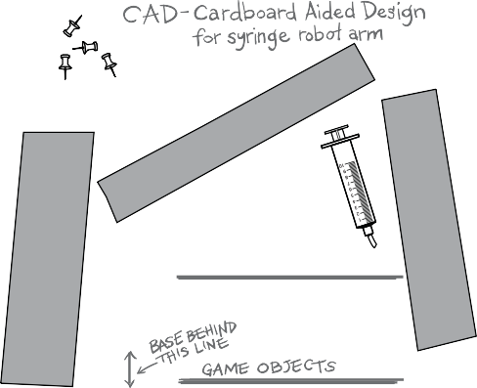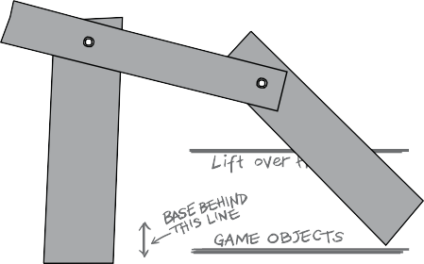

Figure 3—The starting point Figure 4—Pin the parts
Pin down base and arm joints. Arm should reach farthest point on playing field.

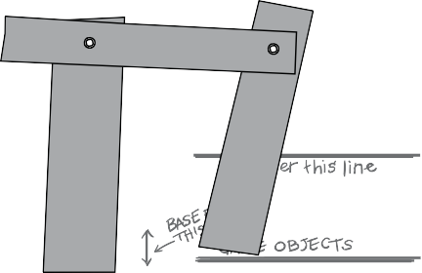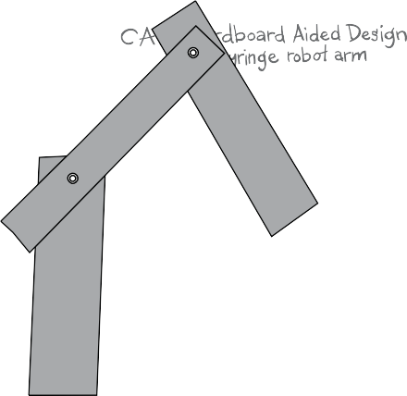

Figure 5—Test nearest reach point
Arm should also reach nearest point on playing field.
Figure 6—Height clearance
Arm should clear the lifting line.

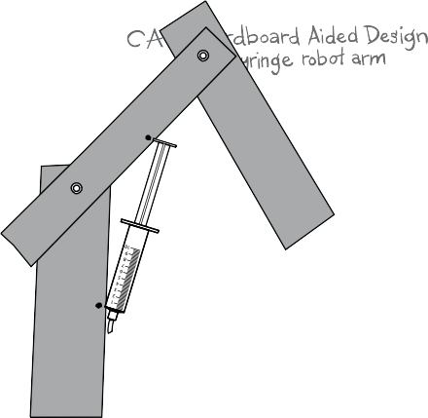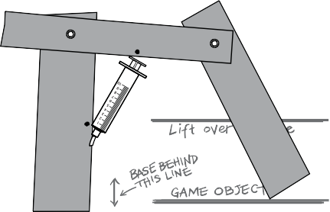

Figure 7—Test-fit shoulder syringe
Test-fit shoulder joint syringe at full extension.
Mark mounting points for the syringe.
Figure 8—Test-fit retracted syringe
Test-fit shoulder joint syringe at full retraction. It MUST fit the same mounting points as at full extension.

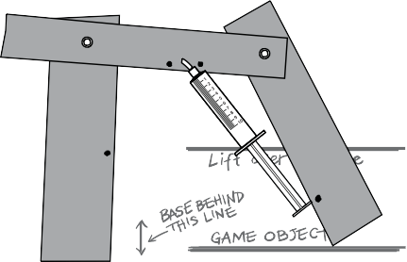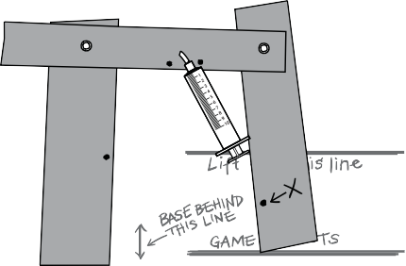

Figure 9—Test-fit elbow syringe
Test-fit elbow joint syringe at full extension. Mark mounting points. Note that this syringe may not intersect
with the shoulder syringe. It may be easier to use two syringes in this exercise.
Figure 10—Test-fit retracted elbow
Test-fit elbow joint syringe at full retraction. Note that it cannot retract the arm to the near side of the playing field. This mounting point will not work.

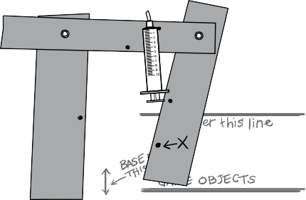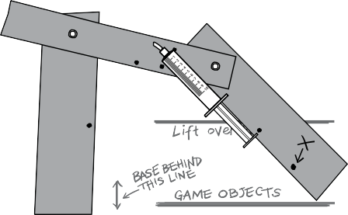

Figure 11—Adjust syringes to fit
Try a new mounting point for the elbow joint syringe. Mark the new mounting points.
Figure 12—Pay attention to torque
The new syringe location might work, but note that it is almost perfectly in line with the lower arm. This means that it will not be delivering a lot of torque to the elbow joint. It might work, but there might be a better design.

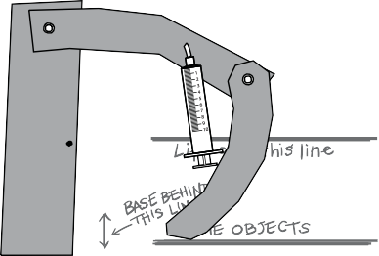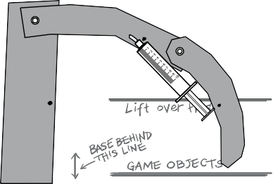

Figure 13—Try curved arms
Students might want to try using bent or curved arms in order to improve mounting points and torque transfer. They may find some inspiration in the backhoe or excavator, although they are
designed for double-acting cylinders.
Figure 14—Curved arms may offer better performance A process of iteration should lead students to develop a workable design. Once they have finalized their design, have
them sketch a ½ scale model on the back of their handout.
The teacher may wish to have the students demonstrate their design using their cardboard model..

End Effectors or “Grippers”
The design of the end effector will be based on the chosen game object and should be designed at the same time as the arm; a similar CAD process may be used. Elastics or springs can be very useful. As you use a syringe to push the effector open, the elastics will hold it tight when
the syringe is retracted.

See the Day 2 notes on pulling on a hydraulic cylinder. You could pull, of course, just not very well.
Links to some examples can be found in the “Resources” section of this activity.

Day 2 Lesson: Fluid Power
These notes are intended to support the fluid power worksheet. It is helpful to have a few syringes and tubing filled in advance of the lesson to serve as demonstrations. A small amount of food colouring in the water will make it easier to see the fluid. Placing the syringes on an overhead projector will allow all students to see the syringes move as the instructor pushes and pulls the pistons. Having buckets filled with water (perhaps a couple of buckets with different colours of water) will help students fill and bleed their systems.
Fluid power systems include both pneumatic and hydraulic systems. In both, power is transmitted from one location to another by moving a pressurized fluid. Gases, like air, are considered fluids because they flow. Liquids, like water, are also fluids.

Hydraulic systems
In hydraulic systems the fluid is a liquid. We use water for our hydraulic arm (that’s where the hydro comes from).
Industrial equipment uses oil, which helps prevent corrosion in the system.

Hydraulic fluids are incompressible. They don’t change their volume when you push on them. When using a hydraulic fluid, it is important to get all of the air out of the system. Even tiny air bubbles will compress under pressure. This makes the system “spongy” or “springy.” Removing the bubbles from the system is called bleeding the system. Have you ever heard of someone bleeding their brakes?

Pneumatic systems
In pneumatic systems the fluid is usually air (that’s where the “pneum” comes from … like pneumonia).
Gases are compressible. Compressed gas acts like a spring: it stores a lot of energy! This can be useful when used in a paintball gun but dangerous when used with “home-made” storage tanks like the Schedule 40 ABS pipe in potato cannons. When a pneumatic vessel fails, it tends to explode violently.

Steam power
Question for students: Would steam power be considered hydraulic or pneumatic?

Answer: It uses water to make steam, but steam is a gas so it is pneumatic. In reality, however, steam often gets its own category because of the high temperatures involved and the fact that the steam often condenses into liquid.
Steam power is a very important part of industrial operations in BC. Its uses include:
- heating buildings
- running industrial plants such a pulp mills and refineries
- creating electricity through turbines driven by steam generated by burning natural gas or even garbage!

People who run and operate steam power plants are called power engineers or steam engineers. There are many good jobs for people who can work safely with steam. You can learn to be a power engineer at BCIT or other schools.

Hydraulics vs. Pneumatics: Quick Reference

 | Hydraulic | Pneumatic
Type of Fluid | Water, oil or other liquid | Air or other gas
Compressible? | No. Does not change volume when under pressure. | Yes. It compresses when under pressure.
Movement | Very precise. Good for moving actuators a specific distance. | Very flexible. Good for gripping objects of unknown size.
Explosion Hazard | Very low. If a cylinder ruptures, a small leak will instantly relieve all of the pressure in the line. (Just don’t get hit by the stream … it will be a very high- pressure jet!) | Very high. If a cylinder ruptures, the stored energy in the compressed  gas will be released as an explosion. Higher pressures bring higher danger!
Spill Hazard | Leaks can create a big mess, particularly when using oil. | No clean up required.
Speed | Liquids are more viscous than air. They move more slowly. | Pneumatic actuators can move very quickly, as air flows easily.
Force | Can be used safely at high pressure, so can transmit high forces safely. | High pressures create an explosion hazard. The working pressure is lower than for hydraulic systems.
General Uses | Larger, heavier, slower moving equipment that transmits a lot of force. | Smaller, quicker moving machines that may pick up objects of unusual sizes or shapes

Pressure, Area and Force: How to Move a Piston with Fluid Power
Our syringes work like a hydraulic or pneumatic cylinder. The cylinder is the “outside” part that stays still and contains the fluid. The piston is the “inside” part that moves. The fluid in the system is under pressure—the same pressure at every point in the system.
Pressure is measured in terms of force divided by area. In the metric system we use the pascal, or one newton of force per square metre. Since the pascal is a very small amount of pressure, we tend to use the kilopascal (kPa). One kPa is 1000 newtons of force per square metre. This is roughly the force exerted by 100 kg of mass at the surface of the Earth. Standard air pressure is about 100 kPa. Standard air pressure is 101.3 kPa at sea level.
In the imperial system we use pounds per square inch (psi). Standard air pressure is about 15 psi.

Imagine a 1" square on the palm of your hand. The air pressure pushing on that square is 15 pounds.
- How much air pressure is pushing on your whole palm?
- Why doesn’t your hand move under the pressure?
- Why don’t you feel it?
- What would happen if the air pressure wasn’t there?

Within a closed hydraulic system it is assumed that the pressure is the same everywhere in the system.
Force can be calculated by multiplying the pressure by the area: F = P × A

Worked Example of Pressure Calculation
If you have 15 psi acting on 3 square inches, you have: F = 15 psi × 3 square inches = 45 pounds of force
If you have 100 kPa acting on a 10-cm diameter circle:
- Convert 1 cm to 0.01 m.

- Calculate the radius of the circle: 0.1 m diameter / 2 = 0.05 m radius

- Calculate the area of the circle: 3.14 x (0.05 m radius)2 = 0.008 m2

- Convert the pressure to pascals: 100 kPa = 100,000 Pa

- Now calculate the force: 100,000 Pa x 0.008 m2 = 800 N

To estimate the equivalent “weight,” divide the newton value by 10:
800 N / 10 = approximately 80 kg of force will be acting on the circle.

The metric example may seem more complex, but the metric system is used by scientists and engineers. Metric calculations become much easier with practice.

Pushing a Piston: Mechanical Advantage
Typically a piston will have two forces acting on it:
- The load: applied by something or someone “outside” the hydraulic system.

- The pressurized fluid: acting on the piston by the fluid “inside” the system.

When the two forces are equal the piston won’t move. When the two forces are unequal, the piston will move.
The piston will move “out” if the pressurized fluid presses with more force than the load. It will move “in” if the load presses with more force than the fluid.

When you have two pistons with different areas, the force acting on each piston will be different (Figure 15). The larger piston, with more surface area, will push with a higher force but it will move a shorter distance than the small piston.
The smaller piston, with less surface area, will push with a lower force. It will move a greater distance than the large piston. This is similar to the principles of gearing, or leverage:
Smaller force × longer distance = bigger force × shorter distance

Piston
Piston

Two single acting cylinders joined by a hose. Which will push with the most force?
Which will travel the longer distance?

Figure 15—Two single-acting cylinders of different diameters joined by a base

Consider a car’s braking system (or hydraulic disc brakes on a mountain bike). The brake pad needs to move a very small distance but push very hard. The brake pedal can move a long distance but needs to be easy to push. The pedal gets a small cylinder and the brake gets a large cylinder.
Since larger cylinders will exert more force at the same fluid pressure, you need to design your arm to work with the cylinders that you have. If the hose keeps popping off the cylinder, then perhaps your fluid pressure is too high.
Do you need a bigger cylinder? Do you need to reduce the load on the cylinder? See the notes under Day 3: Moments and Counterbalances, below.

Pushing vs. Pulling a Piston
Question for students: When you pull on one piston, what pushes on the other piston?

Answer: The other piston is “pushed” by ambient air pressure, which is usually much lower than the pressure inside the system.
You can’t pull on a hydraulic system. Well, you CAN … but not with as much force as you can push. What happens if you pull harder? Bubbles form inside the system. Demonstrate by placing syringes on an overhead projector and pulling. Where do the bubbles come from? Dissolved gases in the water.

Consider a bottle of soda pop. Do you see bubbles in it when it is closed? What pressure is it at when it is closed? What happens when you open it? What pressure is it at after opening? There is a LOT of carbon dioxide gas dissolved in soda.
Students may have heard of scuba divers being affected by “the bends.” This happens when oxygen and carbon dioxide build up in their blood at high pressure when they are under water. If they come up to the surface too fast, their blood bubbles, just like the soda pop when it is opened. The bubbles block the flow of blood and can kill.
If you pull hard enough you will get water vapour. As water pressure is reduced, the boiling temperature drops. This is used in vacuum dehydration of foods. But industrial hydraulic cylinders can push AND pull. How do they do it?
Our syringes are a single-acting piston: fluid contacts only one end of the piston. The pistons are designed to push in one direction only.
Most industrial cylinders are double-acting: fluid contacts both ends of the cylinder (Figure 16). The piston can be pushed in both directions. Do you think it will push harder in one direction than the other? Take a look at the area of the piston on each side. The shaft on one side slightly reduces the area. There isn’t as much area, so there isn’t as much force!

Pis
ton
Fluid hoses
Seals
Piston rings

Figure 16—Double-acting cylinder

Fluid Power Worksheet

Name: Date: Block:

These are some of the words and ideas that engineers use when working with fluid power. They are also used by mechanics and equipment operators when controlling and repairing heavy equipment. Can you think of any other careers where people need to know about fluid power?

Terms:
Hydraulics use a such as or

to make things move.

Pneumatics use a such as to make things move.

A liquid is an fluid. That means that it doesn’t “shrink” when you push on it.

A gas is a fluid. That means that it acts kind of like a spring when you push on it.

Pressure is a measure of divided by .

Air pressure acts on us all the time. One “atmosphere” of air pressure is the pressure we feel on Earth at sea level. In metric measure, one atmosphere is measured as
kPa. In imperial measure it is measured as psi.

Our robot will use syringes to make things move. In the photo below, label the part of the syringe that is the “piston.” Label the part that is the “cylinder.” Label the piston rings that keep the fluid
in the syringe.

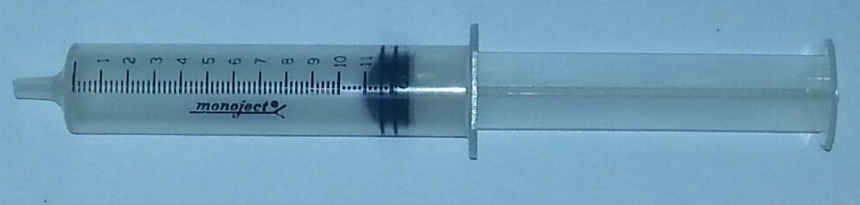

The fluid can push on the piston to make it move. How hard the piston pushes is called the
It is calculated by multiplying the of the fluid by the of the piston.

When filling a hydraulic system with fluid, it is important to get all the out of the system. This is called the system.

Calculations
When engineers, mechanics and equipment operators use fluid power, they need to know how much force their system can apply. These are some of the calculations that they use. Fill in the spaces.

 | 10 cc syringe | 5 cc syringe
Diameter of piston | 14.5 mm | 12 mm
Diameter of piston in metres (divide mm by 1000)
Radius of piston (divide diameter by 2)
Area of piston (3.14 × radius squared)
Force on piston at 100,000 Pa
(multiply area by 100,000)

Which piston exerts the larger force at 100 kPa?

Why does the larger piston exert the larger force?

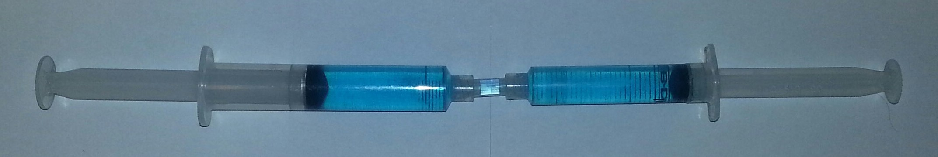

10 cc syringe
5 cc syringe

In the photo above, a 10 cc syringe is connected to a 5 cc syringe so that the fluid can flow from one to the other. If you push on the piston in the 10 cc syringe, the 5 cc syringe’s piston will
move outward. It will move with force than is pushing on the 10 cc syringe piston, but will move a distance.
If you push on the piston in the 5 cc syringe, the 10 cc syringe’s piston will move outwards. It will move with force than is pushing on the 5 cc syringe piston but will move a distance.
Fluid power works best when pushing. When you “pull” on one syringe you are relying on ambient pressure to push the other piston inward. If you pull too hard, then will form in the hydraulic fluid.

Day 3 Lesson: Moments and Counterbalances
These notes are to complement the “Moments and Counterbalances Worksheet.” Having a long (1–2 m) lever arm with holes drilled at regular intervals and a selection of weights to hang from the arm will help illustrate the concepts described here.
A moment, also known as torque, is a twisting force that is the result of a force pushing at a distance from a pivot point. A 100 g mass at the end of a 10-cm long pivot will create a moment of 10 cm × 100 g = 1000 g × cm (Figure 17).

10 cm

100 g

Figure 17—A moment

Technically, the metric unit for torque is the newton metre. Since in Earth’s gravitational field 100 g of mass creates 1 N of force, and 10 cm = 0.1 m, our calculation would be better stated as:
1 N × 0.1 m = 0.1 Nm

The imperial unit for moment is the foot-pound, although you’ll also find inch-pounds used on smaller torque wrenches. One newton meter is 0.738 foot-pounds or 8.85 inch-pounds.
Regardless of whether you are using metric, imperial, inch-pounds, g x cm, Nm or foot-pounds, the basic concept is the same: a moment, or torque, is simply force x distance.
Since the force of gravity is always pulling down, moments change as a robot arm lifts an object (Figure 18).

When a 10-cm arm is rotated to 45 degrees, the load is now only 7 cm from the pivot point. The moment about this pivot point is now 100 g × 7 cm = 70 g × cm, or more accurately,
1 N × 0.07 m = 0.07 Nm.
100 g
7 cm

Figure 18—Load is closer to pivot point

What would the moment be when the arm is perfectly vertical?
You may wish to have a student demonstrate by holding a weight in one hand with their arm extended horizontally. Have them slowly rotate their arm to vertical while keeping their arm straight. Ask, “When did the load feel heaviest?”
To counteract a clockwise moment, we need to apply a counter-clockwise moment. In Figure 19, the syringe is applying an upward force at a distance of 5 cm from the pivot, so it must counteract a clockwise moment of 100 g × 10 cm = 1000 g × cm.
The syringe must create a counter-clockwise moment of 1000 g × cm.

10 cm
5 cm
100 g

Figure 19—Piston counteracts moment

Since the piston is 5 cm from the pivot, we can calculate the upward force: 1000 g × cm / 5 cm = 200 g.
Had we calculated it all in newton metres, we would have arrived at 2 N of upward force. This makes sense: the load is twice as far from the pivot as the syringe, so the syringe must exert twice as much force.
Sometimes a hydraulic actuator (syringe) can’t provide enough force to lift the arm. Adding a counterbalance can help. In Figure 20, the 100 g counterbalance at a distance of 5 cm from the pivot provides 100 g × 5 cm = 500 g × cm of counter-clockwise moment. This means that the syringe only needs to create a 500 g × cm counter-clockwise moment. The syringe only needs to push with a force of 100 g (1 N).

10 cm
5 cm
5 cm
100 g
100 g

Figure 20—Counterbalance supporting load

Sometimes adding a counterbalance can make the arm too heavy or too slow. Springs or elastic bands can be used to provide a counteracting force (Figure 21).

10 cm
5 cm
5 cm
100 g

Figure 21—Elastics or springs replacing counterweight

It can be more difficult to calculate the effect of a spring or elastic band. The amount of tension changes as the band is stretched or relaxed. One alternative is to use a constant force spring, which is a coil of thin metal strip that can be used at the pivot point to counteract the load.
There are two main types of load that a robot arm experiences:
- The live load: the weight of whatever is being lifted
- The dead load: the weight of the arm, grippers and actuators

Normally counterbalances are used to counteract the dead load of the arm. The live load is left for the actuators (pistons or motors) to manage.
An additional live load to consider is the momentum of the arm. A heavy arm does not want to start (or stop) moving quickly. Fast-moving arms have to be either very light or very powerful.
When a heavy live load must be held in position for an extended time, it may be helpful to also apply a brake or locking mechanism to the pivot point. This reduces the strain on the motors or cylinders holding the arm in place.
Your arm design will likely be a bit more complicated to calculate. The syringes will probably be at an angle to the arm. This can be calculated by hand or modelled by computer.
The syringe in Figure 22, for example, has to push harder than a vertical syringe because it is
at an angle. So long as you understand the basic principles of moment, however, you should be able to make your arm work.

10 cm
5 cm
5 cm
100 g

Figure 22—More complex piston arrangement

Moments and Counterbalances Worksheet

Name: Date: Block:

Your robot arm will rotate about joints, or pivot points. The amount of force acting on the arm and the distance of that force from the pivot point will be important in making sure that your arm can lift its load. Learning about moments and counterbalances will help you design and build a better robot arm.
A is a twisting force, also known as . It is
the result of a pushing at a distance from a point.

In metric measure the standard unit for a moment is the
or Nm. In imperial measure people use the
or ft. lb.

The equation to calculate a moment is × . In this diagram the live load is 100 g and acts at a distance of 10 cm from the pivot.

10 cm
5 cm
100 g

100 g of mass in Earth’s gravitation gives a force of N. A distance of 10 cm expressed in metres is m.
The moment is:

N × m = Nm.

The syringe must counteract the moment of the live load. The syringe is at a distance of
m, so we can calculate the force on the syringe as Nm /
= N.

This force is roughly the same as that exerted by a mass of g. This makes sense because the syringe pushes as hard, but at
the distance as the load.

The moment can change as the arm rotates. In this diagram the arm is still 10 cm long, but now the load is closer to the pivot point. The moment is now:

N × m = Nm.
100 g
7 cm

To help balance an arm and make it easier to lift, we sometimes add a weight on the opposite

side of the pivot point from the main load. We call this a |  | .
In this arm it creates a counter-clockwise moment of  Nm. | N × | m =

10 cm
5 cm
5 cm
100 g
100 g

This means the syringe only has to create a moment of Nm to balance the arm.

One problem with counterbalances (also called counterweights) is that they make an arm
.

Robot arm designers can help support the load by adding or
to help pull the arm up.

There are two main types of load on the arm. The load is the
weight of the object the arm is lifting, while the load is the weight of the arm itself. The weight of the object might change, but the weight of the arm usually
remains constant. For this reason robot designers will usually use the counterbalance to support the moment caused by the dead load, and let the piston or motor support the weight of the live load.

Robot Arm Quiz

Name: Date: Block:

Score: /16

- Matching—Place the letter that best represents the term in the column indicated. (0.5 mark each–6 marks)

Place Letter Here | Term
 | Hydraulic power | A  Force / Area | B  About 100 kPa in metric, about 15 psi in imperial | C  A metric unit of force, about equal to a mass of 100 g
 | Pneumatic power | A  Force / Area | B  About 100 kPa in metric, about 15 psi in imperial | C  A metric unit of force, about equal to a mass of 100 g
 | Pressure | A  Force / Area | B  About 100 kPa in metric, about 15 psi in imperial | C  A metric unit of force, about equal to a mass of 100 g
 | Air pressure at sea level | D  10 cm  100 g | E  Fluid power using a liquid such as oil or water as the fluid | F  The metric unit of torque, the newton metre
 | Bleeding | D  10 cm  100 g |  | F  The metric unit of torque, the newton metre
 | Moment | D  10 cm  100 g |  | F  The metric unit of torque, the newton metre
 | Newton | G  A weight or spring added to the back of your robot arm to assist with lifting the load | H  Fluid power using a gas such as air as the fluid | I  The imperial unit of torque, the foot pound
 | Nm |  | H  Fluid power using a gas such as air as the fluid | I  The imperial unit of torque, the foot pound
 | Ft. lb. |  | H  Fluid power using a gas such as air as the fluid | I  The imperial unit of torque, the foot pound
 | Live load | J  The weight of the structure; in this case, the weight of the arm | K  Removing air bubbles from a hydraulic system | L  The weight of the object you are moving
 | Dead load |  | K  Removing air bubbles from a hydraulic system | L  The weight of the object you are moving
 | Counterbalance |  | K  Removing air bubbles from a hydraulic system | L  The weight of the object you are moving

- Our syringes work best when pushing. Why? (1 mark)

- What do we call a cylinder that can both PUSH and PULL? (1 mark)

- In this photo there are two syringes of different diameters. (3 marks)

15 mm diameter
10 mm diameter

  - If the syringe on the right (10 mm) is pushed with a force of 8 N, how much force will the larger syringe exert?

  - Which piston will move the greatest distance?

- In this diagram an arm has a counterweight that exerts 5 N at a distance of 0.15 m from the pivot point and a syringe that exerts 6 N at a distance of 0.1 m. (5 marks)

.3 m
.15 m
.1 m
6N
5N
F

  - How much torque does the counterweight create?

  - With the counterweight and syringe working together, how much force can be exerted to lift the load labelled “F”?

Extension Activities
This challenge can be extended by placing robots on opposite sides of the playing field. The robots can either cooperate to gather game objects as quickly as possible, OR compete to gather more game objects than the other arm.
You can also change the goals and have the robots place game objects ON the field, potentially for playing a game of Tic-Tac-Toe.
Advanced students may wish to design components in CAD and create them using a 3D printer, laser cutter or CNC machine.
Students who finish early may wish to experiment with a motor-controlled robot arm kit such as this one, if available:
http://www.pitsco.com/Robotic_Arm_Edge_Kit

Assessment

Student name:

“Cardboard Aided Design” Score: /5
Team demonstrates shoulder and elbow joint movement. Team demonstrates suitable range of motion for end effector. Team demonstrates suitable locations for piston mount points.
Mount points do not exceed syringe extension/retraction limits. Mount points allow for syringe to rotate arm.
Scale Model Drawing Score: /5
Scale model matches “CAD” model.
Drawing completed with care and attention to detail.
Student uses straightedge, pencil and eraser.
Drawing shows key measurements.
Pivot points
Syringe mount points

Robot Arm Quiz Score: /16

Robot Arm Construction Score: /10
Parts fit snugly
Appropriate use of fasteners and adhesives Tubing secured and tidy
Overall appearance of final product

Robot Arm Performance Score: /10
Arm can pick up playing piece.
Arm has sufficient range of movement to pick up pieces anywhere on playing field. Arm can successfully deposit playing pieces in receptacle or goal location.
Arm has reasonable degree of control.
Arm demonstrates reliability and robustness.

Robot Arm Competition Score: /10
Criteria based upon the challenge as set by the teacher

Total score: /56

Electronics and Robotics Robot Arm Challenge

Robot Arm Design (1 square = 1 cm Name: Partner’s Name: Block:

Robot base must be behind this line Playing field—robot must be able to reach each end and lift above the grey line.

Robot Arm Challenge Answer Key

Fluid Power Worksheet
These are some of the words and ideas that engineers use when working with fluid power. They are also used by mechanics and equipment operators when controlling and repairing heavy equipment. Can you think of any other careers where people need to know about fluid power?

Terms:

Hydraulics use a fluid such as oil or water to make things move. Pneumatics use a gas such as air to make things move.
A liquid is an incompressible fluid. That means that it doesn’t “shrink” when you push on it.

A gas is a compressible fluid. That means that it acts kind of like a spring when you push on it. Pressure is a measure of force divided by area.
Air pressure acts on us all the time. One “atmosphere” of air pressure is the pressure we feel on
Earth at sea level. In metric measure, one atmosphere is measured as about 100 (101.3) kPa. In imperial measure it is measured as 15 psi.
Our robot will use syringes to make things move. In the photo below, label the part of the syringe that is the “piston.” Label the part that is the “cylinder.” Label the piston rings that keep the fluid
in the syringe.

The fluid can push on the piston to make it move. How hard the piston pushes is called the
force It is calculated by multiplying the pressure of the fluid by the area of the piston.

When filling a hydraulic system with fluid, it is important to get all the air out of the system. This is called bleeding the system.

This work is licensed under a Creative Commons Attribution-NonCommercial-ShareAlike 4.0 International License unless otherwise indicated. 121

Calculations
When engineers, mechanics and equipment operators use fluid power, they need to know how much force their system can apply. These are some of the calculations that they use. Fill in the spaces.

 | 10 cc syringe | 5 cc syringe
Diameter of piston | 14.5 mm | 12 mm
Diameter of piston in metres (divide mm by 1000) | 0.0145 m | 0.012 m
Radius of piston (divide diameter by 2) | 0.00725 m | 0.006 m
Area of piston (3.14 × radius squared) | 0.000165 m2 | 0.000113 m2
Force on piston at 100,000 Pa (multiply  area by 100,000) | 16.5 N | 11.3 N

Which piston exerts the larger force at 100 kPa? 10 cc syringe

Why does the larger piston exert the larger force?

greater surface area on piston (bigger diameter)

10 cc syringe
5 cc syringe

In the photo above, a 10 cc syringe is connected to a 5 cc syringe so that the fluid can flow from one to the other. If you push on the piston in the 10 cc syringe, the 5 cc syringe’s piston will move outward. It will move with less force than is pushing on the 10 cc syringe piston, but will move a greater distance.
If you push on the piston in the 5 cc syringe, the 10 cc syringe’s piston will move outwards. It will move with more force than is pushing on the 5 cc syringe piston but will move a shorter distance.

Fluid power works best when pushing. When you “pull” on one syringe you are relying on ambient air pressure to push the other piston inward. If you pull too hard, then bubbles will form in the hydraulic fluid.

Moments and Counterbalances Worksheet

Your robot arm will rotate about joints, or pivot points. The amount of force acting on the arm and the distance of that force from the pivot point will be important in making sure that your arm can lift its load. Learning about moments and counterbalances will help you design and build a better robot arm.

A moment is a twisting force, also known as torque It is the result of a force pushing at a distance from a pivot point.
In metric measure the standard unit for a moment is the newton metre or Nm. In imperial measure people use the foot pound or ft. lb.
The equation to calculate a moment is force × distance

In this diagram the live load is 100 g and acts at a distance of 10 cm from the pivot.

10 cm
5 cm
100 g

100 g of mass in Earth’s gravitation gives a force of 1 N. A distance of 10 cm expressed in metres is 0.1 m.
The moment is: 1 N × 0.1 m = 0.1 Nm.

The syringe must counteract the moment of the live load. The syringe is at a distance of 0.05 m, so we can calculate the force on the syringe as 0.1 Nm / 0.05 m = 2 N.
This force is roughly the same as that exerted by a mass of 200 g. This makes sense because the syringe pushes twice as hard, but at half the distance as the load.

The moment can change as the arm rotates. In this diagram the arm is still 10 cm long, but now the load is closer to the pivot point. The moment is now: 1 N × 0.07 m = 0.07 Nm.

To help balance an arm and make it easier to lift, we sometimes add a weight on the opposite side of the pivot point from the main load. We call this a counterweight (or counterbalance). In this arm it creates a counter-clockwise moment of 1 N × 0.05 m = 0.05 Nm.
100 g
7 cm

10 cm
5 cm
5 cm
100 g
100 g

This means the syringe only has to create a moment of 0.05 Nm to balance the arm.

One problem with counterbalances (also called counterweights) is that they make an arm

heavy (or slow).

Robot arm designers can help support the load by adding springs or elastics to help pull the arm up.

There are two main types of load on the arm. The live load is the weight of the object the arm is lifting, while the dead load is the weight of the arm itself. The weight of the object might change, but the weight of the arm usually remains constant. For this reason robot designers will usually use the counterbalance to support the moment caused by the dead load, and let the piston or
motor support the weight of the live load.

Robot Arm Quiz

Name: Date: Block: Score: /16
- Matching—Place the letter that best represents the term in the column indicated. (0.5 mark each–6 marks)

Place Letter Here
Term
E
Hydraulic power
A
Force / Area
B
About 100 kPa in metric, about 15 psi in imperial
C
A metric unit of force, about equal to a mass of 100 g
H
Pneumatic power
A
Pressure
B
Air pressure at sea level
D
10 cm
C
Newton
G
A weight or spring added to the back of your robot arm to assist with lifting the load
H
Fluid power using a gas such as air as the fluid
I
The imperial unit of torque, the foot pound
F
Nm
I
Ft. lb.
L
Live load
J
The weight of the structure; in this case, the weight of the arm
K
Removing air bubbles from a hydraulic system
L
The weight of the object you are moving
J
Dead load
G
Counterbalance
K
Bleeding
D
Moment
E F
Fluid power The metric unit using a liquid of torque, the such as oil or newton metre water as the
fluid
100 g

- Our syringes work best when pushing. Why? (1 mark)

They are single-acting syringes that rely upon air pressure to “pull”

- What do we call a cylinder that can both PUSH and PULL? (1 mark)

Double acting

- In this photo there are two syringes of different diameters. (3 marks)

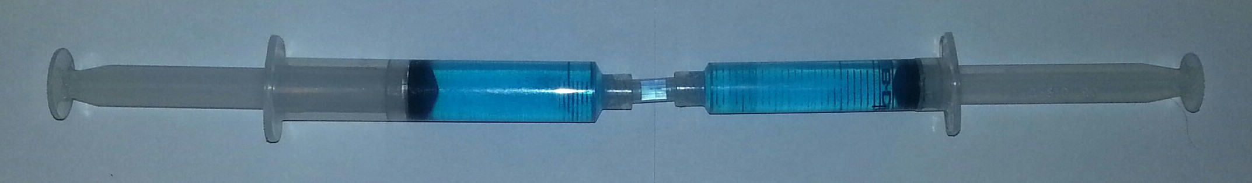

15 mm diameter
10 mm diameter

- If the syringe on the right (10 mm) is pushed with a force of 8 N, how much force will the larger syringe exert?

Area of 10 mm syringe = 0.0000785 m2 Area of 15 mm syringe = 0.000176 m2
Water pressure = 8 N / 0.0000785 m2 = 101,910 Pa
Force on 15 mm syringe = 0.000176 m2 × 101,910 Pa = 17.9 N
(The area of the larger syringe is just over twice that of the smaller one, so the force is just over twice as much, too.)
- Which piston will move the greatest distance?

the smaller piston (10 mm dia.)

- In the diagram an arm has a counterweight that exerts 5 N at a distance of 0.15 m from the pivot point and a syringe that exerts 6 N at a distance of 0.1 m. (5 marks)

.3 m
.15 m
.1 m
6N
5N
F

  - How much torque does the counterweight create?

5 N × 0.15 m = 0.75 Nm rotating counter-clockwise
  - With the counterweight and syringe working together, how much force can be exerted to lift the load labelled “F”?

Counterweight torque = 0.75 Nm rotating counter-clockwise Syringe torque = 6 N × 0.1 m = 0.6 Nm rotating counter-clockwise. Total “lifting” torque = 1.35 Nm
1.35 Nm / 0.3 m = 4.5 N of force that can be exerted to lift the load

Assessment
Student name:

“Cardboard Aided Design” Score: /5
Team demonstrates shoulder and elbow joint movement. Team demonstrates suitable range of motion for end effector. Team demonstrates suitable locations for piston mount points.
Mount points do not exceed syringe extension/retraction limits. Mount points allow for syringe to rotate arm.
Scale Model Drawing Score: /5
Scale model matches “CAD” model.
Drawing completed with care and attention to detail.
Student uses straightedge, pencil and eraser.
Drawing shows key measurements.
Pivot points
Syringe mount points

Robot Arm Quiz Score: /16

Robot Arm Construction Score: /10
Parts fit snugly
Appropriate use of fasteners and adhesives Tubing secured and tidy
Overall appearance of final product

Robot Arm Performance Score: /10
Arm can pick up playing piece.
Arm has sufficient range of movement to pick up pieces anywhere on playing field. Arm can successfully deposit playing pieces in receptacle or goal location.
Arm has reasonable degree of control.
Arm demonstrates reliability and robustness.

Robot Arm Competition Score: /10
Criteria based upon the challenge as set by the teacher

Total score: /56

Robot Arm Challenge Answer Key
Electronics and Robotics

Multi-bot Challenge

Description
Robotics competitions help students by engaging them in a time-bound activity, encouraging teamwork and having them follow rules similar to those outlined by a governing body. The benefits of competition include promoting collaborative work among students in diverse communities, offering pride in awards, and encouraging innovation and problem-solving in an energized, public education forum.
The students’ primary objective in this activity is to attempt to complete one of the competition challenges listed below. You may choose to select a classroom challenge from the resources recommended or create your own challenge. Two recommended game challenges appear in this activity. Before beginning the activity you may want to prepare a scoreboard and have a timer handy.

Lesson Outcomes
Students will be able to work in a team environment to:
- Construct and operate a robot to perform the game challenge(s)
- Follow instructions to complete a complex task
- Solve technical problems individually and collaboratively

Assumptions
Students will:
- Understand basic construction techniques
- Have formed teams and partnerships within the classroom
- Have access to robotics platforms and necessary equipment
- Have little or no experience in working with a larger team, coordinating work and allocating resources
- Have some experience with basic robots

Key Terminology
De-scoring: the act of removing a game element from within a goal or from within a score zone.
Game element: items used by the robot to achieve a score.
Field: the arena area where the competition takes place.
Goals: a location where the game elements must be placed to obtain a score.

This work is licensed under a Creative Commons Attribution-NonCommercial-ShareAlike 4.0 International License unless otherwise indicated. 129

Score zone: the scoring area within the competition arena. When a game element enters this area, a score is usually assigned, but not as high as if it was inside the goal.
Scoring: the act of placing a game element within a goal or within a score zone.

Estimated Time
4–8 hours per game challenge

Recommended Number of Students
Two to four students per robot

Facilities
  - A competition arena – ideally one from VEX Robotics or FIRST LEGO League. This should be a middle- to large-sized space that can accommodate a large table or floor area where the competition can take place (e.g., cafeteria, gym or large classroom).
  - Work benches (optional)
  - Storage for robots, kits and tools

Tools
  - Tools are platform-specific based on the robotics platform selected.
  - A basic tool kit that includes pliers, wrenches and files (to round off sharp corners)
  - Computers with appropriate software, ideally laptop computers (1 per team)
  - Timer

Materials
  - An area to construct robots
  - A competition arena – ideally using a competition arena from VEX robotics or FIRST LEGO League.
  - Timer
  - Scoreboard (can use a blackboard or whiteboard to record most scores)
  - Robots that can move, grab and release
  - The intermediate-level challenge requires robots with a sensor at the back, programmed to pause the robot for three seconds when touched.
You may choose to purchase or custom-design your own game elements and arena from the dollar store or the hardware store.

Resources

VEX Robotics
https://www.vexrobotics.com/

Every spring the Robotics Education and Competition Foundation establishes a new VEX game to be played around the world. This game can be found at: http://www.roboticseducation.org/vex-robotics-competitionvrc/current-game/
The current year’s VEX IQ game can be found at: http://www.roboticseducation.org/vex-iq-challenge/viq-current-game/

LEGO
https://www.lego.com/en-us/mindstorms/

Each year FIRST LEGO League creates a new game to be played with LEGO robots. More information can be found here:
http://www.firstlegoleague.org

When researching specific tasks or troubleshooting unique problems, teams should be directed to seek assistance from the larger robotics community. There are discussion forums focussed on each of the major robotics platforms. Your students may find tips, advice and answers to their questions at the sites below. Please remind them that it is standard forum etiquette to “search before you post” to see if your question (or something like it) has already been answered.

VEX IQ Forum
http://www.vexiqforum.com/

VEX FORUM
https://www.vexforum.com/

FIRST Lego Robotics Forums
http://forums.usfirst.org/forumdisplay.php?24-FIRST-LEGO-League

While international challenges can be fun and exciting and form part of a larger robotics course or club activity, there are many small “in-house” competitions that can be held within the time frame of a Youth Explore Trades Skills module.
One example is “Freeze Tag,” where robots attempt to get behind their opponents and tap a bumper switch, “freezing” the opponent. This is a video of such a competition at Highland Middle School, in Courtenay:
https://www.youtube.com/watch?v=UrHt1S720zk&feature=youtu.be

Another game, using golf balls, can be seen at: https://www.youtube.com/watch?v=CB-zp3Yi7qU
A game suitable for VEX IQ or LEGO style robots can be seen at: https://www.youtube.com/watch?v=w3ROKA1j21E

Demonstration
Introduce your students to the game by showing a video and describing the rules of the game. It helps to have the game arena and game pieces available as part of this introduction.

Procedure
- Determine which game challenge you will follow; arrange the playing field and game elements.
- Introduce the challenge to the students and assign each team a designation (e.g., Team A, B, C).
- Guide the students through a design and build process to create a robot capable of playing the game.
- Create a scoreboard either on paper or in MS Excel so that each robot has a chance to be paired up with every other robot once. Keep score for each team. Use Table 1 as an example.

 | Blue Team (Blue Alliance) |  | Red Team (Red Alliance)
Round 1 | A | B | C | D
Round 2 | A | C | D | B
Round 3 | A | D | C | B
Playoff Round 2 | Winning team 1 from Playoff Round 1 |  | Winning team 2 from Playoff Round 1

Table 1–Competition scoreboard for four teams

Game Challenge #1: Clear the Field (Beginner Level)
In this challenge, two teams with two robots each compete to clear the field of balls. The four competing robots are placed inside the game field.
Both teams will have two minutes to clear the field by picking up and placing the balls in the four corner goal areas (two corner goal areas per team). See Figure 1 for an example.
All balls must be touching the game floor mat before and after the game.

The goal area posts can be moved but must be put back before time expires.

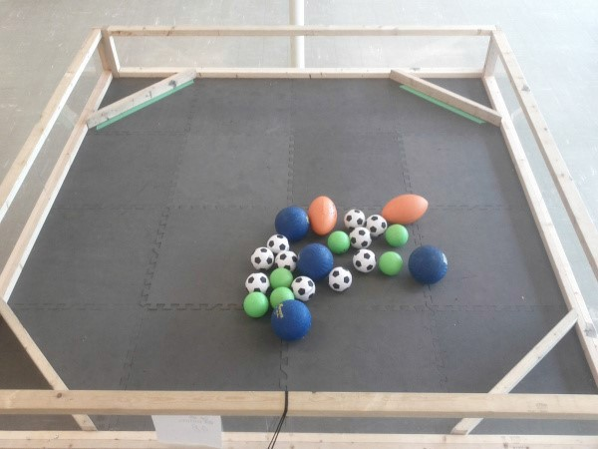

Figure 1—Clear the field arena

Game Challenge #2: Bumper Bot (Intermediate Level)
This is a challenge played with two, three or four robots, each with a sensor at the back. When the sensor is touched it causes the robot to pause for three seconds.
The object of the game is to collect as many game objects as possible. To gain advantage, robots can bump competitors on the back side sensor, which will cause it to pause for three seconds.
Each round of the game lasts 90 seconds.
The robot (or team of robots) with the highest number of game objects in their corner wins. An example of this game appears here:
https://youtu.be/UrHt1S720zk

Assessment
The evaluation of this lesson is based on the four learning outcomes outlined above.

Prior to teachers using the evaluation grid it is recommended that students perform some form of peer-assessment and self-assessment.

 | Outcome To Be Assessed | 6 | 5 | 4 | 3 | 2 | 1 | 0
Outcome 1 | Constructs and operates a robot to perform the game challenges
1.1 | Quality of robot construction.
1.2 | Quality of robot software.
Outcome 2 | Follows instructions to complete a complex task
2.1 | Robot has been designed in keeping with recommended best practices.
Outcome 3 | Solves technical problems individually and collaboratively
3.1 | Works together with team members and other teams.
3.2 | Engages in leadership roles, provides critical insight or ideas.

Total Points:

6 | Completed successfully at the exceptional level | Exemplary
5 | Completed successfully at higher than the expected level | Accomplished
4 | Completed successfully to the expected level | Emerging
3 | Attempted successfully at the minimum level | Developing
2 | Attempted – Unsuccessful – Close to Successful | Beginning
1 | Attempted – Unsuccessful | Basic
0 | Not Attempted | N/A
Comments:
The evaluation of this lesson is based on the learning outcomes outlined above.

Extension Activities
”Classroom Challenges” on the following website lists additional activities that can be completed as an extension to this activity.
https://vsbrobotics.wordpress.com/

